

Rootes of the Pacific Northwest

Common Rootes

Weather is improving (yes, I realize that is always debatable depending on the day) and I hope you have had an opportunity, or at least soon will, to get your Sunbeam or Rootes vehicle on the road. We do encourage you to come out for the next couple club outings. On May 21, we will be touring Jim Green’s Performance Center in Monroe. Paul Jelinek put this together for the club and certainly I am looking forward to seeing the new facility. Many of you might well know Jim Green from his North Seattle facility and have bought performance parts from him in the past. As indicated in the Events Calendar, Green is a leader in Ford 427 Cammer engines. The Cammer used a timing chain about 7 feet long to drive the overhead cams. Data from the time showed that the engine added about 225 hp to the ratings of the “normal” 427 side oiler. Hope that you can make this meeting. Then in June we follow with another tour, this one of a British car restoration shop in Seattle. We thank both businesses for opening up their doors for our visit. This is a great opportunity to see something new (or old) and socialize with your fellow Rootes owners.
Don’t forget to consider all the other car related activities we have in the NW. I did the Tulip Rallye this year and there were

about 320 cars participating. Many of the local clubs are now using this event as their “start of the season” event. This year there were groups from almost all the British car clubs, plus Porsche, Mini, Corvair, Alfa Romeo, Corvette and even a new Fiat 500. Did I ever tell you about my 1974 Fiat 128? Oh, never mind, I promised Judy I would try to watch my language. Although we didn’t make it an “official” club event since it is so close to Sunbeam NW, the Bellevue ABFM is always well attended, and a great opportunity to view British iron. We are getting into the season, where there is literally something going on every weekend, if you are so inclined.
Those of you that have been in the club for awhile, know that this time of year, the current board starts seeking individuals to manage the club in the coming year. Clubs need new leadership and ideas to stay vibrant and worthwhile. Yes, it gets repetitious, but that does not mean that it isn’t worthwhile to seek new leadership. Every member gets some benefit from the club, or they wouldn’t continue to pay dues. By the same token, since all of the club leadership is a volunteer, every member has the obligation to give back to the club, if they expect the club to flourish and provide activities for them in the future. The same people cannot be expected to continue in the volunteer roles indefinitely. Now if they want to continue in their role, and the club agrees, then I, and all of you, should thank those individuals for their timeless contributions. However, the obligations of the club rest with the entire membership. Please don’t wait, hoping someone else will volunteer before you. If you haven’t been in a leadership position with the club before, or it has been quite awhile, then it is time for you to consider stepping up. I explained last month that after two years, I thought it was time that someone else took over the President position. Kathryn Fitzgerald and Mike Clark have shared the VP/Newsletter role for 6 years, and they also do not plan to run for office again. We all owe them both a heartfelt thank you, so please do so the next time you see them. Do you want to quit reading about the elections coming up? Then volunteer, and I won’t have anything to talk about. Nominations are due by the August meeting, elections in Sept and the new officers take over at the AGM in October. Really, there are only a couple months to put together the slate of new officers.
I know that many of you have already signed up for Sunbeam Northwest and made hotel reservations. If you haven’t yet done so, I would encourage you to do both. If the hotel releases our block of rooms before you call them, you could well be staying 5 miles up the freeway at a Super 8. Not a bad place, but certainly not the Little Creek. We will be using advance registrations to try to calculate the number of trophies to prepare for each class. For an event like SNW, everything is done well in advance, so the more registrations we have in advance, the better estimates we can make. We don’t want you to leave the event unhappy, so please help us help you and register right away. Remember that it has been several years since a SNW was held and it is likely to be several years before the next one, so this is the year. Get that car finished, so you can participate in the event . You have been telling yourself for the past couple years, that one of these days, you need to get it finished, so now is the time. Don’t forget to promote SNW to any individuals that are not club members. SNW is meant for everyone and we encourage anyone with a Rootes vehicle to attend and enjoy.
See you on the road,

Kevin Jewell
____________________________________

Secretary’s Report

April 9, 2011 Meeting held at Max and Kathryn Pahmeier home

Meeting called to order by Dave Dunn
Old Business:
Budd Bennion reminded those present that the ABFM is scheduled on July 23, two weeks before our August Sunbeam NW event. He surmised that not many members would have time to attend the July event, but that it was always a fun outing.

FYI, I’ve included last year’s result that was posted by the ABFM website. The club had a nice mix of Rootes cars. Results of the 2010 All British Field Meet SU-01 Rootes Group/Sunbeam –
Sunbeam Alpine
1 Blue 1964 Sunbeam Harrington Alpine BUELL ISH of REDMOND, WA #421
2 Green 1967 Sunbeam Alpine ED ERIKSON of VASHON ISLAND, WA #258
3 Red 1966 Sunbeam Alpine DONNA RUDIGER of ARLINGTON, WA #310
SU-02 Rootes Group/Sunbeam –
Sunbeam Tiger
1 Gray 1965 Sunbeam Tiger DENNIS JUNK of ROY, WA #552
2 Red 1967 Sunbeam Tiger DAN KUENZI of Camano Island, WA #505
3 Black 1966 Sunbeam Tiger PAUL SANDERS of BAINBRIDGE ISLD, WA#186
SU-03 Rootes Group/
Sunbeam – Other
1 Blue 1959 Hillman Minx Deluxe CRAIG BURLINGAME of BELLEVUE, WA#221
2 Carmel 1960 Hillman Husky BUDD BENNION of SEATTLE, WA #131
3 1959 Hillman J KARAMANOS of Camano Island, WA #241

Dave reviewed the upcoming Sunbeam NW events:
Friday: Concours de Elegance; and Rally, which should end with a BBQ at Allen Park.
Saturday: Autocross - dinner on our own
Sunday: Awards (in the morning)

The food at the Casino restaurants have been taste tested and determined PTC worthy. There is a Buffet and a café/restaurant. Lounges/Bars are also conveniently located in the casino. It was determined that the last Sunbeam NW was held in 2005, and that members that missed this one would wish they hadn’t.
New Business:
Dave reminded those present to be thinking of
new officers for next year. Kevin will be
stepping down as well as Mike and Kathryn.
If you are interested in being an officer, contact Kevin or Budd.
Budd told us that we had 69 members currently; the Oregon members have drifted away. The Oregon members asked for an event in Oregon, to which Budd suggested they plan something and we would help any way we could.
New member Susan Pray, with a Series 5, attended the meeting and told some of the history of her garage find Alpine.

Upcoming PTC meetings:
May 21 – Tour of Jim Green’s Speed Shop…10 AM… 17520 – 147th Street SE, Monroe, 98272. Jim indicated that he’d like to see a lot of Rootes cars around his shop on Saturday.
June 18 – Tour of Brit-Sport of Seattle…11 AM… 4214 – 24th Ave W., Seattle, 98199
July 9 – PTC’s driving tour with lunch in Snohomish

Pictures are of Larry Atkisson’s tech session-the overhaul of window frames. Max’s workshop was a great location for Larry’s session on rebuilding window channels in the Alpines and Tigers.
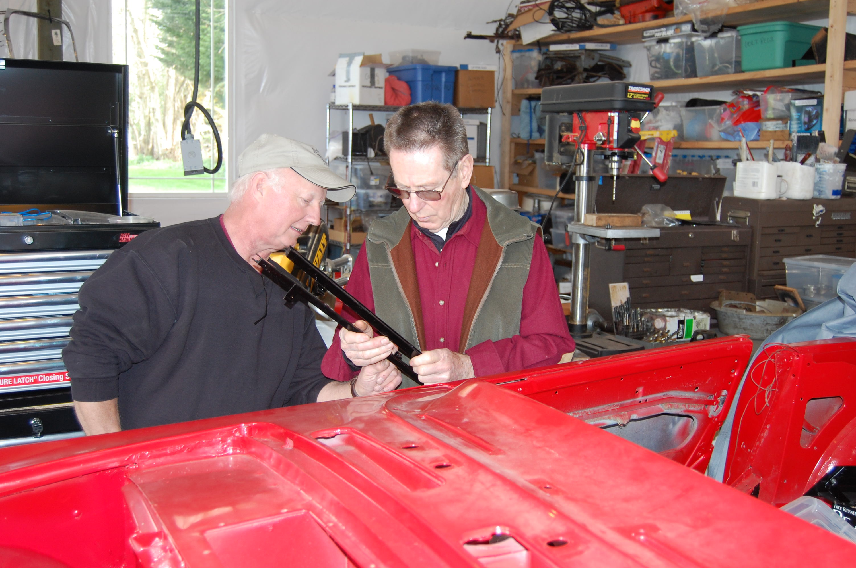

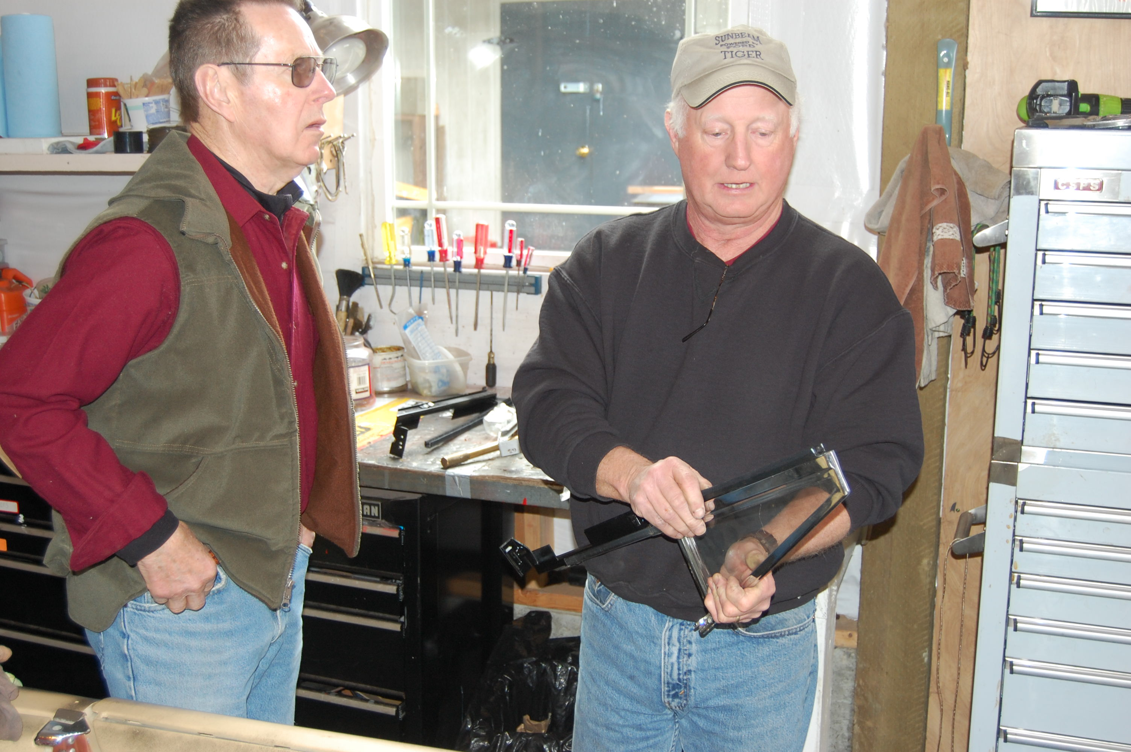

Meeting was adjourned Minutes submitted by Jim Clark

____________________________________
2009-2010 Executive and Officers

President: Kevin Jewell
12120 – 202nd Ave. SE
Woodinville, WA 98077-5639. Ph. 425-885-0103
kevinj@olyprecast.com

VP/Newsletter Kathryn Fitzgerald/Mike Clark 4723 Woodside Place
West Vancouver, BC V7S 2X5
Tiger2@telus.net

Secretary: Jim Clark
17711 – 10th Ave. NW
Shoreline, WA 98177
206-533-1187
jwclark2@comcast.net

Treasurer: Bob Bennion
37904 Fawn Rd NE.
Hansville, WA 98340
360-638-1992
904star@centurytel.net

Chairpersons

Activities: Larry & Eileen Ingersoll
29206 61st Ave S
Auburn, WA 98001
253-946-0762
Laingersol@aol.com

Membership: Budd Bennion
14720 30th NE
Seattle, WA 98155
206-364-8478
budd.bennion@comcast.net

Historian: Brett Simpson
10005 SE 267th St.
Kent, WA 98031
253-859-5096
brsjal1@comcast.net

2011 EVENTS CALENDAR

Official PTC activities are printed in red. We have listed other possible activities of which you might want to participate. Call a couple friends and try something new.

Now Exotics at Redmond Town Center (Desert Fire Restaurant). On nice Saturdays the exotics (mostly Italian, but others also show) mingle starting about 8:30 AM. There is no cost and if you are looking to see some nice cars it’s worth the trip.

May 21 Visit and Tour Jim Green’s Performance Center in Monroe. Tour to start at 10 AM. Address is 17520 147th St SE, Monroe, 98272. Jim Green’s has been serving the high performance community for over 44 years. They are one of the country’s few Ford 427 SOHC specialists. If you have never seen a “Cammer” up close, this alone is worth the visit.

May 21 ABFM, VanDusen Garden, Vancouver, BC. Featured marques are Rover, Triumph TR6 and Triumph motorcycles. More information, www.westerndriver.com/abfm.

June 18 PTC visit (meet there by 11 AM) with Brit-Sport of Seattle. It is amazing what we find in our own backyard. Brit-sport specializes in the restoration of British sports cars. The owner will give us a tour of their facilities and also walk us thru one of their projects. Address is 4214 - 24th Ave W, Seattle, 98199 (lower level). You can check them out at www.britsportofseatte.com. They will serve coffee and donuts, and for those interested some of us will be going to lunch afterwards.

July 9 PTC scenic tour and then lunch in Snohomish. Start at Target parking lot, Redmond, at the end of Highway SR-520. Meet about 10:15 AM, with tour to start promptly at 10:30. Tour is about 50 miles, and we will have written directions for everyone. Snohomish is a fun town to visit, and lots of shops, including Black Cat Antiques. Black Cat always has lots of automobile memorabilia, plus toys etc from the 50’s. If you decide you don’t want to do lunch, you can start with the shops and enjoy an ice cream on the way.

July 16 Summer Fun at the Park. Want to try to different car show at a beautiful setting? Journey to the Clock Tower Park, 1408 Palisade Blvd, DuPont, WA for an all marque car & truck show. Show hours are 8-3 PM, and cost is only $10 if registered by 6/30/11. More information, www.dupontcarshow.com.

July 21 School Daze, a track event at Pacific Raceway sponsored by the Corvette Marque Club of Seattle. This is an opportunity to drive at speed on the race course. Most performance cars are accepted, including sedans. Instructors will be provided for novice drivers or those not familiar with the track. More information will be posted at www.corvettemarqueclub.com.

July 23 Bellevue 23rd Annual ABFM at Bellevue College. Honoring 80 years of MG Car Club and celebrating 50 years of Jaguar E-Type. For more information, www.abfm.com.

Aug 5-7 Sunbeam Northwest. PTC has returned to sponsor the latest Sunbeam Northwest. Activities include a concours, autocross and rally. This is a “must do” for all Sunbeam and Rootes Group owners. Host hotel is the Little Creek Casino in Shelton, WA. More details are elsewhere in this newsletter and will be repeated over the next few months. Suggest you make your reservations now, as the block of rooms could go quickly. You can always cancel, if your plans have to change.

Dec 10 PTC Annual Holiday Party. The day time party went very well in 2010, so our 2011 hosts Max & Kathryn Pahmeier decided to follow the “new tradition”. We will meet at Noon. Address is 16106 SR 9SE, Snohomish, WA, 98296. For more information, contact Max at Pahmeier@frontier.net. More details later, but advance notice for your planning.

If you know of other events we should be listing, please contact our activity chairs, Larry & Eileen Ingersoll.

Laps from The Past

June, 1993: Brent Edinger’s Series V race car is on the cover. Brent consistently lapped Pacific Raceway in the 1:55 range, which is pretty darn quick, especially for a 4 cylinder. Many of you remember this yellow (Buttercup) car, and it has been raced by a couple other owners since.

May, 1996: Featured on the cover is the amazing Sunbeam Fun wagon, said to be the largest selling motor home in the world. Not only does it meet US safety standards, but the ad says it also meets local housing codes. SNW XVI was to be held in July in Centralia. Open headers are allowed at the autocross and AVGAS is available. Has it already been that long ago?

June, 1998: PTC membership stands at 105. Bill Sandell’s band The Rootes Group was to perform at the All-Ford Picnic. In his column, Dick Sanders reports seeing his first Sunbeam rotting away in a field near Kelso, while enjoying dinner on Amtrak. Seems there are lots of “Someday I will get around the fixing that car” landmarks along the Amtrak route.

June, 2001: Ross Evans hosted our club meeting at his home in Port Orchard. Dues are $27. Thinking of old derelicts (cars, not people) Dick reports on the Portland Swap meet with the comment that there were zero Rootes parts, unless you counted the headlight rims attached to the Hillman estate car that no one would take, even with an offer of a free tow.

June, 2005: PTC June meeting will be held as part of the XXX Drive Inn, Corvair & Orphan Car Show. John Rankin, the 2005 owner of Buttercup (see June, 1993) reports that the dreaded malady “Stromberg Dislocation” happened to him entering Turn 5 at Pacific Raceway. Just after the hard braking and a downshift to 3rd, the throttle stuck wide open. Seems the carb bolts came loose and as the rear carb reacted to gravity, it jammed the throttle open. Suspect that a few other racers were just as concerned with John’s sudden funny driving style.

Kevin
____________________________________

SUNBEAM NORTHWEST, AUGUST 4 – 7, 2011

We have finalized arrangements with Little Creek Casino as our host hotel for Sunbeam Northwest. They have blocked 50 rooms, all NON-SMOKING. You can make your reservations at your convenience, although we have already heard that being August, this is going to be a busy weekend at the Casino, so you might want to book now.

If you want a smoking room, just let them know your preference when you call.
The hotel is dog friendly, just let them know and there’s a $30.00 a night extra fee. You can reserve rooms anytime…just mention the date and “Pacific Tiger Club”

Check in Aug -Thurs 4-Fri 5-Sat 6
Check out Aug - Sun 7
Reservations 360-427-7711 or 1-800-667-7711
All rooms in the block are non-smoking (N)
Check In Date | Room Type | No. of Rooms | Room Rate
08/04/11 | KGN | 20 | 89.00
 | QQN | 30 | 89.00
08/05/11 | KGN | 20 | 109.00
 | QQN | 30 | 109.00
08/06/11 | KGN | 20 | 109.00
 | QQN | 30 | 109.00
___________________________

PTC Meeting
May 21 @ 10:00 AM

May 21 – Tour of Jim Green’s Speed Shop at 10 AM at 17520 – 147th Street SE, Monroe, 98272
Jim indicated that he’d like to see a lot of Rootes cars around his shop on Saturday.
____________________________________

Tigers United XXXIII

TU Will be held at the Queen Mary in Long Beach, CA this year. It will probably be the largest Tiger gathering in the world this year. People are coming from all over the country, from Europe and from Australia to attend. 270 room nights have already been booked at the hotel and many participants have already registered.

This United will explore the Tiger's history that was made in the mid-sixties in southern California. We will learn about the construction of the prototypes from the men who were actually there. We'll also cover mid-sixties Tiger racing. We'll explore historic Tiger sites and other iconic locations that figure large in the development of our southern California car culture.

We've gotten great rates from the Queen and expect a very large turnout. In fact, we are starting to run out of some of the hotel rooms so if you're interested you should act quickly. This link takes you to the section on the CAT web site that has event details. www.catmbr.org/VB_forum/forumdisplay.php?f=34

Hope to see you there,

Buck Trippel
CAT President
____________________________________
PICNIC IN THE PARK and
SHOW N' SHINE CAR SHOW (2nd Annual)
Buck Lake Park in Hansville
Sunday, July 24, 10 AM - 4 PM

We need your help! If you know of any Sunbeam Events, please contact your Activities Co-coordinator and we’ll get it in the newsletter.
Want to avoid mail delays? Receive your next issue of the PTC Newsletter emailed to you on-line. Contact us at Tiger2@telus.net with your email address

We want to hear your great stories! Do you have a great story to share? Send us the details with your photos. Let us know!

DO WE HAVE YOUR CURRENT ADDRESS AND EMAIL? HELP US KEEP OUR RECORDS UP TO DATE AND SEND YOUR CHANGES TO BUDD OR THE EDITOR.
____________________________________

Gasoline Pricing

With gas pricing now over $4 and with some predicting $5/gallon, I wanted to report pricing in Turkey, during our visit in April. The Turkish government controls the refining and distribution of fuel and most stations were very close in prices. Standard grade was priced at $9.02/US gallon and their 95 (European) octane was $10.54. Even with that level of pricing there were larger cars than we expected.

An even worse problem is parking. Istanbul is a city of 15 million with 3 million cars and 500,000 parking spots. As a result there are cars parked haphazardly wherever possible. There is an industry making concrete “mushrooms” about a foot high that are used along the edge of the sidewalks to keep cars from parking on the sidewalk.

Kevin

Renewing your membership?
Members are asked to observe their renewal dates on each month’s address label. The date indicates when your dues are due to continue receiving the PTC Newsletter. Please send all membership correspondence to Budd at: 14720 30th NE, Seattle, WA. 98155 (206)364-8478 or via email: budd.bennion@comcast.net.
Annual Membership fee $32.00 US/35.00 Foreign for foreign members.
Canadian Funds Payment to PTC
We ask each Canadian member to calculate the current exchange rate into US funds. Example: dues today $35.00USD=38.50 CAD (based on 10% exchange rate)
Make payment payable to Pacific Tiger Club and we will process via our bank. Exchange rates are constantly changing. For assistance you may use the following website: http://www.xe.com

TECH TIP

No pun intended, but I have found the solution to the electric corrosion problems on any car can often be fixed very simply and effectively by - dipping the electric part, be it a terminal end, wire end, component, switch, whatever in most cases - into Tarn-X, the grocery store available solution for brightening copper pans. Don't know exactly what it is, but it loves to dissolve surface tarnish on copper/brass/bronze bits, and being a very liquid, it wicks into crevices and between the wires and crimped terminal to dig out corrosion, and even make electric stuff solderable again if necessary.

I just dip-stripped two identical assembled interior lights of my '83 Renault 18i wagon into a small pill bottle cap for the recommended two minutes. The light bases are nylon to resist the bulb heat, and the switch contacts for manual on, door-open on, and off, are made of multiple bits of brass, riveted together thru the nylon, and in complex shape, so that cleaning by any other means would have meant drilling out the tiny rivet, separating the pieces and hand-sanding or filing all their contact areas laboriously. The Tarn-X penetrated & flowed in & out of all the geometric details and after rinsing and drying and “voila” all the contacts worked for the first time in years. I now have automatic interior lights which have worked steadily for two weeks and I've used this stuff to dip Citroen fuse blocks with all their intricate terminals/contacts, and dipped individual terminals crimped on their wires, and re-established continuity.

This stuff works. A neighbor who supposedly had continuity in the guts of his lawn tractor starter solenoid according to his VOM, found the switch still wouldn't carry the current because as soon as the high starter current hit the contacts/conductors, the high current re-established the corrosion open-circuit by instantaneously heating the contacts so they re-oxidized and failed. After treatment by Tarn-X, the solenoid works. As it penetrates even crimped-together switches in their housings, it can clean switches without disassembly, drains out, and after rinsing, if they're dried well, you get functionality back without steel part corrosion. Try it - you might like it.

Thanks – Budd Bennion

Do you have an interesting tech tip to share with the readers? We are always interested in any submissions.

Profile your car!
We would like to have a profile of your car, even if everyone knows who you are. Please email your profile to Mike & Kathryn. New to the PTC, Let us know the details, as we would like to do a feature article on your car!

Want to avoid mail delays? Receive your next issue of the PTC Newsletter emailed to you on-line. Contact us at Tiger2@telus.net with your email address

Vintage Racing

Info for NW vintage events sponsored by SOVREN can be found at: www.sovren.org

FOR SALE:

1967 - Sunbeam Alpine
Soft top, original hard top and cover.
98% Original

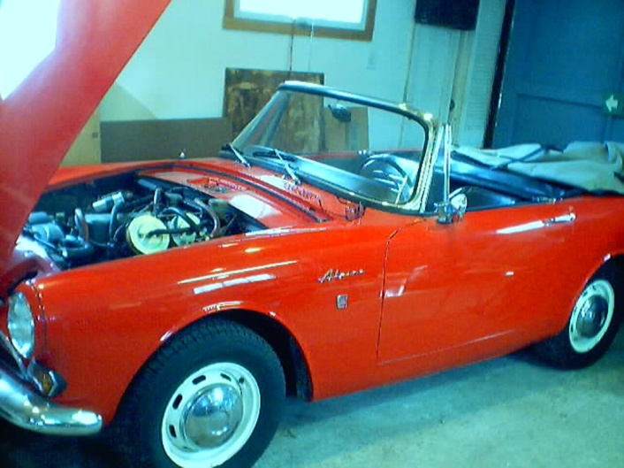

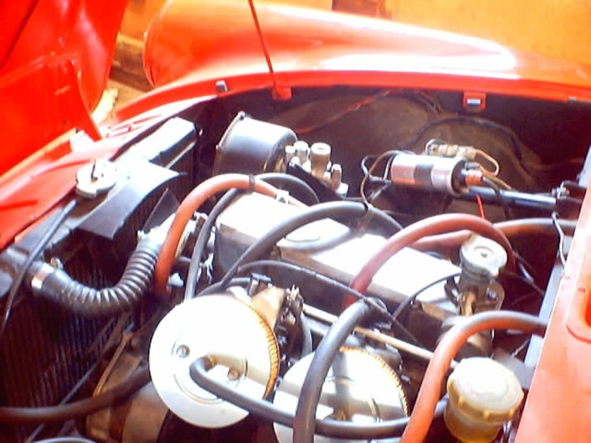

Are you buying, selling or trading? Email us at Tiger2@telus.net

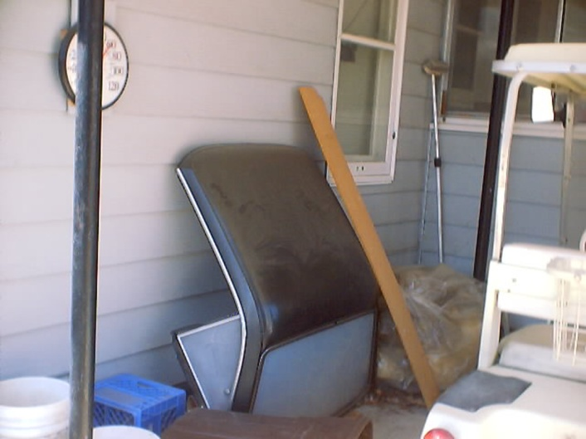

Price: $ 5,000.00

Mike Seek 236 W Second St.
Tonasket, WA. 98855 Phone: (509) 486-1301

Email To: lou6453@yahoo.com
___________________________________

1965 Sunbeam Tiger for Sale, the real deal, $27,000.00 OBO, please call, 425-271-2459 for questions or pictures.

REGALIA

Hats, Hats, Hats… We got ‘em! $15.00 +2.50 for shipping, all have the "Pacific Tiger Club" Logo on the front, some have Tiger or Alpine on the side and some have no added logo on the side. Make all forms of payment to "Pacific Tiger Club" and mail to Budd Bennion, 14720 30th Ave NE, Seattle WA 98155-7512.
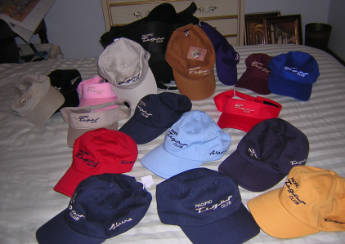

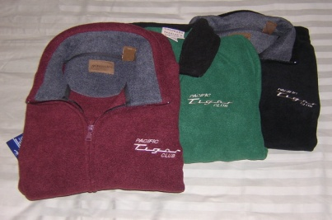
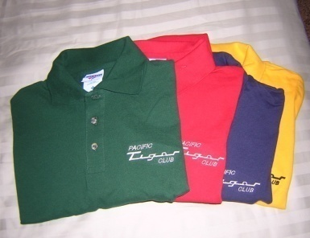

Save postage by picking up regalia at club meeting
Fleece jackets $30 + postage $4
Polo shirts- Lady's = $20 + postage $3
Men’s = $15 + postage $3



Pacific Tiger Club
12120 – 202nd Ave. SE
Woodinville, WA 98077-5639
425-885-0103
kevinj@olyprecast.com

