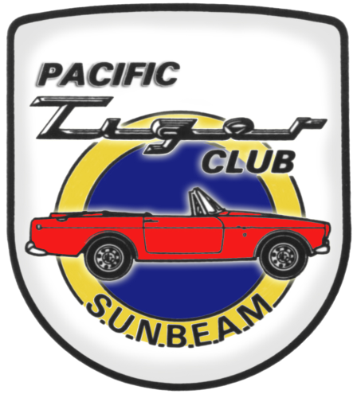

Rootes of the Pacific Northwest

Common Rootes

Sunbeam Northwest is fast approaching and a couple weeks ago I got a wake-up call regarding the hotel facility. A friend was trying to stay Saturday night at Little Creek so that he would be there first thing Sunday morning to help set up an event at the Shelton airport. There was a group entertaining at the Casino and there was not a room to be reserved anywhere. He finally ended up just West of Olympia.

We were warned some months ago that the Little Creek Casino had a big group the weekend we are going to be there and they fully expected to be sold out. I can’t encourage everyone enough to get your room reserved for August. You can always cancel later, but I think it is likely that if you miss the reservation block you could well also be staying in Olympia. Generally, the hotel will release the balance of the rooms in our block one month before the event, so be forewarned.

If you want to enjoy a scenic tour ending in the scenic town of Snohomish, then join us for the PTC tour on July 9. Details are in the activity listing. If your Rootes vehicle isn’t running, then bring your daily driver. If your Sunbeam is running this is a great test run for the Sunbeam Northwest event

4 weeks later.

Have you ever thought about driving at speed on a race track? If the thought interests you, consider turning out for the School Daze track day on July 21. This is not a race, but a driver training event. There will be four groups, mostly determined by driver experience, so track novices will not be grouped with those of more experience.

All novices will have an instructor for the day at no additional cost. I have participated in this event for some years, and have also been an instructor. I can assure you that it is not only a lot of fun, but you will learn more about your car’s capabilities on the track than you could ever learn on the freeway on-ramp. Plus it is a lot safer. Details are available in the activity list or call Kevin if you have specific questions.

Speaking of club elections, Dave Dunn has agreed to run for president. OK, we have one of the positions filled. Now you can consider serving in another office, without having to worry about being president. Please let Dave or myself know if you would be willing to run for office.

Lastly, please get your registration sent in for Sunbeam Northwest and definitely get your room reserved. We look forward to seeing you there. At the last club meeting I recapped the local major Sunbeam events of the past decade, and concluded that it could well be another 5 years before PTC put on another Sunbeam Northwest. So this is the year you need to attend.
See you on the road.

Kevin Jewell
____________________________________

The Allure of the Automobile

JUN 11, 2011 – SEP 11, 2011
Opening in June 2011, The Allure of the Automobile will showcase 16 of the world’s most luxurious, rare, and brilliantly conceived automobiles designed between 1930 and the mid-1960s. From the avant garde 1937 Hispano-Suiza owned by French apéritif baron André Dubonnet to the ultra-cool convertible 1957 Jaguar XK-SS Roadster once owned by Hollywood legend Steve McQueen, the exhibition traces the evolution of the motorcar, showcasing developments in automotive design and engineering.
Organized by the High Museum of Art in Atlanta, the exhibition will be guest curated by Ken Gross, the former director of the Petersen Automotive Museum in Los Angeles.
http://specialexhibitions.portlandartmuseum.org/allure/
Also:

Cars in the Park
In celebration of The Allure of the Automobile, the Portland Art Museum will welcome local car clubs to the Park Blocks. Enjoy the exhibition in the Museum galleries and then take a stroll along Park Avenue where local car enthusiasts will show off their vehicles all summer long.
Cars in the Park is free and will take place Saturdays from 10 a.m. to 5 p.m.
June 18: All Chevrolet
June 25: Italian Cars
July 2: Muscle Cars
July 9: American Vintage
July 16: Hot Rods
July 23: Mercedes & BMW
July 30: All Ford
August 6: Porsche
August 13: All English
August 20: Rod and Custom
August 27: Mopar
September 3: Two-Seaters @Meters
September 10: Green Car
____________________________________

2009-2010 Executive and Officers

President: Kevin Jewell
12120 – 202nd Ave. SE
Woodinville, WA 98077-5639. Ph. 425-885-0103
kevinj@olyprecast.com

VP/Newsletter Kathryn Fitzgerald/Mike Clark 4723 Woodside Place
West Vancouver, BC V7S 2X5
Tiger2@telus.net

Secretary: Jim Clark
17711 – 10th Ave. NW
Shoreline, WA 98177
206-533-1187
jwclark2@comcast.net

Treasurer: Bob Bennion
37904 Fawn Rd NE.
Hansville, WA 98340
360-638-1992
904star@centurytel.net

Chairpersons

Activities: Larry & Eileen Ingersoll
29206 61st Ave S
Auburn, WA 98001
253-946-0762
Laingersol@aol.com

Membership: Budd Bennion
14720 30th NE
Seattle, WA 98155
206-364-8478
budd.bennion@comcast.net

Historian: Brett Simpson
10005 SE 267th St.
Kent, WA 98031
253-859-5096
brsjal1@comcast.net

2011 EVENTS CALENDAR

Official PTC activities are printed in red. We have listed other possible activities of which you might want to participate. Call a couple friends and try something new.

Now Exotics at Redmond Town Center (Desert Fire Restaurant). On nice Saturdays the exotics (mostly Italian, but others also show) mingle starting about 8:30 AM. There is no cost and if you are looking to see some nice cars it’s worth the trip.

July 9 PTC scenic tour and then lunch in Snohomish. Start at Target parking lot, Redmond, at the end of Highway SR-520. Meet about 10:15 AM, with tour to start promptly at 10:30. Tour is about 50 miles, and we will have written directions for everyone. Snohomish is a fun town to visit, and lots of shops, including Black Cat Antiques. Black Cat always has lots of automobile memorabilia, plus toys etc from the 50’s. If you decide you don’t want to do lunch, you can start with the shops and enjoy an ice cream on the way.

July 16 Summer Fun at the Park. Want to try to different car show at a beautiful setting? Journey to the Clock Tower Park, 1408 Palisade Blvd, DuPont, WA for an all marque car & truck show. Show hours are 8-3 PM, and cost is only $10 if registered by 6/30/11. More information, www.dupontcarshow.com.

July 21 School Daze, a track event at Pacific Raceway sponsored by the Corvette Marque Club of Seattle. This is an opportunity to drive at speed on the race course. Most performance cars are accepted, including sedans. Instructors will be provided for novice drivers or those not familiar with the track. More information will be posted at www.corvettemarqueclub.com.

July 23 Bellevue 23rd Annual ABFM at Bellevue College. Honoring 80 years of MG Car Club and celebrating 50 years of Jaguar E-Type. For more information, www.abfm.com.

Aug 5-7 Sunbeam Northwest. PTC has returned to sponsor the latest Sunbeam Northwest. Activities include a concours, autocross and rally. This is a “must do” for all Sunbeam and Rootes Group owners. Host hotel is the Little Creek Casino in Shelton, WA. More details are elsewhere in this newsletter and will be repeated over the next few months. Suggest you make your reservations now, as the block of rooms could go quickly. You can always cancel, if your plans have to change.

Aug 20 Rodger & Anne Flescher’s annual BBQ for family and friends (which includes all of you Sunbeam friends). This is potluck, so be sure to bring something to share. Time is 1 PM to 6 PM; address is 2000 22nd St. Bellingham. Many of us have enjoyed their hospitality over the years. You can make the drive more enjoyable by taking Chuckanut Drive, which brings you into Bellingham close to where they live.

Sep 10 Fantastic opportunity to tour 4 collections. We will start at 10 AM at Group 2 (www.group2motorsports.com) at 4442 27th Ave W. Seattle 98199. Group 2 is a business specializing in Alfa race cars, but also have some Renaults and Fiats. Then we move to three collections, those of the late Ken McBride, Bill Cotter and John Goodman. Ken’s collection ranges from early brassies and classics by Olds, Packard, Dusenberg, Rolls, Bentley, as well as mid century got rods, Ferraris, Mercedes 300 GL, Porsche and more. Bill Cotter has vintage race cars by Ford, Shelby, Porsche to current Ferrari and a Ford GT, 2 BMW 2002 turbos, an Alpine SV and a Mark 1 Tiger. John Goodman’s collection has an early Atlas Unlimited Hydro, several former LeMans Ferraris and a Greenwood Corvette. One of each productions Corvette through ’69 and much more. Group 2 and two of the collections are located adjacent to each other. The third collection is about 5 blocks away. Plan to start arriving about 9:30 so you can find parking, so we are ready to start at 10 AM sharp. All of these people have opened their doors to us on a Saturday, so let us be considerate of their time as well. Thanks to club member Walter Suman for organizing this tour.

Oct 8 PTC Annual General Meeting. We will continue with the lunch time AGM, hosted again by Kevin & Judy Jewell. More details to come, for now put the date on your calendar.

Dec 10 PTC Annual Holiday Party. The day time party went very well in 2010, so our 2011 hosts Max & Kathryn Pahmeier decided to follow the “new tradition”. We will meet at Noon. Address is 16106 SR 9SE, Snohomish, WA, 98296. For more information, contact Max at Pahmeier@frontier.net. More details later, but advance notice for your planning.

If you know of other events we should be listing, please contact our activity chairs, Larry & Eileen Ingersoll.

SUNBEAM NORTHWEST AUGUST 4 – 7, 2011

We have finalized arrangements with Little Creek Casino as our host hotel for Sunbeam Northwest. They have blocked 50 rooms, all NON-SMOKING, until July. You can make your reservations at your convenience, although we have already heard that being August, this is going to be a busy weekend at the Casino, so you might want to book now.

If you want a smoking room, just let them know your preference when you call.
The hotel is dog friendly, just let them know and there’s a $30.00 a night extra fee. You can reserve rooms anytime…just mention the date and “Pacific Tiger Club”
____________________________________

Visit to Jim Green’s Performance Center

For the May meeting, PTC visited Jim Green’s Performance Center. For decades, Green had a speed shop on Aurora in Lynnwood. Many of you probably shopped there. He recently sold that property and moved his speed shop to Monroe. However, it is far more than a speed shop. He acquired a building of about 36,000 sq ft. The speed shop occupies maybe 20% of that area and perhaps 30% more is taken up with the machine shop and shop where they do rod work and other “restomod” work. Half of building is his museum and consists of quite a few of his collection of cars over the years. Just a few at random that we had the opportunity to inspect:
- A digger dragster with a small block Chevy. Green later sold that car to Jerry Ruth and Ruth started his career with the digger. Green later bought it back. Anyone from the Northwest would be sure to recognize the name Jerry Ruth.
- 1954 Ford Road Racer that Green put together for the 2004 recreation of the Mexican Pan American. NASCAR chassis, Ford 351 Windsor (moved 5” rearwards), T-5 transmission and a sound to die for.
- ‘57 Ranchero with a 427 SOHC (Cammer). This was just one of many vehicles there with Cammer engines. There was also a Cammer still on the original shipping platform.
- A couple of “flip-flop” pickup trucks with bodies on hydraulics.
- Sled pulling tractor with three supercharged Big Block Fords.
- The back of shop was filled with cars in progress, including the first rod that Green ever rode in. His uncle brought the car from the Philippines about 1950. The rod pulled a double pontoon boat in the 1951 Seafair parade and the Commodore and Queen were in the boat and Green was the kid in the passenger seat.
- So a lot of history from the 1950s to ‘80’s.

Jim Green took the group on a tour of the entire facility which lasted about 1 ½ hours. If you are in the Monroe area, stop and visit the speed shop, located across the main highway from the Fairgrounds. The museum is adjacent to the entrance and is open to wander around. Of course, he would hope that you also stop in the speed shop and take something home. Our thanks to Mr. Green for allowing the club to visit and also for his generosity with his time to give us a complete history of what we were seeing. Thanks also to Paul Jelinek for setting up this meeting.

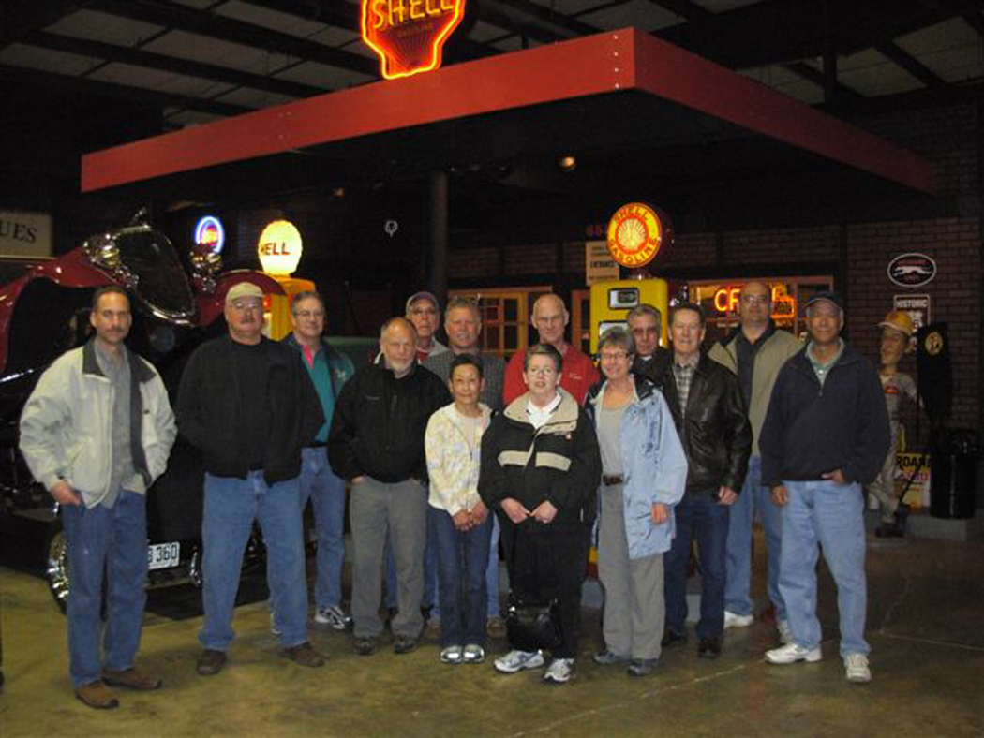
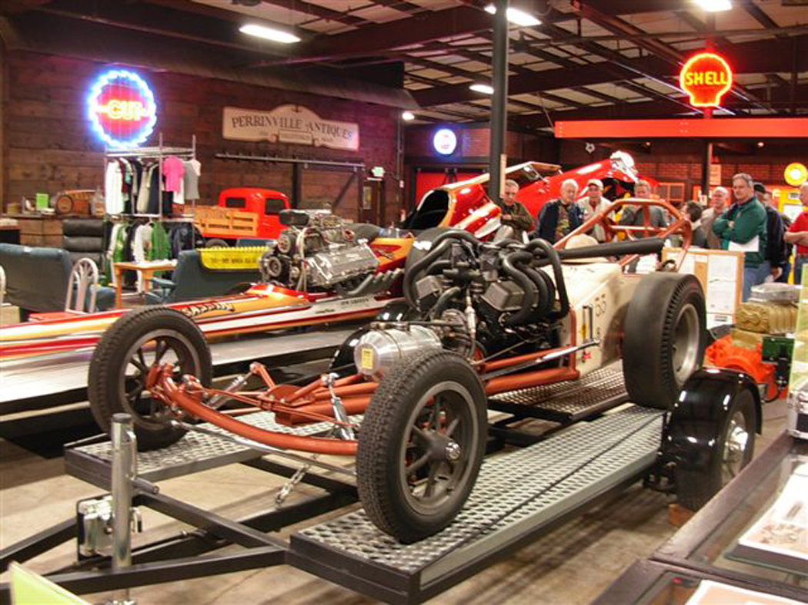
____________________________________

PTC meeting at BritSport

Mark does ground up restorations of European cars. He also does a lot of transmission and over drive rebuilds.
He will do a body repair or a complete repaint. He has a number of shops he works with for chrome, upholstery or engine and mechanical work. He has about 6
projects working at a time. Some of the full restorations require a lot of research to make sure it is correct. Check out his web site at britsportofseattle.com. There
are pictures of works in progress and contact information.

Budd Bennion

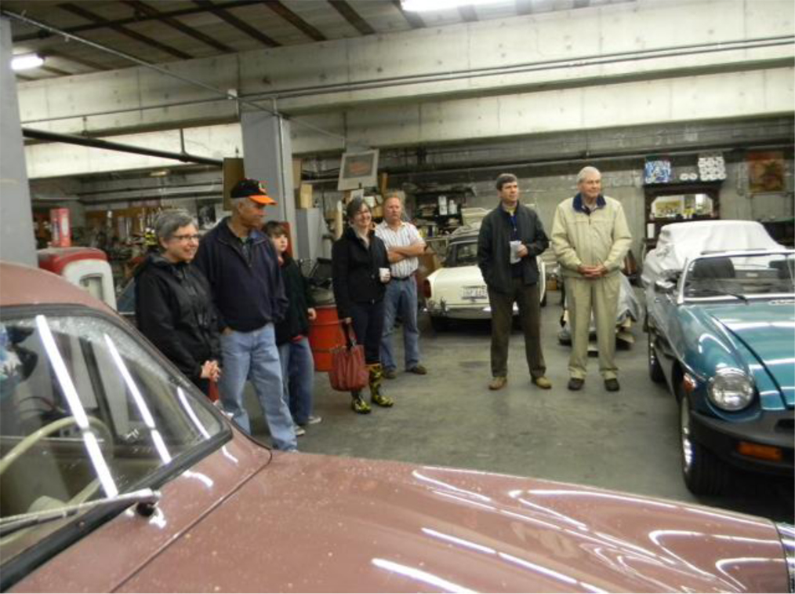

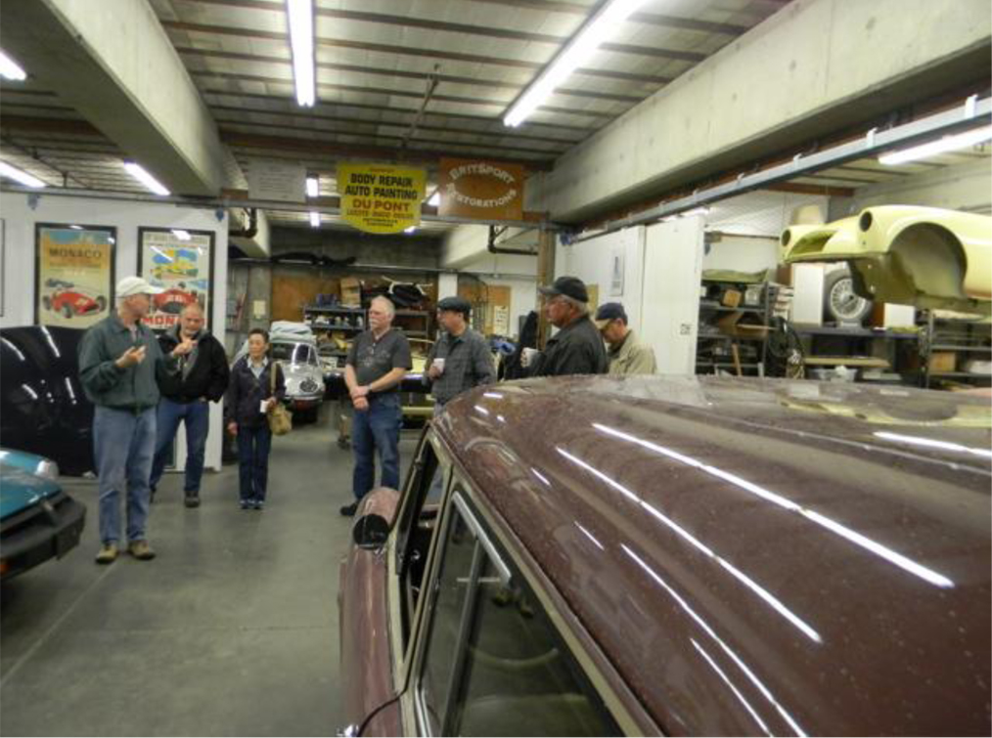

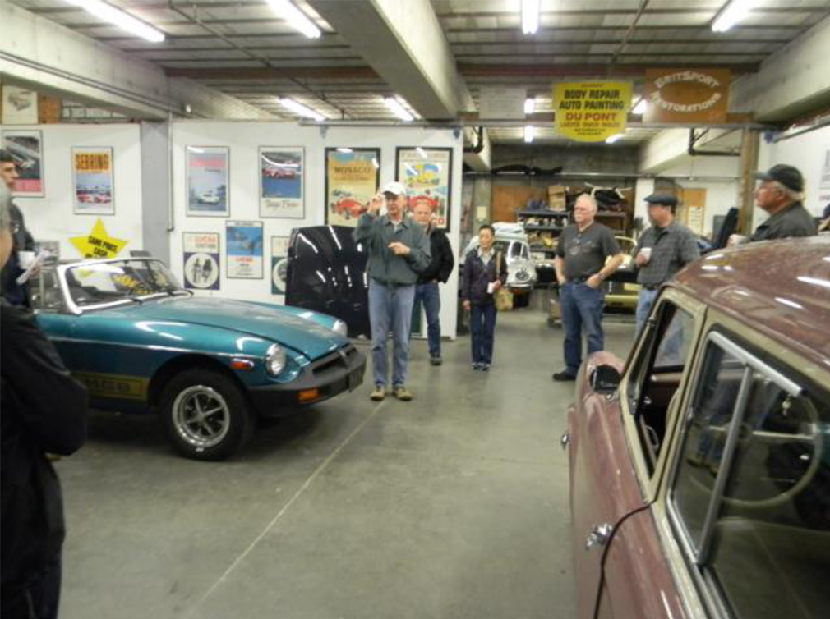
Fill ‘er Up!
by Dick Sanders

Original sightings of Sunbeams in TV shows are pretty rare these days, but Jim Leach bucked that trend recently, spotting not one but two new Sunbeams on the boob tube. The first is of the blink-and-you-missed-it variety. In season 1, episode 10 of Adam 12, there’s a gold (or maybe Orchid Green?) Sunbeam with Mk II Tiger-style racing stripes in a parking lot. Found at imdb.com
The second Sunbeam appearance is much more substantial – and a surprise that it’s been undiscovered ‘til now given the extensive screen time on a then highly-rated show. It Takes a Thief (season 2, episode 9) features a red Series V Alpine. Midway through the show, star Robert Wagner needs immediate transportation and looks for a car to steal. A restaurant patron obliges him by mistaking Wagner for a parking valet and tossing him his keys – to an Alpine. A female companion then follows Wagner, driving a non-descript Italian (?) convertible on a journey to the bad guy’s lair. What sticks out in this sequence is that all of the driver close-ups and car interior shots are backwards, with the female companion shown driving an Alpine, and Wagner behind the wheel of the Italian job. The hulu.com link has expired but will undoubtedly resurface.

Ohan Gurlekian of Vancouver, B.C. has staged a number of well-received Rootes Rendezvous weekends over the last seven years. Taking a break from that event this year, Ohan continues to ready a Sunbeam Imp to participate in a future Targa Newfoundland Rally. As with his first Targa effort several years ago with his Alpine (which garnered both several minutes of airtime on a subsequent Speed channel highlight show) Ohan is using his entry in the race as a charitable fundraising tool. This time the beneficiary will be B.C. Children’s Hospital. If that doesn’t sound ambitious enough for you, Ohan also has plans to drive his Alpine from Vancouver, B.C. to Armenia(!) in 2015 while benefiting charities for children in both Armenia and Lebanon. More info can be found at: www.hovig.org.

Sunbeam Northwest is coming up fast in the rear-view mirror. Kevin Jewell’s been working hard to coordinate it all since the end of last year and the pieces are fitting together nicely. The event host site, Little Creek Casino, is close-in for many of us (just 10 miles west of Olympia) but still far enough out in the country to make you feel like you’ve gotten away from it all. I’ve been scouting out the event rallye and have found a few roads off the beaten path that I think you’ll enjoy. In addition to the usual “gimmick rallye” route questions to answer along the way, we’ll follow the weekend’s casino theme by also making it a poker run. Place your bets gentlemen, and don’t forget to reserve your rooms ASAP. Oh, and for all those rock & roll fans out there, George Thorogood tickets are available for his concert at the Casino on Saturday night, August 6th.

Two Sunbeams with strong race pedigrees have come up for sale recently. A 1953 Talbot-style Alpine factory rallye car, driven by Peter Collins among others, has an asking price of around $120K (US) Similarly priced is the Harrington-prepared Sunbeam Alpine, winner of the Index of Thermal Efficiency trophy at the 1961 24 Hours of LeMans. Both cars have been restored to factory-racing spec, though the Harrington currently sports a Holbay 1725 for vintage racing.

Finally, back to Sunbeam Northwest for a minute. A local Alpine owner recently asked me, “Dick, is auto crossing safe for my Alpine. The Sunbeam is getting pretty old. Won’t something break?” The answer for potential novice drivers is yes, something could break, but unless you really thrash the heck out of it, the odds aren’t any worse than if you were driving it to the grocery store.
For most novices, the first step is just finding your way through the course without getting lost or knocking down any cones. An agile mind counts way more than a hot motor or a lead foot in your first event. In other words, you likely won’t be going fast enough to hurt anything.
For car preparation, check your oil level and brake/clutch fluids. Inflate the tires evenly, using a starting point at the high end of the recommended pressure range. Make sure the lug nuts are tight. If you’re a tall driver, remove the inside rear view mirror for better peripheral vision. Note: autocross safety rules always require that you remove every loose item form the interior and trunk, including the spare.
To prepare yourself as a driver on race day, take the pre-race course walk-through seriously. You’re not restricted to one lap. Walk it twice, or even three times, until you’re comfortable with your knowledge of the route. [One trick I use after the walk-through is to draw the course from memory, then compare it to the course map handout.] Stop at various points on the track and ask yourself what the best line through the next corner(s) would be, trying to think at least one corner beyond. Actually squat down occasionally to give yourself the approximate vantage point you’ll have from the driver’s seat. You’d be surprised how different your perceptions of the track are with your eyes just two feet lower.
When you’re waiting at the starting line for your first run, don’t be freaked out by what suddenly seems like an impenetrable sea of orange cones in front of you (particularly if you didn’t do the ‘squatting’ exercise). Pull out your trusty course map and remember the first few turns (“right, left, right….”). Once you get past the first few gates, it should start to get easier. Since the course for Sunbeam NW was one used in the past by the hosting Corvette Club, it will probably not be “tight,” meaning wider corners where you can put your Alpine in 2nd gear almost immediately and not worry about looking at the tach or, if you have a non-synchro box, shifting back down into 1st.
“What if I get lost?” Don’t worry, it happens to everybody. If suddenly nothing looks familiar, DON’T just idle off the course feeling like an idiot and waste most of your run. You can come to complete stop and reconnoiter, or make a slow, safe 360 loop to the last point you know you were on-course, then pick up that mystery gate you missed off to the far right and finish your run. At the novice stage, the learning curve is steep and every second on the track is valuable.
Once you’ve gotten a couple of runs under your belt, the day-glow orange tide should start to recede and be less intimidating. You can start experimenting with different lines through the corners, getting a real feel for how your Sunbeam handles at different speeds and angles, maybe even varying tire pressures to induce more under steer or over steer. It’s at that point when auto crossing not only becomes a whole lot of fun, but it also starts making a better, safer driver out of you out on the street.

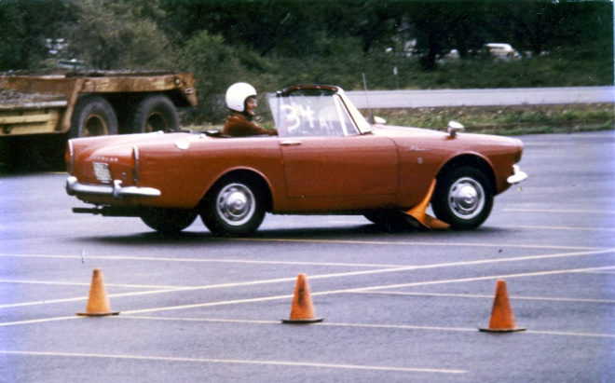

My 2nd autocross. It’s 1979, the first Sunbeam Northwest event, with racing at Lane Community College near Springfield, Oregon. By the end of this practice lap, I was dragging several more trapped cones. There weren't enough left to mark the course for my 2nd lap, so I was black-flagged.
____________________________________

Tigers United XXXIII

TU Will be held at the Queen Mary in Long Beach, CA this year. It will probably be the largest Tiger gathering in the world this year. People are coming from all over the country, from Europe and from Australia to attend. 270 room nights have already been booked at the hotel and many participants have already registered.

This United will explore the Tiger's history that was made in the mid-sixties in southern California. We will learn about the construction of the prototypes from the men who were actually there. We'll also cover mid-sixties Tiger racing. We'll explore historic Tiger sites and other iconic locations that figure large in the development of our southern California car culture.

We've gotten great rates from the Queen and expect a very large turnout. In fact, we are starting to run out of some of the hotel rooms so if you're interested you should act quickly. This link takes you to the section on the CAT web site that has event details. www.catmbr.org/VB_forum/forumdisplay.php?f=34

Hope to see you there,

Buck Trippel
CAT President
____________________________________
Want to avoid mail delays? Receive your next issue of the PTC Newsletter emailed to you on-line. Contact us at Tiger2@telus.net with your email address

PICNIC IN THE PARK and
SHOW N' SHINE CAR SHOW (2nd Annual)
Buck Lake Park in Hansville
Sunday, July 24, 10 AM - 4 PM

DO WE HAVE YOUR CURRENT ADDRESS AND EMAIL? HELP US KEEP OUR RECORDS UP TO DATE AND SEND YOUR CHANGES TO BUDD OR THE EDITOR.

If you know of any Sunbeam Events, please contact your Activities Co-coordinator and we’ll get it in the newsletter.

We want to hear your great stories! Do you have a great story to share? Send us the details with your photos. Let us know!

Renewing your membership?
Members are asked to observe their renewal dates on each month’s address label. The date indicates when your dues are due to continue receiving the PTC Newsletter. Please send all membership correspondence to Budd at: 14720 30th NE, Seattle, WA. 98155 (206)364-8478 or via email: budd.bennion@comcast.net.
Annual Membership fee $32.00 US/35.00 Foreign for foreign members.
Canadian Funds Payment to PTC
We ask each Canadian member to calculate the current exchange rate into US funds. Example: dues today $35.00USD=38.50 CAD (based on 10% exchange rate)
Make payment payable to Pacific Tiger Club and we will process via our bank. Exchange rates are constantly changing. For assistance you may use the following website: http://www.xe.com
TECH TIP

The Ethanol Issue
By: Moss Technical Services
Gasoline containing ethanol has become the new standard for fuel, and it presents a new set of challenges and work for classic car owners. You’ve got to be vigilant now to ensure a good running engine and prevent damage to your cherished car.
What’s the problem, you ask?
Ethanol, made from corn or grain, is added to gasoline to oxygenate it, replacing the older additive, MTBE. Names for gasoline mixed with ethanol include E10, gasohol, corn fuel, alcohol fuel, and reformulated or renewable fuel.
The key problem is that ethanol absorbs water from the atmosphere. In fact, fuel with 10 percent ethanol absorbs up to 50 times more water than standard gasoline. Older gas tanks found in many classic cars vent to the atmosphere, increasing the likelihood that moisture will be absorbed into the gas tank at a rapid pace.
The end result of water in the fuel is phase separation. The fuel separates into two distinct layers: a thick layer of gasoline mixed with a little ethanol on top, and a thinner layer on the bottom consisting of water mixed with most of the ethanol. And it doesn’t take much water for this to happen—phase separation occurs in a gallon of 10 percent ethanol blend with just 3.8 teaspoons of water.
Vented or Closed Fuel Tank?
Not sure whether your British car has a vented or closed fuel tank? You need to know this detail in order to have a feel for how long the gas in your tank will remain good. A sure giveaway of a closed tank is the presence of a carbon canister, which was added for pollution control purposes along with the closed fuel tanks. It’s often located at the back of the engine compartment, on the passenger side. To verify what it looks like and the positioning in your car, look at the diagram of the engine compartment for your car model on the Moss website, mossmotors.com. Note that some aftermarket gas caps are vented, so they can render a closed system open to the atmosphere.
Fuel Phase Separation Problems
What happens to your car and its’ performance when water causes fuel phase separation?
Reduced fuel longevity: A gasoline/ethanol blend absorbs water until it triggers phase separation. The blend has a 90-day product life in a closed tank, but lasts just 30 to 45 days in a vented tank often found in classic cars. With 10 percent ethanol blends, owners are supposed to replace the fuel in vented tanks about once a month by driving or draining, taking into consideration the humidity in the atmosphere and temperatures.
Lower fuel octane: The ethanol in a gasoline blend provides some of the octane rating. When phase separation occurs, the octane rating of the remaining fuel can drop by as much as three points.
Poor engine performance: The fuel pump could easily pick up a slug of the water/ethanol slurry at the bottom of the tank, interrupting the flow of gas to the engine. This will cause the engine to miss, run rough and possibly stall altogether.
Corrosion and rust: Water in the bottom of the fuel tank and inside the fuel lines will cause corrosion and rust, and the solvent properties of the ethanol will loosen that up, along with bits of sediment and deposits. The resulting debris floating in the fuel could clog fuel filters, fuel lines and carburetor float valves.
Specific Parts Affected by Ethanol
Fuel tank: Ethanol could dislodge sediment and deposits in older gas tanks and fuel lines. Loose debris in the fuel could clog the fuel filter, or cause engine flooding if the carburetor float valve sticks.
Fuel pump: Rubber diaphragms inside the fuel pump may have problems with ethanol exposure.
Carburetor float valve: Float valve needles on early cars were brass, and these were replaced with plastic needles or brass needles with Viton (a specific type of rubber) tips. Ethanol can cause the plastic needles to swell up and stick either open or shut, which causes either massive flooding or starves the carburetor for fuel. Some owners have resorted to shaving down the plastic needle to get it to ride smoothly and seat properly. Instead, you can install an all-brass needle and seat, or a Vito tipped needle if available for your car model, which are not affected by lower levels of ethanol.
Carburetor floats: The Zenith-Stromberg floats found specifically/ only in the TR4 and 4A made of foam covered with a skin may deteriorate when exposed to ethanol. Other plastic floats, like those used by SU, may also be affected.
Hoses: Ethanol could dry out or deteriorate rubber hoses.
Seals: Ethanol could shrink, swell or deteriorate seals, depending on the material.
Gaskets: Ethanol may deteriorate the rubber in rubber/cork composite gaskets. Fibre washers and gaskets are not affected.
Aluminum and aluminum alloy parts: Aluminum and alloys fare fine with 10 percent ethanol, but are damaged by 25 percent ethanol.
Part 2: (conclusion) in the next newsletter.
____________________________________

Do you have an interesting tech tip to share with the readers? We are always interested in any submissions.

Profile your car!
We would like to have a profile of your car, even if everyone knows who you are. Please email your profile to Mike & Kathryn. New to the PTC, Let us know the details, as we would like to do a feature article on your car!

Want to avoid mail delays? Receive your next issue of the PTC Newsletter emailed to you on-line. Contact us at Tiger2@telus.net with your email address

Vintage Racing

Info for NW vintage events sponsored by SOVREN can be found at: www.sovren.org

FOR SALE:

1. Hardtop - It is complete but for the quarter windows [originals are in place - opaque]. The clips and hinges need to be chromed. In 2009 it was repainted and new rear window installed plus all the related new rubber from Sunbeam Specialties and the uninstalled new [white] headliner. It is now here in CA with me so I could sell it to someone's friend in CA or it will come back with me, hopefully for SBNW.

Price: $2500.

Rob Carpenter

2. 71-73 HILLMAN/SUNBEAM AVENGER, PLYMOUTH CRICKET PARTS - Shop manual set. Mostly new: ext. front lens, estate left tail, Hoses brake kits, eng. gasket set, ex. twin down pipe, wheels, eng. head.
LATE 60's ARROW/HUNTER SEDAN,ALPINE COUPES (baby barracuda) New frt.&rear ext. lamp assy.&/or lens, speedo cluster. Used frt. & rear axle assy. / eng. / trans. / wheels,
etc.
CALL AS I HAVE DISSASSEMBLED A COUPLE OF WRECKED 1969 SUNBEAM ALPINE COUPES and ALPINE ROADSTER.
503-351-3618
Richard cricket-73@comcast.net

3. 1967 - Sunbeam Alpine
Soft top, original hard top and cover.
98% Original
Price: $ 5,000.00
Mike Seek 236 W Second St.
Tonasket, WA. 98855 Phone: (509) 486-1301
Email To: lou6453@yahoo.com

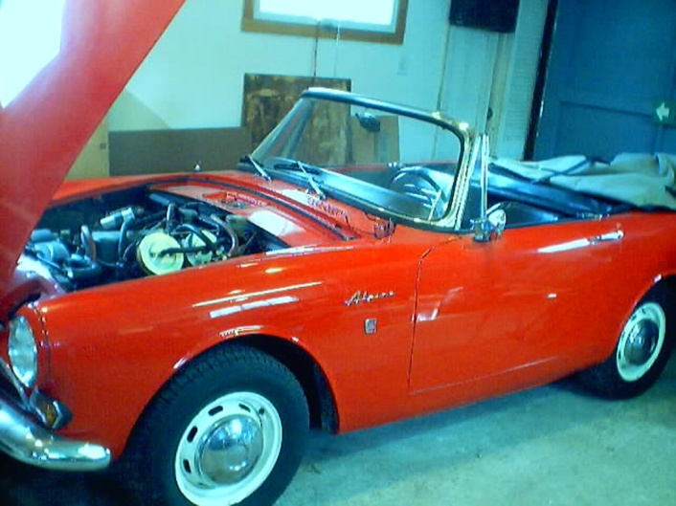

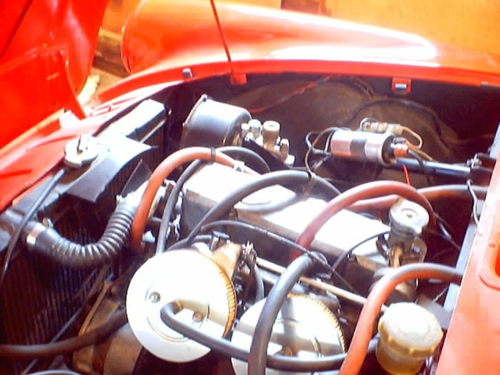

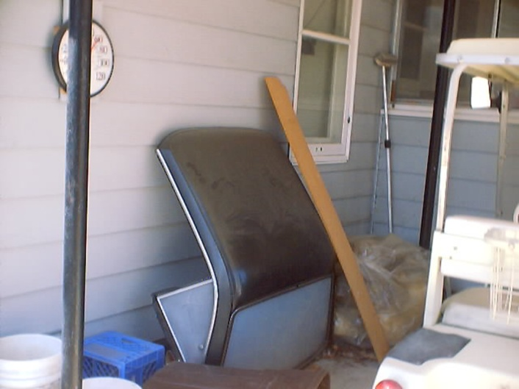

4. 1965 Sunbeam Tiger for Sale, the real deal, $27,000.00 OBO, please call, 425-271-2459 for questions or pictures.

Are you buying, selling or trading? Email us at Tiger2@telus.net

‘53 – ‘55 SUNBEAM ALPINE

Sunbeam, the historic British Racing Marque and Talbot (related to the French Talbot) came together under Rootes group pressure in 1938. The first car produced under the hyphenated name set the pattern for all future models; it was a sports touring car, developed from one of the Hillmans of the period, rather than a competition sports design. There was nothing unusual about the small (72 cu. in.; bore and stroke, 2.48 X 3.74 in.), L-head engine, but it was well made and completely reliable. Shortly there appeared a larger Sunbeam-Talbot, the 184 cu. in., 2.95X4.72, six-cylinder model, also an L-head.
In the postwar era, Sunbeam-Talbot production has followed the original plan. As compared to the Jaguars and Ferraris, these modern cars are prosaic, but satisfying. The original engine has been modified to use pushrod-operated overhead valves, and a larger four-cylinder engine has replaced the prewar sixes. It is this larger four that is the basis of the very commendable Sunbeam-Alpine, introduced in March, 1953 and named for a memorable showing in the Alpine Rally, where a factory team won four Coupes des Alps plus the Coupe des Dames.
The Alpine was derived from the Sunbeam-Talbot "90" which was an orthodox passenger model. A sporty roadster body was designed for the Alpine, and the engine received special attention from the engineers, who hopped it up for better performance yet retained the durability for which the marque has been famous. By upping the compression ratio to 7.5-to-l and re-designing the intake manifold, horsepower was increased to 80 at 4,400 r.p.m. The springs were stiffened considerably both front and rear, providing firmer control and detracting slightly from the easy riding qualities of the passenger car, and the wishbones-and-coil-spring independent front suspension of the front wheels was bolstered by a heavier anti-roll bar.
A "Super-Tuning Kit" was also available to buyers who wished to get yet more performance from their Alpines. With this, the compression ratio shot up to 8.5 to l, raising engine output to 105 b.h.p. at 4,500 r.p.m. One of these cars, further modified by the addition of a belly pan, a metal cockpit cover and the Laycock de Norman-ville overdrive, clocked a high speed of 120.459 m.p.h. at Jabbeke, Belgium, then went on to Montlhery to average 111.2 m.p.h. for one hour.
Despite its high-speed potential, the Alpine is intended as a dependable pleasure car for highway use rather than a sports racing machine. The relatively long wheelbase and heavy weigh tag it as an endurance car, which is precisely why the factory specializes in affairs like the Alpine and Monte Carlo rallies, body and engine design it appeals to that special class of driver the British have always been so successful with, the man who likes high-speed, responsive cars, yet does not care to fuss interminably. It is primarily a masculine car.

Thanks to: Bob Bennion

REGALIA

Hats, Hats, Hats… We got ‘em! $15.00 +2.50 for shipping, all have the "Pacific Tiger Club" Logo on the front, some have Tiger or Alpine on the side and some have no added logo on the side. Make all forms of payment to "Pacific Tiger Club" and mail to Budd Bennion, 14720 30th Ave NE, Seattle WA 98155-7512.
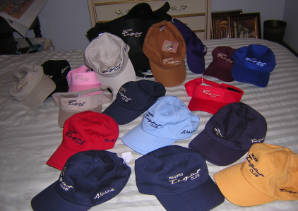

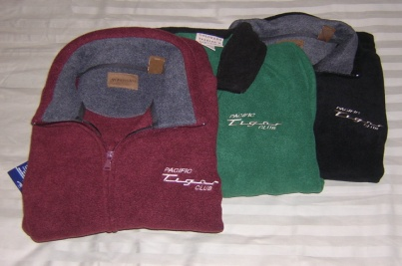
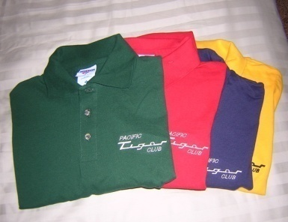

Save postage by picking up regalia at club meeting
Fleece jackets $30 + postage $4
Polo shirts- Lady's = $20 + postage $3
Men’s = $15 + postage $3

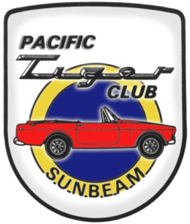

Pacific Tiger Club
12120 – 202nd Ave. SE
Woodinville, WA 98077-5639
425-885-0103
kevinj@olyprecast.com

