

Rootes of the Pacific Northwest

Common Rootes

The first Sunbeam Northwest was held in 1979. In 1981, PTC hosted SNW III in Olympia. Thirty years later we just finished hosting the latest SNW event. Great turnout, great events, great fun, no complaints (at least to me), what is there not to like? The hotel outdid themselves in providing spacious rooms, not only the sleeping rooms, but for our registration and meeting. They had created special banners which were a great hit and since we had many requests for the banners for garage art, we added them to the door prizes. The dedicated parking area was large enough for our parking and then we moved over a lot for the concours display. The rallye took us thru some very scenic countryside on the way to our BBQ at Allyn Park. There were entrants on the rallye that had sworn they would never rallye again, at least together, and when it was all over almost everyone was still smiling. The autocross was probably one of the best we have ever had. No curbs or poles to hit, wide open, with lots of spin room. The course encourage the participants to pull out the stops and most did, enjoying some very fast times. Anyway, if you missed SNW, you missed a good one. Thank you to all that helped with the event, and there are far too many to list today. Also thank you to all that

participated. We needed all of you volunteers and participants to make it the success it turned out to be.

Let me digress and talk a bit about the 1981 SNW III. The registration fee was $12/car. Banquet tickets were sold separately and cost $15/person. From the old newsletter I have it appears that the individual events were probably additional cost, and I certainly do remember that at one time we had an ala carte pricing system. Being in Olympia, there was quite a bit to do with the “artesians”. We met the artesians at the hospitality room and later encircled the artesians at the autocross. We had a tour of the Olympia brewery. Later, just before the banquet we had “The Blitzing Hour”. I do remember kegs at many of the early SNW events and even remember a few “contests” being held, although I am pretty sure that I would not have participated, or led any teams in any such contests.

We do have club officer elections coming up at the September meeting. Putting their names into the hat for office are:
President: Dave Dunn
VP: Mike Clark & Kathryn Fitzgerald
Treasurer: Bob Bennion
Secretary: We need someone to step up and run for this office.
There are also appointed offices/committee heads which are not elected, so they are not listed here. Nominations are always welcome from the floor in September. If you have thoughts about the direction you think the club should be going, this is your chance to participate in the leadership of the club. Remember that the club relies on all of us to be successful.

If you haven’t been to one of the tours/visits this year, you have missed some good opportunities. In September we have another fantastic opportunity to tour 4 auto collections in one day. Sounds like between them they have something for everyone, even an unlimited hydroplane for our Seattle hydro fans. Thanks to Walt Suman who suggested and then organized this tour. More details are elsewhere in the newsletter, but this one looks like a must see.

See you on the road.

Kevin Jewell
____________________________________

Sunbeam Northwest 2011 Report

At the Maryhill Hill Climb, in October of 2010, several PTC members started talking about the possibility of PTC hosting a Sunbeam Northwest event in 2011. Talk soon turned to action, and before you know it Sunbeam Northwest 2011 was history. I want to take this opportunity to present an overview of the event and results. We know the cars and many of the owners aren’t getting any younger. Consequently, we made a wild assumption that if we could get 35 registrants, we would consider the event a success. Well, we got 53 registrants. Not all brought cars, some still in progress and a few last minute sad stories, but with those 53 registrants were about 45 cars. So, we were off to a great start. The host hotel was the Little Creek Hotel and Casino near Shelton. The facility had a variety of restaurants and of course gaming options. There was also a concert that some of the participants attended on Sat night. Friday morning had a bit of mist in the air. It was drizzling in Shelton, about 8 miles North, but we never did see the rain. As the weekend continued, the weather got better. Mostly overcast, but dry and warm, actually proving to be great weather for the Sat autocross. The Evergreen Award has convinced most participants to participate in all the events, even if you are sure that you can’t win in any particular event. After all, this is all about using these cars as they are supposed to be used. Although, we will admit that we doubt Rootes Group ever had the faintest notion that their creations would still be motoring on, 45 years or more later.

Concours Results:
Saloon
1st Budd Bennion, Hillman Husky
Alpine
1st Jerry Logan, Harrington LeMans
2nd Bill & Sharon Smith
3rd Ed Erikson
Stock Tiger
1st Brett Simpson
2nd David Redmond
3rd Brian Nickels
Personalized Tiger
1st Russ Colgan
2nd Ross Evans & Genevieve Blyth
3rd Gary & Jeanne Haslip
Modified Tiger
1st Alex & Joan MacLaurin
2nd Eric & Barb Kimbrough
3rd Bob & Bev Hokanson

Rallye Results:
Driver/Navigator (official time 52 min, 12 sec)
1st Dave Dunn/Anita Dunn
2nd Bruce Whalen/De Whalen
3rd Dave Redmond/Sally Kuhl
Poker Jeff Mang/Gord Herrman, 3-Aces

Autocross Results:
First Time Novice
1st Dave Wright 66.287
2nd Keene Brewer
Men’s Alpine
1st Dick Sanders 61.710
2nd Jerry Logan
Women’s Alpine
1st Marilynn Seifert 86.542
Men’s Stock Tiger
1st Kevin Jewell 63.758
2nd Ron Simcox
Women’s Stock Tiger
1st Judy Jewell 71.491
Men’s Prepared Tiger
1st Gary Haslip 57.870
2nd Brian Faerge
3rd Ross Evans
Women’s Prepared/Modified Tiger
1st Jeanne Haslip 68.908
2nd Linda Atkisson
Men’s Modified Tiger
1st Mike Hokanson 54.100
2nd Bob Hokanson
3rd Trevor Fitzgerald
4th Ed Fullerton

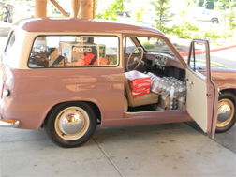
Try to put all that in your Tiger…

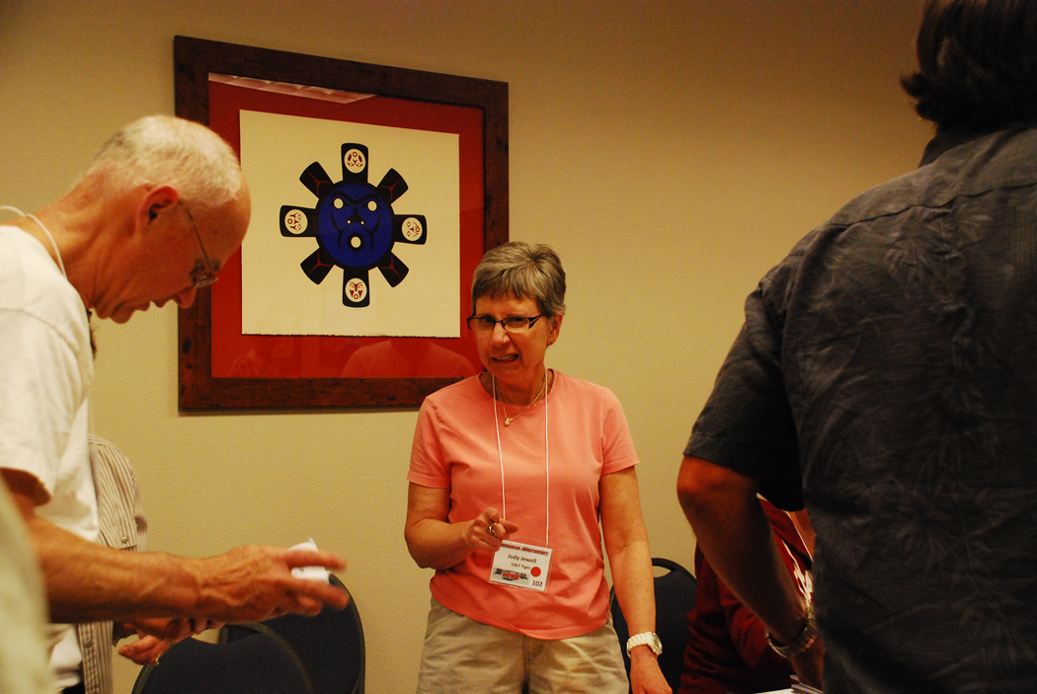
Don’t mess with the registration staff…

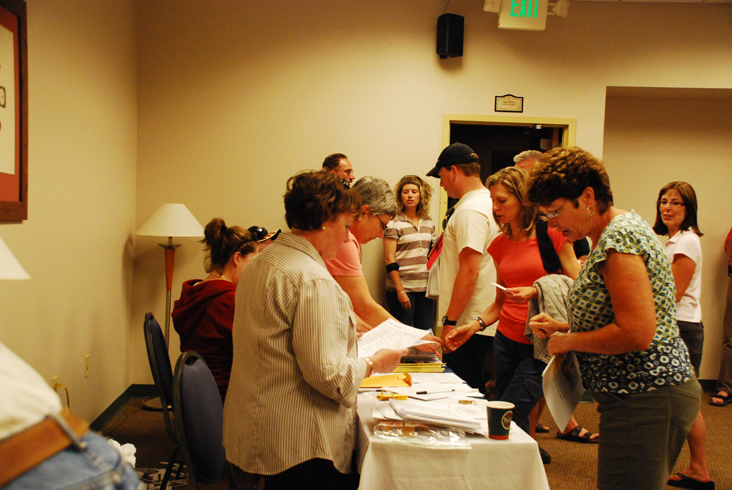
Organized confusion – ably handled by the registration crew.

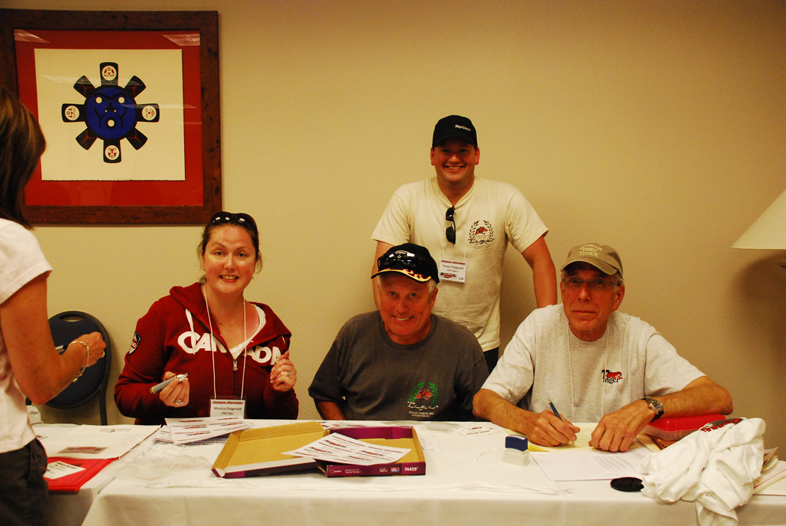
How could you doubt the sincerity of this crew?

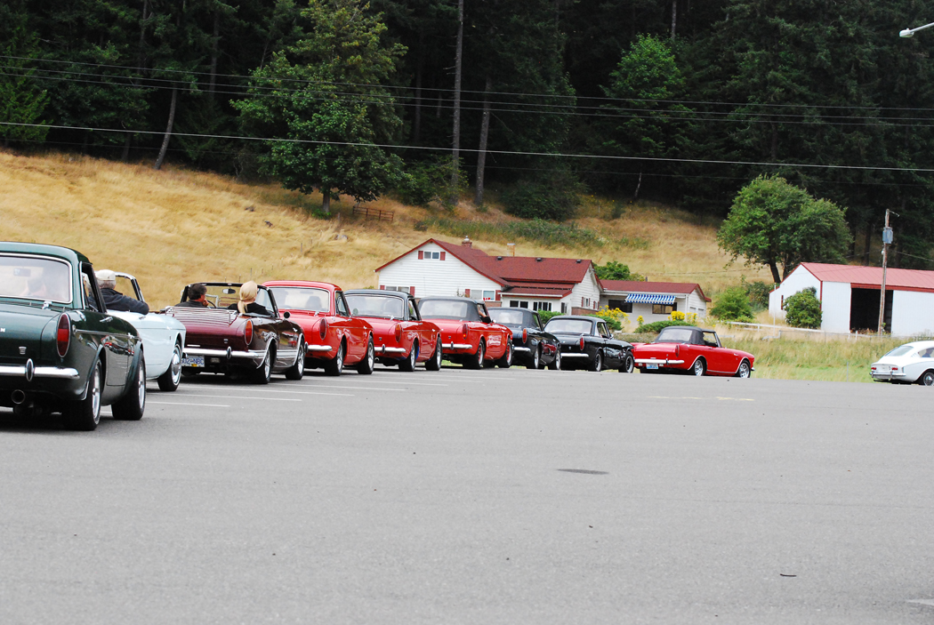
The line-up for Dick and Hollie’s very fun rallye…

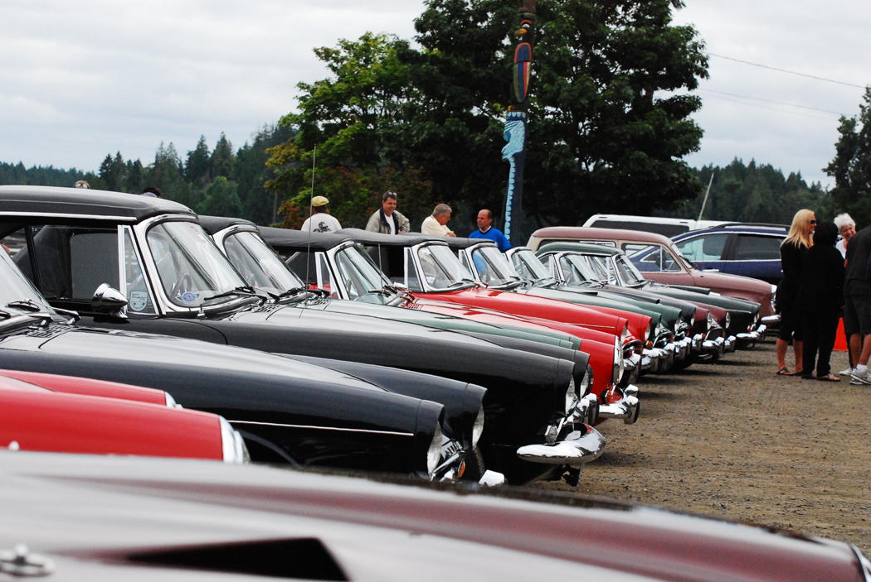
Picnic at Allyn…

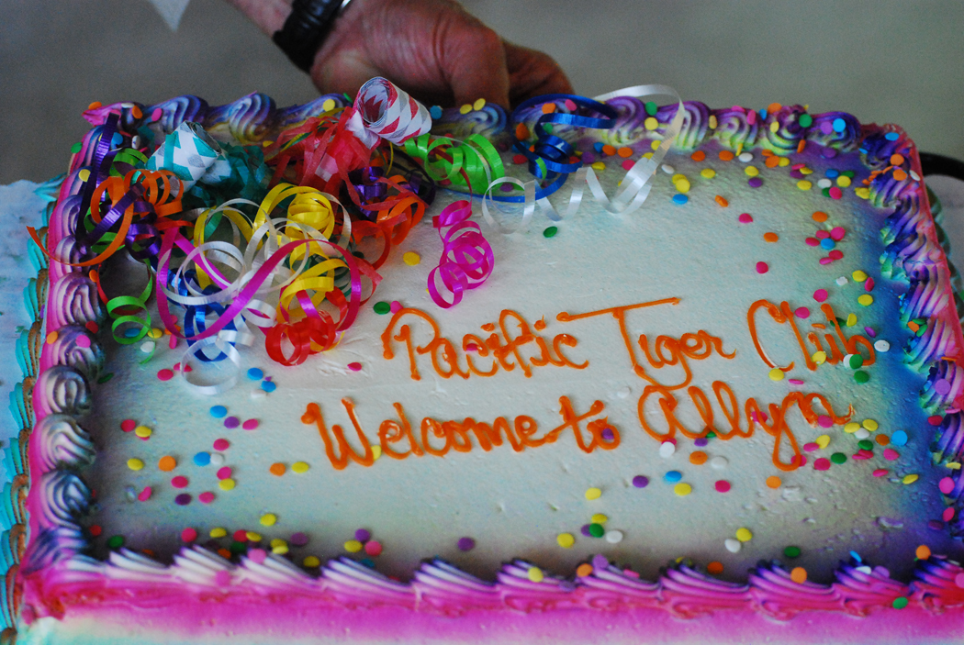
The firefighters did a great job of looking after our crew…

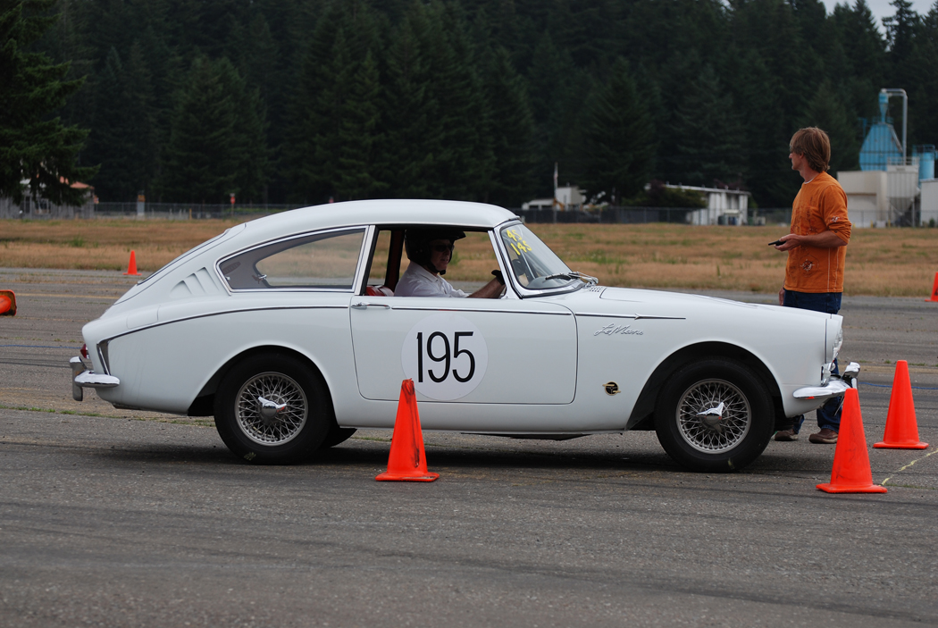
Lined up for the Autocross…

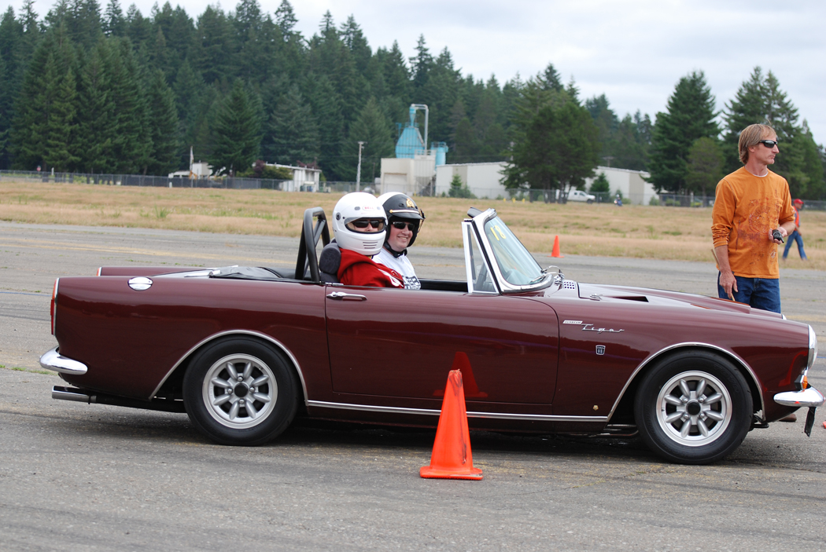

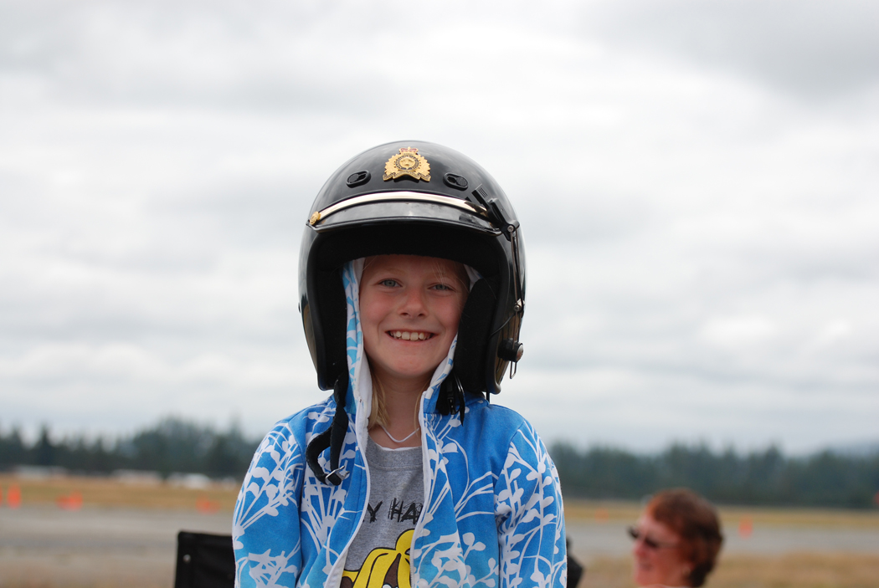
Taking a passenger along for the thrill of the autocross wasn’t uncommon…

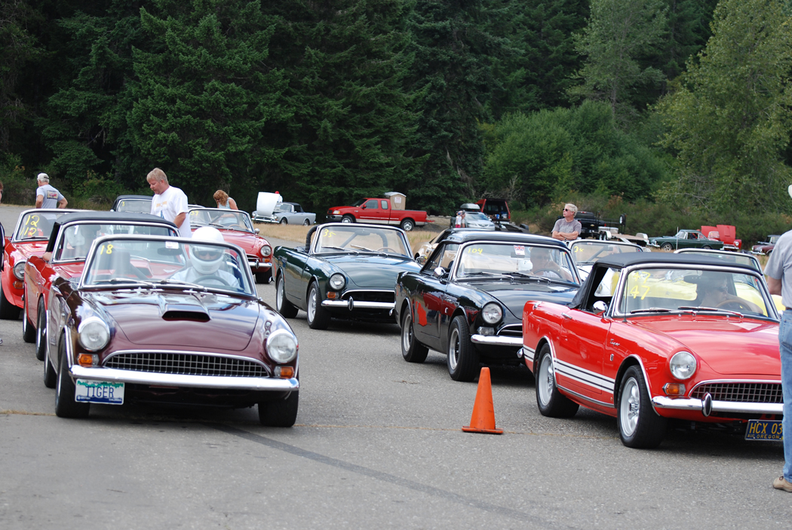

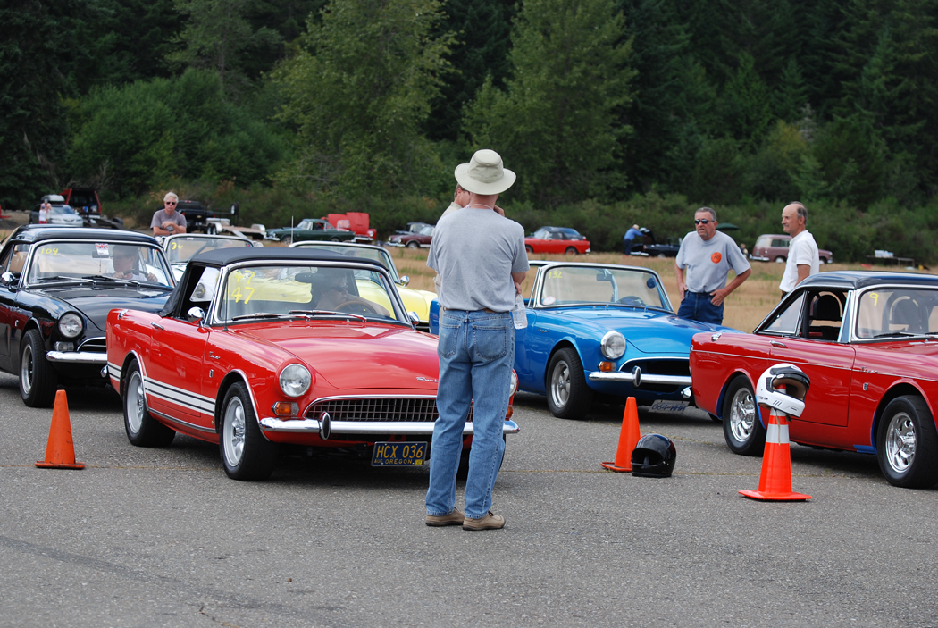
Getting ready to rumble…

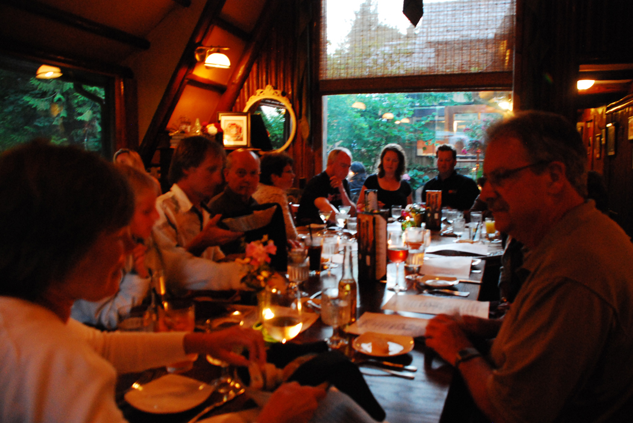
It wasn’t all cars, there was some quality socializing going on as well…
____________________________________

A History of Sunbeam Northwest

In 1974, the first Tigers United was held in Grants Pass, OR. Tiger owners from all over the West Coast (British Columbia, Washington, Oregon and California, plus probably a few other states and provinces) converged for a weekend of socializing and Tiger talk. The original idea was that Grants Pass was about equal distance from San Francisco and Vancouver, BC. Tigers United became an annual event with three more events in Grants Pass. In 1978, it was decided to move Tigers United V to Redding, CA to make it an easier travel for the Southern California participants. Although I was a fairly new Tiger owner, as the PTC president, Judy and I jumped into our daily driver Tiger and headed to Redding to represent our club. During the event in Redding, the discussion continued about having TU VI in the Los Angeles area. I tried to discourage that move by explaining that moving the event to LA was the equivalent of moving it to Vancouver, BC; i.e. either way we would be at the extreme end of the expected participants living areas. Consequently, if it is was held in LA, I predicted there would be very few from British Columbia, Washington or Oregon that would attend. I lost the argument, and plans continued for the next event to be in the LA area.

A group of NW Sunbeam enthusiasts gathered early to discuss putting on an event that those of us in the NW could attend in 1979. Jerry Rathburn, an Oregon Tiger owner, emerged as the spiritual leader of the group. One of the first things they decided was that this event would recognize all Sunbeams, not just Tigers. In later years, this was expanded to all Rootes vehicles. Thus Sunbeam Northwest I was held in Eugene in Sept of 79. Originally, the autocross was a separately priced event, and in 79 the autocross held at Lane Community College cost a whopping $5. The event was very successful, and SNW II was held at Otter’s Crest the following year. PTC hosted SNW III in Olympia and subsequently hosted quite a few of the events. It was during a PTC hosted event that we did away with the ala carte pricing of the event, charging one fee to participate in the entire event. We went further by creating the Evergreen Award as the grand award for the event. The winner of the Evergreen Award must participate (not necessarily win) in all events.

SNW was held annually for about the first 20 years, and then became more sporadic. Consequently, we called this year’s event Sunbeam Northwest 2011, since it would be miss-leading to use the Roman numerals. To date, all SNW events have been held in Oregon, Washington or British Columbia. At this point, we don’t know when the next SNW will be held, but most of us at the 2011 event have already committed to being there next time. Hope you do so.

Kevin
________________________________

2010-2011 Executive and Officers

President: Kevin Jewell
12120 – 202nd Ave. SE
Woodinville, WA 98077-5639. Ph. 425-885-0103
kevinj@olyprecast.com

VP/Newsletter Kathryn Fitzgerald/Mike Clark 4723 Woodside Place
West Vancouver, BC V7S 2X5
Tiger2@telus.net

Secretary: Jim Clark
17711 – 10th Ave. NW
Shoreline, WA 98177
206-533-1187
jwclark2@comcast.net

Treasurer: Bob Bennion
37904 Fawn Rd NE.
Hansville, WA 98340
360-638-1992
904star@centurytel.net

Chairpersons

Activities: Larry & Eileen Ingersoll
29206 61st Ave S
Auburn, WA 98001
253-946-0762
Laingersol@aol.com

Membership: Budd Bennion
14720 30th NE
Seattle, WA 98155
206-364-8478
budd.bennion@comcast.net

Historian: Brett Simpson
10005 SE 267th St.
Kent, WA 98031
253-859-5096
brsjal1@comcast.net

2011 EVENTS CALENDAR

Official PTC activities are printed in red. We have listed other possible activities of which you might want to participate. Call a couple friends and try something new.

Now Exotics at Redmond Town Center (Desert Fire Restaurant). On nice Saturdays the exotics (mostly Italian, but others also show) mingle starting about 8:30 AM. There is no cost and if you are looking to see some nice cars it’s worth the trip.
Sep 10 Fantastic opportunity to tour 4 collections. We will start at 10 AM at Group 2 (www.group2motorsports.com) at 4442 27th Ave W. Seattle 98199. Group 2 is a business specializing in Alfa race cars, but also have some Renaults and Fiats. Then we move to three collections, those of the late Ken McBride, Bill Cotter and John Goodman. Ken’s collection ranges from early brassies and classics by Olds, Packard, Dusenberg, Rolls, Bentley, as well as mid century got rods, Ferraris, Mercedes 300 GL, Porsche and more. Bill Cotter has vintage race cars by Ford, Shelby, Porsche to current Ferrari and a Ford GT, 2 BMW 2002 turbos, an Alpine SV and a Mark 1 Tiger. John Goodman’s collection has an early Atlas Unlimited Hydro, several former LeMans Ferraris and a Greenwood Corvette. One of each productions Corvette through ’69 and much more. Group 2 and two of the collections are located adjacent to each other. The third collection is about 5 blocks away. Plan to start arriving about 9:30 so you can find parking, so we are ready to start at 10 AM sharp. All of these people have opened their doors to us on a Saturday, so let us be considerate of their time as well. Thanks to club member Walter Suman for organizing this tour.

Oct 8 PTC Annual General Meeting. We will continue with the lunch time AGM, hosted again by Kevin & Judy Jewell. More details to come, for now put the date on your calendar.

Dec 10 PTC Annual Holiday Party. The day time party went very well in 2010, so our 2011 hosts Max & Kathryn Pahmeier decided to follow the “new tradition”. We will meet at Noon. Address is 16106 SR 9SE, Snohomish, WA, 98296. For more information, contact Max at Pahmeier@frontier.net. More details later, but advance notice for your planning.

If you know of other events we should be listing, please contact our activity chairs, Larry & Eileen Ingersoll.

LAPS FROM THE PAST

July, 1993: PTC sponsored Sunbeam Northwest XIV in Centralia. Forty nine cars were registered. Tom & Melody Bennett won the Evergreen Award with their black MKII.

Sept, 1996: Eric Heuscher is the latest club member to purchase a Tiger. This one was once owned by PTC member Dave Dunn. Bud Bohrer was headed to Kansas with his Tiger to compete in the SCCA Solo II Nationals. A large group of PTC attended the Friday night cruise in at the Burger King in North Seattle.

Aug, 2000: Cover photo shows Starke Shelby in his Tiger leading a C2 Corvette at Pacific Raceway. The club was still enjoying the Show N Shine at Ballard Locks. There were 19 Rootes vehicles at this year’s ABFM in Bellevue. The latest PTC member was George Tipp, now of Puyallup. You might remember George from SUNI I where he showed up with a factory diesel powered SuperMinx.

Aug, 2004: SUNI IV has just concluded. The venue this year was Park City, Utah. It was reported that the club had decided not to return to the Ballard Locks due to a Corps of Engineers management change. The new management basically said “We don’t need no stinking cars to draw visitors to the locks”.

2011 GREENWICH CONCOURS d’ELEGANCE

This year the Concours featured hybrids. No, not the Toyota variety hybrid. Rather the featured cars were European-American hybrids-cars with American running gear and V8’s in European bodies. Of primary importance was a circle of 11 vehicles. There were Allards, 1952 Chrysler-Ghia, 1958 Dual Ghia, 1957 Facel Vega, 1971 Iso Grifo, and a l966 Sunbeam Tiger. The article does not report on the ownership of any of the displayed vehicles. (Reported in the July 25, 2011 Autoweek).

Kevin
____________________________________

The Allure of the Automobile

JUN 11, 2011 – SEP 11, 2011
Opening in June 2011, The Allure of the Automobile will showcase 16 of the world’s most luxurious, rare, and brilliantly conceived automobiles designed between 1930 and the mid-1960s. From the avant garde 1937 Hispano-Suiza owned by French apéritif baron André Dubonnet to the ultra-cool convertible 1957 Jaguar XK-SS Roadster once owned by Hollywood legend Steve McQueen, the exhibition traces the evolution of the motorcar, showcasing developments in automotive design and engineering.
Organized by the High Museum of Art in Atlanta, the exhibition will be guest curated by Ken Gross, the former director of the Petersen Automotive Museum in Los Angeles.
http://specialexhibitions.portlandartmuseum.org/allure/
Also:

Cars in the Park
In celebration of The Allure of the Automobile, the Portland Art Museum will welcome local car clubs to the Park Blocks. Enjoy the exhibition in the Museum galleries and then take a stroll along Park Avenue where local car enthusiasts will show off their vehicles all summer long.
Cars in the Park is free and will take place Saturdays from 10 a.m. to 5 p.m.
June 18: All Chevrolet
June 25: Italian Cars
July 2: Muscle Cars
July 9: American Vintage
July 16: Hot Rods
July 23: Mercedes & BMW
July 30: All Ford
August 6: Porsche
August 13: All English
August 20: Rod and Custom
August 27: Mopar
September 3: Two-Seaters @Meters
September 10: Green Car
Want to avoid mail delays? Receive your next issue of the PTC Newsletter emailed to you on-line. Contact us at Tiger2@telus.net with your email address

DO WE HAVE YOUR CURRENT ADDRESS AND EMAIL? HELP US KEEP OUR RECORDS UP TO DATE AND SEND YOUR CHANGES TO BUDD OR THE EDITOR.

If you know of any Sunbeam Events, please contact your Activities Co-coordinator and we’ll get it in the newsletter.

We want to hear your great stories! Do you have a great story to share? Send us the details with your photos. Let us know!

Renewing your membership?
Members are asked to observe their renewal dates on each month’s address label. The date indicates when your dues are due to continue receiving the PTC Newsletter. Please send all membership correspondence to Budd at: 14720 30th NE, Seattle, WA. 98155 (206)364-8478 or via email: budd.bennion@comcast.net.
Annual Membership fee $32.00 US/35.00 Foreign for foreign members.
Canadian Funds Payment to PTC
We ask each Canadian member to calculate the current exchange rate into US funds. Example: dues today $35.00USD=38.50 CAD (based on 10% exchange rate)
Make payment payable to Pacific Tiger Club and we will process via our bank. Exchange rates are constantly changing. For assistance you may use the following website: http://www.xe.com

The following is an email your editor received from a fairly new Tiger owner who attended SNW 2011. I thought it worth publishing as it shows that the “spirit” is alive and well in someone who has been around long enough to know better, but is still willing to take on the adventure…

As many of the recipients of this note know, there was a Pacific Northwest Tiger convention in Shelton Washington on Aug. 5 - 7. (Near Olympia at the end of the Hood Canal, at Little Creek Casino and Resort.) Anyway, Judy and I went and, because we needed to go Boise, Idaho soon, we decided to head there from the convention. The last couple of months had been good for the Tiger: she received her Collector's status plates, then at the convention she passed a TAC inspection, that is, she was inspected by 3 (yes 3! experts) and certified to be a real Tiger and not a converted Alpine. So now it will go into the book of Norman where real Tigers are cataloged.

The convention was great and we met some wonderful people with help and advice which will serve us well. There were 42 Tigers, and we learned there were 12 from Vancouver Island. We did not participate in the very interesting autocross, as I did not want to unduly stress the Tiger before the trip to Boise.

However, this story is about trying to drive a 40 year old car 1500 miles through high desert of Eastern Oregon and Washington in the hot heat of August.

The trip was a mixed bag.
We left after the event breakfast on the final day. We decided to travel the north side of the Columbia River because it is a 2 lane interesting road as far as I-82, then go to I-84 in Oregon, spend the night in Pendleton and attack the Blue Mountains the following day. All went well until about 2:30 PM. We looked at the gas gauge on the beginning of the last stretch to I-82 and realized the 90 miles to the next gas station would be problematic. Also, temperature was rising both outside and on the gauge. So we backtracked to the last bridge and crossed over to I-84 in Oregon. Heat kept rising on the gauge. It was too hot with top down, so we stopped for a drink. While putting the top up, a bolt in the A arm broke. Could not find parts, but a trucker had a temporary fix with a cotter pin and duct tape. So, up went the top and off we went. Temperature gauge kept rising so we quit about 4PM and checked into a crummy motel in Arlington, OR. I put the hood up to cool the engine and after an hour or so looked it over. No sign of water loss anywhere and tank remained full.

The next morning we got up early, 5AM, to be able to get over the mountains before the heat rose. It was a great trip. Car ran beautifully, roaring up the mountains with the temp gauge below 100 C the whole way. Breakfast at La Grande, then on to Boise. Although running at what are very high RPMs today, the Tiger ran in Idaho at 75-80 MPH very smoothly, no heat problems.

The good news is on the whole, the longer and harder we drove, the better she ran. We must have burned out all of the carbon and some of the restrictions in the water lines, as engine became smoother and more responsive and water temperature dropped about 4 degrees and stayed down in the hotter weather.

The bad news, we had some minor, but serious setbacks:
First, in Boise the clutch started acting up and finally would no longer work. I was able to get to a friend's house starting the car in gear, but it was not fun. He, in turn, had a friend who was a long time mechanic for the Boise Fire Department. We put her up on a jack; found the clutch slave cylinder was leaking. We bled the line filled it up and decided if we watched it we could get home. Hoverer, he said if I could find a new cylinder, he would help me replace it. So I called Sunbeam Specialties in California, he said a rebuild would probably be enough, so he over-nighted a kit, and the next evening, we rebuilt the cylinder, and all has been well since in that department. We also fixed the top A arm right and tightened some loose bolts we found in the radiator cowling.

So, off to return to some cooler weather in Victoria. We decide to drive the first day to a B&B in the Yakima Valley wine country. But it was not to be. We avoided one problem when a gas station I had planned on stopping at was out of business, so, we had to drive another 60 miles to the next one. The gas gauge proved to be completely accurate (and it is a British gas gauge-:). Furthermore, it fell steadily, not like most gauges where as it gets closer to empty it falls faster. When we got to the station, it was between 0 and 1 gal and took 11.6 gallons. Now, I know we are talking about imperial gallons, so a full tank of 12 Imp gals is 14 US gals, but the gauge is accurate and reliable and that is good to know. BTW: We checked the mileage and got 17MPG on the road at speeds between 60 and 80, and 12MPG banging around Boise.

OK, on to the next adventure. Tiger again roared over the Blue Mountains, but started to shake a little on the flats. I slowed down and kept on going, but it kept getting worse. I turned off the freeway to go to Richland, Washington, but on the way into town there was a loud bang and we were stopped. I figured it might be a U-joint but could not tell. AAA flat bedded us to the only garage open Sunday, but they were too busy to look at it. He then took us to a foreign car mechanic and we left the car at his shop. We tried to reach him on his cell that night and the next morning...no luck. I walked to his shop at 7:30, and it said he opened at 9AM. I kept wondering what a German mechanic looking at a British/American hybrid would think. Then I looked at the shop next door which had just opened, and the owner was driving a beautiful 1972 Olds 442. I thought, "I bet he will have more empathy for the Tiger than the German", so I walked over. He was indeed intrigued, and we pushed it, against traffic, to his garage. There we had good news. The Tiger had thrown 3 of 4 bolts on the U-joint, and the joint had hit and displaced the muffler. We had to go to a parts store to get proper hardened bolts and we reattached the drive shaft, and then straightened out the muffler. I then drove it around a few blocks, all was well, smooth and no exhaust rattles.

Also at this time, as I was hysterically trying to figure out what went wrong, I closed the trunk carelessly and it locked itself and would not open. All our clothes and medicines were in the trunk as well as a ham sandwich. By going in through the back seat I was able to get my clothes out of the suitcase and Judy's meds out of hers, but no luck liberating the ham sandwich or getting the suitcases out. My buddy with the Olds 442 and I worked at it with pokes and prods from the inside, but no luck.

So we were on our way again by 10AM. We decided to take the scenic route and went to Chelan, WA for lunch. Pretty lake and nice drive, but rooms were hard to come by and very dear, so we then went to the Alpen Rose Inn in Leavenworth. Leavenworth is kind of ketch, it is a Bavarian Village copy, but the hotel was charming, we met some interesting people and we were glad that we had stopped there.

The next day we drove some great mountain roads, Wash 2, with little traffic and great weather to just north of Seattle, then took the freeway to the Anacortes Ferry, and were home by 5:30 that evening. 1,560 miles from Port Angeles - Boise - Victoria.

The next day I took her to Al Roberts at Strebor Engineering, told him of the ham sandwich disaster and he and I were finally able to get the trunk open - at no charge! (BTW: just make sure the catch has not set before you close the trunk and all will be well).

Anyway, there it is:
- I would not be afraid to take it on another long trip (but after a suitable recovery time), I think I worked out all the kinks, but you never know.
- I would not try the Eastern Oregon/Washington desert in August again. Without air conditioning it is just too hot when it is in the high 30 Cs or 90 Fs, especially with the top down.
- For such a small car the Tiger is very commodious, we had plenty of room to store stuff.
- She is a very comfortable car; days of 6 to 8 hour driving did not leave my back sore. Only problem was occasional cramps in my accelerator leg as there is not enough room to get it straight.
- Car attracted lots of favorable attention, not many of these things once you get off the seaboard.
A lovely car, met interesting people, overcame some challenges, and, most of all, arrived home safe and sound with no permanent damage to car: Hey, is this not what life is all about?

Ivan & Judy
____________________________________

TECH TIP

The Ethanol Issue
By: Moss Technical Services
Continued from last issue:
Avoiding Ethanol Problems
Run your engine on fresh fuel from a major supplier in a location with lots of traffic.
Add fuel stabilizers when you put gas in your car to lengthen the life span of the fuel.
Buy higher-octane gasoline to be certain your engine gets the minimum octane necessary for good performance.
Keep track of the dates you buy fuel, how much you bought, and how much is in the tank when left sitting for a period of time.
Keep a log book for reference.
If you have a closed tank, make sure it is truly closed. Listen for a hiss of air escaping when you take the gas cap off after driving.
Test your gas tank periodically to see if water is accumulating or phase separation has occurred.
Treat accordingly.
If you don’t have a fuel filter before the carburetor (many British cars only have a screen), consider installing one to catch loosened rust and sediments from the gas tank before it clogs engine components. Moss offers one with a glass bowl for at-a-glance inspection, yet it features a period-correct look (Fuel Pressure Regulator/ Filter #377-435). Check your fuel filter often.
Consider adding a second fuel filter between the tank and the fuel pump to protect the fuel pump from damage from loose debris from the tank (Moss part #377-310).
Keep engine parts well lubricated to counteract the solvent effect of ethanol.
Regularly inspect all fuel system components, seals and connectors from the tank to the carburetor. Ensure there are no leaks and the system is in good shape.
Full or Empty?
Trying to decide whether you should keep your fuel tank completely full or near empty? The answer isn’t clear. It all depends on how you’re using your car, the humidity where you live, the type of tank found in your car, and your willingness to closely monitor the situation.
During the driving season:
Some British car owners keep very little fuel (treated with fuel stabilizer) in their tank, and when they take it out, they first stop at the gas station to put in about the amount of gas they think they will need. That way they are always running fresh gas, and they park it back in the garage with a small amount of treated fuel to minimize the amount of gas that could go bad and separate. But British fuel gauges are notoriously inaccurate, so you could run the risk of running out of gas on the way to the gas station.
Other owners keep the tank completely full, which means the surface of the fuel exposed to the humidity in the atmosphere is restricted to just the diameter of the fuel filler neck rather than the larger surface area inside the tank. Of course absorption of water by the ethanol is affected by whether the tank is vented or not, and by the humidity at that time of year. But considering the short life span for ethanol/gasoline blends, you’ll have to add fuel stabilizers and drive the car enough to regularly burn up the gas so your whole tank of fuel doesn’t go bad.
During the winter:
Whether you’re storing your car over the winter or driving it every once in a while in cold temperatures, your strategy for your fuel tank may be different at this time of year. If you leave a vented tank full, even with fuel stabilizers, you’ll have phase separation and water in two months. That means draining the tank every two months to eliminate the bad fuel and harmful water. If you leave it until spring, you could have to deal with the effects of rust and also still have to drain the tank. If you’re lucky enough to have a closed tank, you may be able to get through the winter with fuel stabilizers, which gives the fuel a six-month life span. You could drive out of the garage come spring unscathed. To be sure, test the tank for the presence of water first, and emulsify or drain the tank contents if necessary. If you leave your tank near empty with just a bit of treated fuel in the bottom during the winter, you won’t have much ethanol to absorb water into the tank or much gas to go bad. But the steel walls of a near-empty fuel tank will condense with the shifting cold-warm temperatures, creating more water in the tank and potentially rusting the sidewalls, as well as the floor of the tank where the water accumulates. This condensation would happen in both vented and closed empty tanks.
Ethanol Solutions
1. Use a fuel stabilizer when you put gas in your British car.
Most of us don’t drive our classic cars on a daily basis, so the short gasoline/ethanol life of 30 to 45 days in a vented tank, or 90 days in a closed tank, is a problem. In order to extend the life of your car’s fuel and delay the phase separation that will eventually occur, you can add a fuel stabilizer to your tank every time you put fuel into it if you’re not sure you’ll use the gas within the product life span.
220-360 E-Xtend Ethanol Gasoline Treatment (8 oz.)
E-Xtend doubles the fuel’s life to about 60 days in a vented tank, and about 180 days in a closed tank. It also contains antioxidants and degumming agents to fight sludge and prevent resin/gum deposits in the fuel tank. As a result, the fuel filter stays cleaner longer and the engine runs better.
For fuel with 10 percent ethanol, the ratio is one ounce of E-Xtend for every six gallons of fuel, so one 8-ounce bottle will treat 48 gallons of fuel. The longneck bottle makes it easy to pour into the filler neck.
2. Test your tank periodically for water presence and phase separation.
When you’re not driving your car and putting fresh gas into the tank, or after the car has been sitting over the winter, you can test your tank to determine if water is present or if phase separation has occurred.
One test method is loosening the fuel tank’s drain plug and capturing a small sample of fuel from the bottom of the tank in a clear container for inspection. Since water collects at the bottom of the tank, you should be able to see the two layers if water is present—a pink layer of gasoline on the top, and a clear or white layer of water and ethanol on the bottom. It looks a lot like unmixed salad dressing. You can use a test kit on the drain sample if it appears mixed up.
If your tank construction allows a dipstick (a dowel or rod works well) to go from the filler neck all the way to the bottom of the tank, you can use a test kit for easier and more reliable results. (This test method won’t work on car models with a bent filler neck unless you can figure out a flexible dipstick that hits the tank bottom.)
220-362 Water Probe Indicator
Simply apply the Water Probe Indicator on the end of the dipstick; it turns red where there is water in the fuel tank. For example, if there’s a half-inch of water in the tank, the stick shows a half-inch of red.
3. Add an emulsifier to treat separated fuel layers.
If you find water in the tank and phase separation has occurred, you can add an emulsifier to the fuel to remix the gasoline, ethanol and water. (Note that if there’s an excessive amount of water, you may have to drain the contaminated fuel from the tank.)
220-355 E-Zorb Ethanol Gasoline Water Remover (16 oz.)
E-Zorb emulsifies the water/ethanol layer at the bottom of the gas tank created by fuel phase separation. The water and ethanol mixes back into the rest of the fuel in the tank. The water passes with the gasoline through the engine and is released as steam. The fuel regains the octane (up to three points) that was lost when most of the ethanol separated from the gasoline.
The ratio is one ounce of E-Zorb for 20 gallons of gasoline/ethanol. The one-pint (16 oz.) bottle will treat 320 gallons of fuel. You’ll have to agitate the fuel and emulsifier in the tank by rocking the car from side to side, and bouncing it up and down. Make sure your suspension can handle this!
Be sure to check out the Moss tech video on Dealing With Ethanol at mossmotors.com.

____________________________________

Do you have an interesting tech tip to share with the readers? We are always interested in any submissions.

Profile your car!
We would like to have a profile of your car, even if everyone knows who you are. Please email your profile to Mike & Kathryn. New to the PTC, Let us know the details, as we would like to do a feature article on your car!

Want to avoid mail delays? Receive your next issue of the PTC Newsletter emailed to you on-line. Contact us at Tiger2@telus.net with your email address

Vintage Racing

Info for NW vintage events sponsored by SOVREN can be found at: www.sovren.org

FOR SALE:

1. 1966 Sunbeam Alpine S-V

I purchased this darling car in May, 2006 from the original owner; the car is road-worthy and just had a complete overhaul of the Stromberg Carburetors and the brake system including an upgraded Brake Servo unit. The car is the original color of 39-Carnival Red; the car was repainted (the original color) in the mid-1980's by the original owner. The body is straight, the previous owner's wife put a few dings in the right rear quarter panel and bent the bumper (see photos). The VIN matches the chassis. I had a custom header put on the car in 2008 because the original exhaust manifold was badly cracked. Everything else on the car is stock equipment. It does not have overdrive; the engine is in good shape with good compression; most of the peripherals have been upgraded since I bought the car (distributor, coil, fuel lines, starter, 5-blade fan, new clutch hydraulics). The car would benefit from upgraded seats and interior work. I have lots of extras that I will include with the car (Tonneau cover, original manuals, some parts for the interior restoration, an extra set of SU carbs, and other minor items including (2) Chrome headlight rims).

I am asking $6500, but will consider all reasonable offers from truly interested buyers. I would like to sell the car before I have to store it for another winter season.

Please contact Donna Rudiger at donna.beamer66@gmail.com
360-770-5756

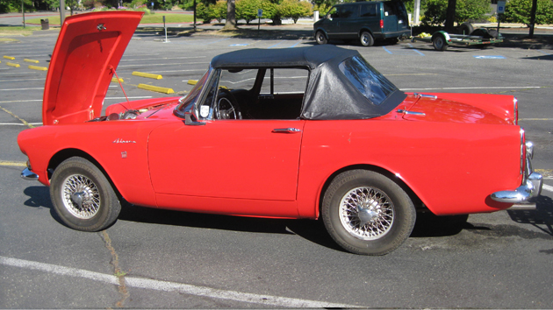

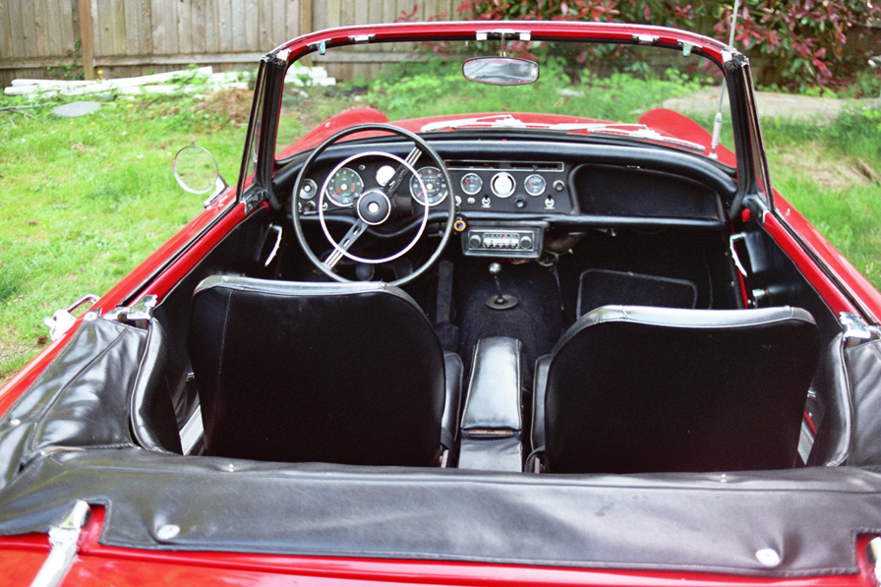

2. Hardtop - It is complete but for the quarter windows [originals are in place - opaque]. The clips and hinges need to be chromed. In 2009 it was repainted and new rear window installed plus all the related new rubber from Sunbeam Specialties and the uninstalled new [white] headliner. It is now here in CA with me so I could sell it to someone's friend in CA or it will come back with me, hopefully for SBNW.

Price: $2500.

Rob Carpenter

3. 71-73 HILLMAN/SUNBEAM AVENGER, PLYMOUTH CRICKET PARTS - Shop manual set. Mostly new: ext. front lens, estate left tail, Hoses brake kits, eng. gasket set, ex. twin down pipe, wheels, eng. head.
LATE 60's ARROW/HUNTER SEDAN,ALPINE COUPES (baby barracuda) New frt.&rear ext. lamp assy.&/or lens, speedo cluster. Used frt. & rear axle assy. / eng. / trans. / wheels,
etc.
CALL AS I HAVE DISSASSEMBLED A COUPLE OF WRECKED 1969 SUNBEAM ALPINE COUPES and ALPINE ROADSTER.
503-351-3618
Richard cricket-73@comcast.net

4. 1967 - Sunbeam Alpine
Soft top, original hard top and cover.
98% Original
Price: $ 5,000.00
Mike Seek 236 W Second St.
Tonasket, WA. 98855 Phone: (509) 486-1301
Email To: lou6453@yahoo.com

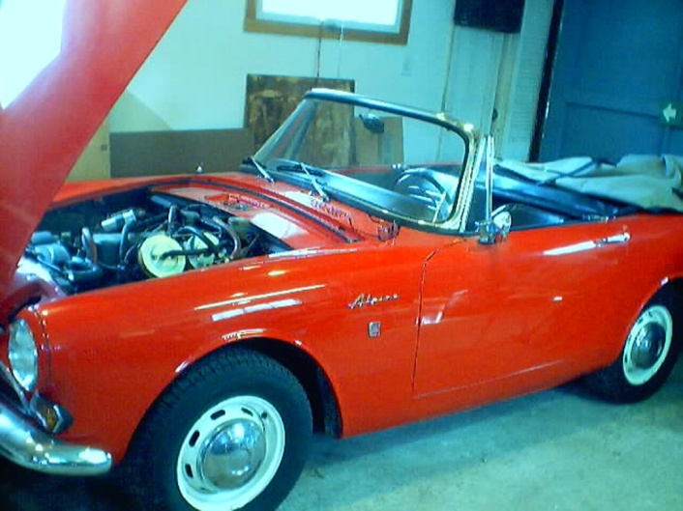

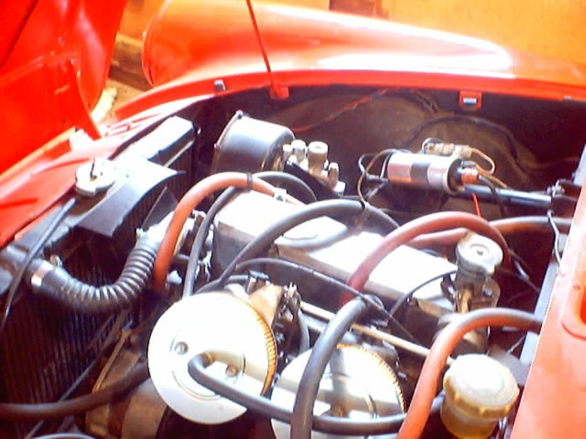

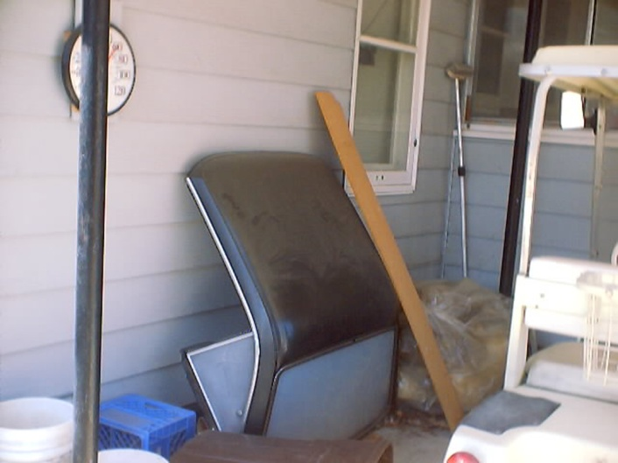

5. 1965 Sunbeam Tiger for Sale, the real deal, $27,000.00 OBO, please call, 425-271-2459 for questions or pictures.

6. Factory Hardtop: Sunbeam Alpine III-V or Tiger.
Complete with new soft components from Sunbeam Specialties.
Quarter windows are original and should be replaced.
No rust.
Clips and hinges should be chromed.
It is freshly repainted black.
The new rear window is installed.
Needs installation of headliner [new included].
Located in Central California until August 25-26 then bringing it to Seattle.
Will deliver between Fresno and Seattle with advance full payment… $2,500.

Rob Carpenter
rootesalpine@gmail.com
360-697-3764

Are you buying, selling or trading? Email us at Tiger2@telus.net

‘53 – ‘55 SUNBEAM ALPINE

Sunbeam, the historic British Racing Marque and Talbot (related to the French Talbot) came together under Rootes group pressure in 1938. The first car produced under the hyphenated name set the pattern for all future models; it was a sports touring car, developed from one of the Hillmans of the period, rather than a competition sports design. There was nothing unusual about the small (72 cu. in.; bore and stroke, 2.48 X 3.74 in.), L-head engine, but it was well made and completely reliable. Shortly there appeared a larger Sunbeam-Talbot, the 184 cu. in., 2.95X4.72, six-cylinder model, also an L-head.
In the postwar era, Sunbeam-Talbot production has followed the original plan. As compared to the Jaguars and Ferraris, these modern cars are prosaic, but satisfying. The original engine has been modified to use pushrod-operated overhead valves, and a larger four-cylinder engine has replaced the prewar sixes. It is this larger four that is the basis of the very commendable Sunbeam-Alpine, introduced in March, 1953 and named for a memorable showing in the Alpine Rally, where a factory team won four Coupes des Alps plus the Coupe des Dames.
The Alpine was derived from the Sunbeam-Talbot "90" which was an orthodox passenger model. A sporty roadster body was designed for the Alpine, and the engine received special attention from the engineers, who hopped it up for better performance yet retained the durability for which the marque has been famous. By upping the compression ratio to 7.5-to-l and re-designing the intake manifold, horsepower was increased to 80 at 4,400 r.p.m. The springs were stiffened considerably both front and rear, providing firmer control and detracting slightly from the easy riding qualities of the passenger car, and the wishbones-and-coil-spring independent front suspension of the front wheels was bolstered by a heavier anti-roll bar.
A "Super-Tuning Kit" was also available to buyers who wished to get yet more performance from their Alpines. With this, the compression ratio shot up to 8.5 to l, raising engine output to 105 b.h.p. at 4,500 r.p.m. One of these cars, further modified by the addition of a belly pan, a metal cockpit cover and the Laycock de Norman-ville overdrive, clocked a high speed of 120.459 m.p.h. at Jabbeke, Belgium, then went on to Montlhery to average 111.2 m.p.h. for one hour.
Despite its high-speed potential, the Alpine is intended as a dependable pleasure car for highway use rather than a sports racing machine. The relatively long wheelbase and heavy weigh tag it as an endurance car, which is precisely why the factory specializes in affairs like the Alpine and Monte Carlo rallies, body and engine design it appeals to that special class of driver the British have always been so successful with, the man who likes high-speed, responsive cars, yet does not care to fuss interminably. It is primarily a masculine car.

Thanks to: Bob Bennion

REGALIA

Hats, Hats, Hats… We got ‘em! $15.00 +2.50 for shipping, all have the "Pacific Tiger Club" Logo on the front, some have Tiger or Alpine on the side and some have no added logo on the side. Make all forms of payment to "Pacific Tiger Club" and mail to Budd Bennion, 14720 30th Ave NE, Seattle WA 98155-7512.
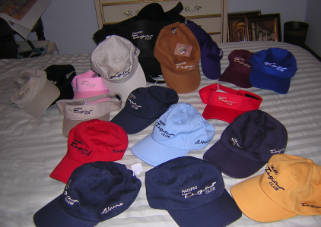

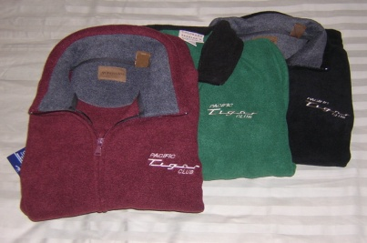
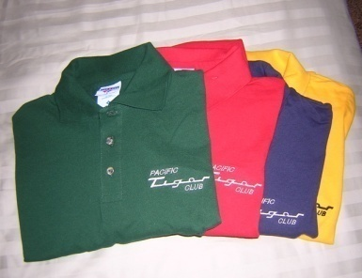

Save postage by picking up regalia at club meeting
Fleece jackets $30 + postage $4
Polo shirts- Lady's = $20 + postage $3
Men’s = $15 + postage $3

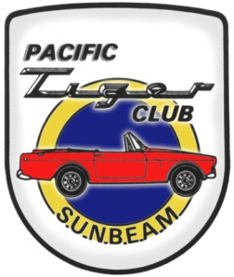

Pacific Tiger Club
12120 – 202nd Ave. SE
Woodinville, WA 98077-5639
425-885-0103
kevinj@olyprecast.com

