|  |
| --- |
|  |
| Rootes of the Pacific Northwest |

**Common Rootes**

Well we have talked about it for the past few months, but it is now official; SUNBEAM NORTHWEST is here. My registration has already been submitted. Registration forms are included in this newsletter and also were distributed to the club email list several weeks ago. You say you didn’t get the early registration notice? Then we must not have your current email address, so simply forward your current email address to Kevin or Budd Bennion and we will be sure you get all the latest. We toured the host hotel a couple months ago. It is definitely upscale from some of our past venues. We purposely picked this facility for its selection of restaurants and the fact that it is a casino, so if you are so inclined, there will be lots to entertain you when you aren’t enjoying the Sunbeams. The town of Shelton is only a couple miles away, so you will have ample choices for a meal or beverage.

Still working on that project? You now have the incentive to get’r done. A few late night work sessions should have you back on the road in time for SNW. This will be our big event for 2011. Although we have chairs for all the events, we will need lots of help for the weekend itself. All of the members of the SNW committee are

volunteers and we would appreciate your help in putting on an event to be remembered. This would be a great time to remember to forward a copy of the SNW registration to Sunbeam owners you know that are not club members. This event is open to all Sunbeam/Rootes owners.

As you can see from the events calendar, the next few months are low keyed. We want you to have the opportunity to come out, visit, learn something new, all without the pressure of preparing your car for a car show etc. If you are working extra hours getting your Sunbeam ready for SNW, then come out in your daily driver. Everyone is welcome, regardless of what you are driving. We have a tech session at the Pahmeier’s, and then two tours of businesses. They have all gone out of their way to open up their garages or shops to us, so let us show them our support by attending.

Don’t forget to try out events that we aren’t necessarily doing as a club. The Tulip Rallye is a favorite of many and this will be the 30th anniversary of this event, so they are planning to incorporate the better details from a selection of the years. Also very popular over the years has been the Bellevue ABFM.

With SNW rapidly approaching in August, it is appropriate to remind the club members that August is also the month we nominate the new board of officers. We nominate in August, vote in September and officially the new board takes over at our October Annual General Meeting (AGM). The current officers are shown in the front of the newsletter, and many have served for multiple terms. This is my notice that I do not plan to run for president in August, as this is already my second year in a row. I would not be surprised to learn that others also would like to see replacements. I think it is important to remember that this club is 100% volunteers and we will need new volunteers to keep the club viable. Please don’t wait for someone else to volunteer; you all have something to offer the club.

See you on the road.

Kevin Jewell

**____________________________________**

**Secretary’s Report**

Meeting held at Dave Dunn’s storage unit in Auburn, WA. Meeting called to order by Dave Dunn 12 February 2011

Old Business: none

New business:

Dave reminded everyone about the planning meeting to be held at Kevin and Judy’s house on February 19, 2011. If you cannot attend; please email or call if you have any ideas or input for the Sunbeam NW event.

August 4, 5, 6, 7th, will be a very busy weekend for the Little Creek Casino, several weddings and conventions are slated. As a result, members should reserve rooms early. “Tiger Club” is the magic phrase to reserve one of the rooms set aside for the club. As a point of interest, it was noted that the rooms with king beds are larger than average.

Other motels are in Shelton-5 miles away, but it is nice to stay at the event.

The event is for all Rootes cars.

Future events discussed:

March is blank

April 9th the club will meet at the home of Max and Kathryn Pahmeier

May 21st the club will meet at Jim Green’s Performance Center

June - Eller’s is scheduled

July - Kevin may have a country drive in the works

Treasurer’s report:

Bob Bennion reported the club had $7831.80 in the bank

Membership report:

Budd Bennion reported 69 members at this time

Larry Atkisson reported that Hurst shifters were not available any more, but that Bill Healy rebuilds old ones and does a good job.

After the meeting, Larry demonstrated removing the window winder mechanism from a Tiger/Alpine.

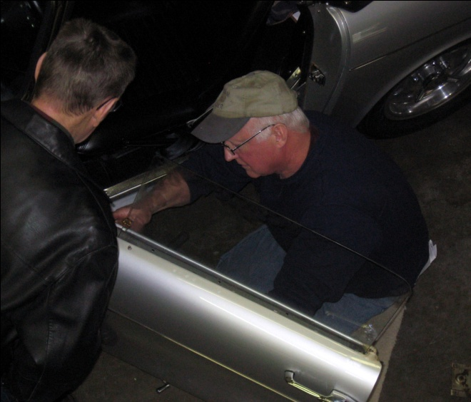

Meeting was adjourned - submitted by Jim Clark

**____________________________________**

**2009-2010 Executive and Officers**

**President:** Kevin Jewell

12120 – 202nd Ave. SE

Woodinville, WA 98077-5639. Ph. 425-885-0103

[kevinj@olyprecast.com](mailto:kevinj@olyprecast.com)

**VP/Newsletter** Kathryn Fitzgerald/Mike Clark 4723 Woodside Place

West Vancouver, BC V7S 2X5

[Tiger2@telus.net](mailto:Tiger2@telus.net)

**Secretary:** Jim Clark

17711 – 10th Ave. NW

Shoreline, WA 98177

206-533-1187

jwclark2@comcast.net

**Treasurer:** Bob Bennion

37904 Fawn Rd NE.

Hansville, WA 98340

360-638-1992

[904star@centurytel.net](mailto:904star@centurytel.net)

#### Chairpersons

**Activities:** Larry & Eileen Ingersoll

29206 61st Ave S

Auburn, WA 98001

253-946-0762

Laingersol@aol.com

**Membership**: Budd Bennion

14720 30th NE

Seattle, WA 98155

206-364-8478

budd.bennion@comcast.net

**Historian:** Brett Simpson

10005 SE 267th St.

Kent, WA 98031

253-859-5096

[brsjal1@comcast.net](mailto:brsjal1@comcast.net)

**2011 EVENTS CALENDAR**

Official PTC activities are printed in red. We have listed other possible activities of which you might want to participate. Call a couple friends and try something new.

**Now** Exotics at Redmond Town Center (Desert Fire Restaurant). On nice Saturdays the exotics (mostly Italian, but others also show) mingle starting about 8:30 AM. There is no cost and if you are looking to see some nice cars it’s worth the trip.

**April 9** Max Pahmeier will host a club meeting at his house. Arrive at 1:00 PM. Address is 16108 SR 9 SE, Snohomish, WA 98296. In February we had a demonstration on rebuilding and installing window regulators. We will continue that tech session today with a demonstration on rebuilding/assembling new channels for the windows. For more information contact Max at pahmeier@frontier.com.

**April 23** 30th Annual LaConner Tulip Daffodil Rallye. Rallye starts at 9:30 AM at Cascade Mall, I-5, Exit 230. Cost is $12 in advance or $15 day of event. Since this is a 30 year anniversary, they have taken some of the best parts of past rallyes and incorporated them into this year’s event. For information contact: [ken.bottini@frontier.com](mailto:ken.bottini@frontier.com). If you have never participated, this is a fun event.

**May 21** Visit and Tour Jim Green’s Performance Center in Monroe. Tour to start at 10 AM. Address is 17520 147th St SE, Monroe, 98272. Jim Green’s has been serving the high performance community for over 44 years. They are one of the country’s few Ford 427 SOHC specialists. If you have never seen a “Cammer” up close, this alone is worth the visit.

**May 21** ABFM, VanDusen Garden, Vancouver, BC. Featured marques are Rover, Triumph TR6 and Triumph motorcycles. More information, [www.westerndriver.com/abfm](http://www.westerndriver.com/abfm).

**June 18** PTC visit (meet there by 11 AM) with Brit-Sport of Seattle. It is amazing what we find in our own backyard. Brit-sport specializes in the restoration of British sports cars. The owner will give us a tour of their facilities and also walk us thru one of their projects. Address is 4214 24th Ave W, Seattle, 98199 (lower level). You can check them out at [www.britsportofseatte.com](http://www.britsportofseatte.com). They will serve coffee and donuts, and for those interested some of us will be going to lunch afterwards.

**July 9** PTC scenic tour and then lunch in Snohomish. Start at Target parking lot, Redmond, at the end of Highway SR-520. Meet about 10:15 AM, with tour to start promptly at 10:30. Tour is about 50 miles, and we will have written directions for everyone. Snohomish is a fun town to visit, and lots of shops, including Black Cat Antiques. Black Cat always has lots of automobile memorabilia, plus toys etc from the 50’s. If you decide you don’t want to do lunch, you can start with the shops and enjoy an ice cream on the way.

**July 16** Summer Fun at the Park. Want to try to different car show at a beautiful setting? Journey to the Clock Tower Park, 1408 Palisade Blvd, DuPont, WA for an all marque car & truck show. Show hours are 8-3 PM, and cost is only $10 if registered by 6/30/11. More information, [www.dupontcarshow.com](http://www.dupontcarshow.com).

**July 21** School Daze, a track event at Pacific Raceway sponsored by the Corvette Marque Club of Seattle. This is an opportunity to drive at speed on the race course. Most performance cars are accepted, including sedans. Instructors will be provided for novice drivers or those not familiar with the track. More information will be posted at [www.corvettemarqueclub.com](http://www.corvettemarqueclub.com).

**July 23** Bellevue 23rd Annual ABFM at Bellevue College. Honoring 80 years of MG Car Club and celebrating 50 years of Jaguar E-Type. For more information, [www.abfm.com](http://www.abfm.com).

**Aug 5-7** Sunbeam Northwest. PTC has returned to sponsor the latest Sunbeam Northwest. Activities include a concours, autocross and rally. This is a “must do” for all Sunbeam and Rootes Group owners. Host hotel is the Little Creek Casino in Shelton, WA. More details are elsewhere in this newsletter and will be repeated over the next few months. Suggest you make your reservations now, as the block of rooms could go quickly. You can always cancel, if your plans have to change.

**Dec 10** PTC Annual Holiday Party. The day time party went very well in 2010, so our 2011 hosts Max & Kathryn Pahmeier decided to follow the “new tradition”. We will meet at Noon. Address is 16106 SR 9SE, Snohomish, WA, 98296. For more information, contact Max at [Pahmeier@frontier.net](mailto:Pahmeier@verizon.net). More details later, but advance notice for your planning.

**If you know of other events we should be listing, please contact our activity chairs, Larry & Eileen Ingersoll.**

**Laps from The Past**

May, 1993: Sporting Classics and Auto Restoration magazine reports on an Ontario man that was racing a MG TD, but decided he needed more horsepower. So he dropped a Ford V8 into a Hillman Minx convertible. This was 1953, so this was a 60 horsepower flathead, but was then hopped up with triple carbs etc. The car made its debut at the 1953 Watkins Glen Grand Prix for Sports Cars. The article claims it ran towards the front with the XK 120s, but it kept pulling the wheel bolts through the wheels. No mention if this was an early Shelby built Tiger prototype.

April, 1998: Club meeting is a tech session at Larry Atkisson’s garage in Seattle. Larry is still leading the club in tech sessions. Planning is already well underway for SUNI III for 1999, in Big Sky, Montana.

May. 2002: Going along with the 1993 Ford flathead theme, the newsletter reported on the April club meeting at Tatom Custom Engines where Dave Tatom specializes in rebuilding Ford flatheads, even adding another main bearing to reduce crankshaft flex. Would you believe that some people pay $25,000 for a flathead? Dave Tatom was one of the original owners of Lakewood Sports Cars of Tacoma in the early 1960’s. Lakewood sold Sunbeams and Simcas, so Dave has a long history with cars.

May, 2005: Report on the March meeting held at the Hydroplane and Race boat Museum in Kent. If you have never been there, put it on your list to visit. Budd Bennion reports on rebuilding his 1725 cc engine and deciding to follow a prior club tech session visit, has the block, head, pistons, valve springs, manifolds, valve cover, side valve cover and thermostat housing all protected with a ceramic thermal barrier. After all that, he still is driving the Husky, because he is afraid if he drove the Alpine that none of us would recognize him.

Kevin

**SUNBEAM NORTHWEST AUGUST 4 – 7, 2011**

We have finalized arrangements with Little Creek Casino as our host hotel for Sunbeam Northwest.  Enclosed is the room rate sheet.  We pay a higher nightly rate on the weekend.  They have blocked 50 rooms, all NON-SMOKING, as shown.  You can make your reservations at your convenience, although we have already heard that being August, this is going to be a busy weekend at the Casino, so you might want to book now.

If you want a smoking room, just let them know your preference when you call.

The hotel is dog friendly, just let them know and there’s a $30. a night extra fee.

Sounds Good! Yes, your group can reserve rooms anytime…just mention the date and “Pacific Tiger Club”

===============================

OK to start reserving rooms.

Check in Aug -Thurs 4-Fri 5-Sat 6

Check out Aug - Sun 7

Reservations 360-427-7711   1-800-667-7711

All rooms in the block are non-smoking (N)

|  |  |  |  |
| --- | --- | --- | --- |
| Check In Date | Room Type | No. of Rooms | Room Rate |
| 08/04/11 | KGN | 20 | 89.00 |
|  | QQN | 30 | 89.00 |
| 08/05/11 | KGN | 20 | 109.00 |
|  | QQN | 30 | 109.00 |
| 08/06/11 | KGN | 20 | 109.00 |
|  | QQN | 30 | 109.00 |

**PTC Meeting**

**April 09 @ 1:00 PM**

Max Pahmeier will host a club meeting at his house. Arrive at 1:00 PM. Address is 16108 SR 9 SE, Snohomish, WA 98296. In February we had a demonstration on rebuilding and installing window regulators. We will continue that tech session today with a demonstration on rebuilding/assembling new channels for the windows. For more information contact Max at pahmeier@frontier.com.

**____________________________________**

**30th LaConnor Tulip Rallye**

We invite your car club to participate in the 30th Annual La Conner Tulip Rallye.

For the past 29 years, the MG Car Club has hosted the LaConner Tulip Rallye-Tour. We have designed the event so that each car club with a minimum five cars entered can win a first place within their club. Some clubs now make this rallye their April driving event.

The LaConner Rallye is a fun event. It’s not time and distance – it’s a light hearted gimmick rallye or tour. Even children have a fun time. The rallye starts in the Mount Vernon area, visits the flower area and moves on to visit water-fronted areas too.

**Date: Saturday, April 23, 2011**

**Time: 9:30 am (Rallye Start)**

**Place: Cascade Mall I-5 Exit 230**

**Cost: $12.00 (advance) $15.00 (Day of)**

We hope you will place this event on your 2011 calendar of events. We have attached the entry form for you to pass on to your club members. We are looking forward to your club’s participation.

Ken Bottini

MGCC NWC

**Tulip Rallye, c/o Ken Bottini, 12835 N.E. 36th St., Bellevue, WA 98005-1323**

**425-883-9615 or E-mail:** [**Ken.Bottini@frontier.com**](mailto:Ken.Bottini@frontier.com)

**Tigers United XXXIII**

Will be held in less than 4 months at the Queen Mary in Long Beach, CA. Here's a little information about what it's about. You may want to share it with your membership. First let me say this. As an "insider" I'm sure, especially knowing the VIP guest list, the speakers' program, the route of the rally and the venue that any who miss this event will regret it for a very long time.

It will probably be the largest Tiger gathering in the world this year. People are coming from all over the country, from Europe and from Australia to attend. 270 room nights have already been booked at the hotel and many participants have already registered.

This United will explore the Tiger's history that was made in the mid-sixties in southern California. We will learn about the construction of the prototypes from the men who were actually there. We'll also cover mid-sixties Tiger racing. We'll explore historic Tiger sites and other iconic locations that figure large in the development of our southern California car culture.

We've gotten great rates from the Queen and expect a very large turnout. In fact, we are starting to run out of some of the hotel rooms so if you're interested you should act quickly.

This link takes you to the section on the CAT web site that has event details.     <http://www.catmbr.org/VB_forum/forumdisplay.php?f=34>

Hope to see you there,

Buck Trippel

CAT President

**____________________________________**

**Peter Brock**

At the new Griot’s Garage facility in Tacoma, they host “Caffeine & Gasoline” Saturday mornings. Peter Brock was the speaker on Dec 4. Peter has a business on the Redmond-Fall City Road in Redmond.

Most Corvette people recognize Peter as a GM designer working for Bill Mitchell who penned much of what was to become the 63 Stingray. Ford fans will remember that Peter was the primary designer of the Cobra Daytona Coupe. Peter spent much of his time talking about the rivalry between Ford and Chevrolet and how that shaped his early career. As Peter tells the story, he got interested in late 1930 German research on automotive aerodynamic design. He attempted to include some of that design into the Stingray, only to be told by Mitchell “Kid, that is the ugliest thing I have ever seen”. As usual, Mitchell got his way, and the lines of the Stingray were fixed. Of course, later, everyone knows that the Stingray wants to lift its front wheels at about 140 mph.

Later Peter went to work for Carroll Shelby, originally to run Shelby’s driving school. The Ford and Chevy executives all belonged to the same country clubs and Ford could see how a small investment with Shelby’s Cobra could twist the knife in the back of the Chevy boys. The Cobra was a successful race car and giving the Corvette fits. However good the Cobra was on US racetracks it was not suitable for the longer straights and higher top speeds on European tracks. At 375 HP, the small block Cobra was limited to about 165 mph. When Ford and Shelby decided to go racing in Europe, they needed to do something different. Peter was tapped to design a new body for the Cobra chassis. They had about 3 months to get the new car ready for the season opener

at Daytona in Feb, 1964. Peter first asked Shelby for the chassis blue prints. However, AC in England was not inclined to cooperate. Seems they were a bit put out by Mr. Shelby. The Cobra was (at least in AC’s mind) originally scheduled to be called an AC Cobra. But Shelby, knowing that he was going after the manufacturer’s championship wanted his name prominent, so he called it a Shelby Cobra. So without blue prints to work with, they took an existing Cobra that had been wrecked in a prior race and started to modify it with a sleeker body. This gave Peter the opportunity to finally apply the German aerodynamic research. As velocity increases, the drag increases by the square of the velocity and the horsepower requirements increase by the cube. So Peter knew that the higher speed Cobra was going to result from a better aerodynamic shape rather than more horsepower or lighter weight. So there were two main design elements incorporated. First, he kept the roof slope to about 7 degrees. This kept the air flow laminar rather than becoming turbulent and creating drag. Second, he cut of the rear of the car with a Kamn back, with the idea that the abrupt rear would actually decrease drag.

When they took the first car to Riverside for testing, Ken Miles brought the car into the pits and accused the crew of changing the rear end ratio from the original Cobra race car. His logic was that he was turning much higher revs coming out of the corners and on the straights. After jacking up the car and testing the ratio, the crew recognized they had a winner on their hands. They called Shelby with the news that the car was far faster than the Cobra roadster and Shelby immediately put the Daytona Coupe on the front burner. One side benefit of the design change was that they got about 25% better fuel mileage with the Coupe than the Roadster, thus allowing longer driving times between pit stops.

The Daytona Coupes were very successful, but ultimately were left in England as Ford and Shelby moved onto the GT40 program. Most of the coupes were returned to Shelby where they were advertised for sale for $8,500 and most sold for $4-5,000. Only six ever made, and worth millions today. Where was I when they were sold?

Peter left Shelby in 1965 and started his own firm BRE (Brock Racing Enterprises). Many will remember that BRE put Datsun racing on the map with a series of Datsun 510’s and 240Z’s.

He had two cars with him at the presentation. Datzilla, a Datsun 510 with a small block Chevy.

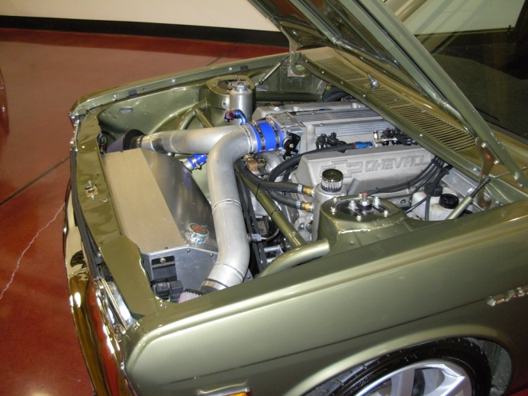

His personal Superformance Daytona Coupe is now equipped with a Corvette LS7.

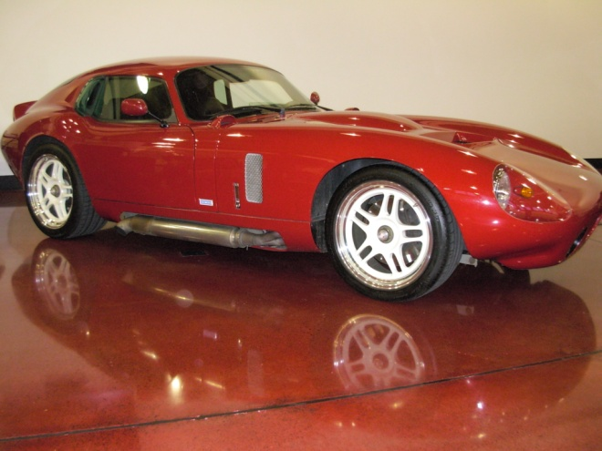

Ford fans for years have complained about all the 32 Fords with small block Chevy’s. Now they have something further to complain about. The Superformance Daytona has a three inch longer wheelbase than the original. Peter says the LS7 allowed him to mount the engine further back, raise the crank centerline 2” and of course is much lighter. He runs with a T56 6 speed and thinks the driveline change has made a much better car.

All in all, it was a very interesting morning. BRE is still in business, and many in the audience were wearing Datsun/Nissan jackets.

Thanks to: Kevin

**We need your help! If you know of any Sunbeam Events, please contact your Activities Co-coordinator and we’ll get it in the newsletter.**

**Want to avoid mail delays? Receive your next issue of the PTC Newsletter emailed to you on-line. Contact us at** [**Tiger2@telus.net**](mailto:Tiger2@telus.net) **with your email address**

# **We want to hear your great stories! Do you have a great story to share? Send us the details with your photos. Let us know!**

**DO WE HAVE YOUR CURRENT ADDRESS AND EMAIL? HELP US KEEP OUR RECORDS UP TO DATE AND SEND YOUR CHANGES TO BUDD OR THE EDITOR.**

**____________________________________**

**Update: House Bill 1134 Has Been Pulled** – If you haven't already heard, according to House Transportation Committee, the proposed House Bill1134 legislation to require annual renewal fees for collector vehicle and horseless carriage license plates has been pulled, and will NOT receive committee consideration this year.

**Profile your car!**

We would like to have a profile of your car, even if everyone knows who you are. Please email your profile to Mike & Kathryn. New to the PTC, Let us know the details, as we would like to do a feature article on your car!

**Want to avoid mail delays? Receive your next issue of the PTC Newsletter emailed to you on-line. Contact us at** [**Tiger2@telus.net**](mailto:Tiger2@telus.net) **with your email address**

**Renewing your membership?**

**Members are asked** to observe their renewal dates on each month’s address label. The date indicates when your dues are due to continue receiving the PTC Newsletter. Please send all membership correspondence to Budd at: 14720 30th NE, Seattle, WA. 98155 (206)364-8478 or via email: **budd.bennion@comcast.net.**

Annual Membership fee $32.00 US/35.00 Foreign for foreign members.

**Canadian Funds Payment to PTC**

We ask each Canadian member to calculate the current exchange rate into US funds. Example: dues today $35.00USD=38.50 CAD (based on 10% exchange rate)

Make payment payable to Pacific Tiger Club and we will process via our bank. Exchange rates are constantly changing. For assistance you may use the following website: **http://www.xe.com**

Be the first on your block to have tires with no compressed air and invisible when in motion. Michelin introduced their radical new design at the Philadelphia Auto Show.

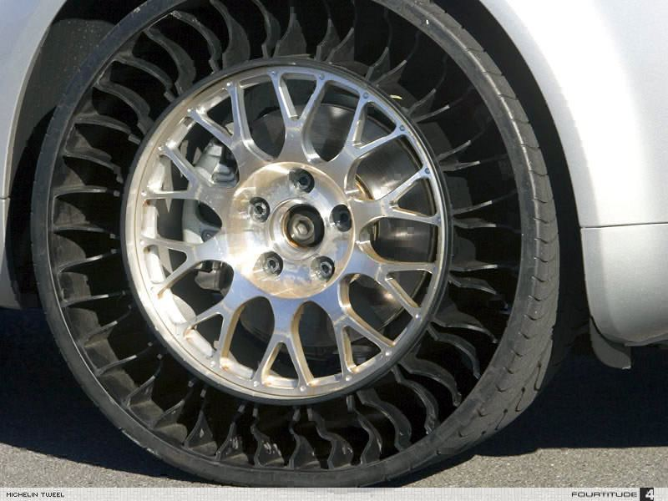

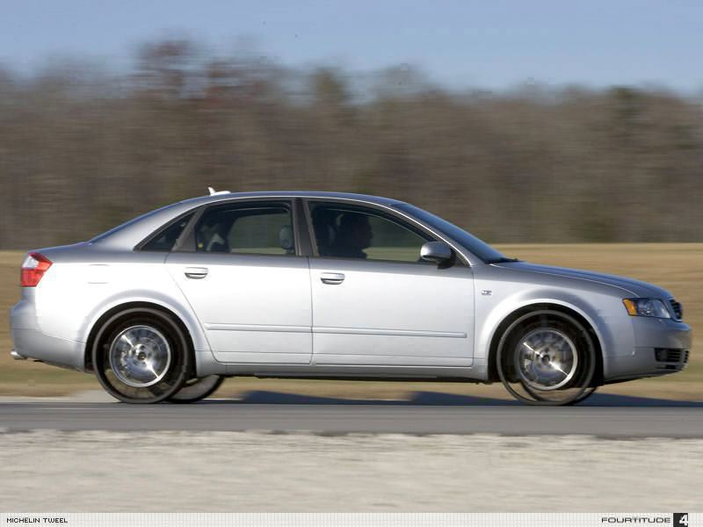

Thanks: Kevin

**TECH TIP**

**Swifter Shifter**

Are you experiencing the sloppy shifter blues?

*If* your 4-speeder feels more like a spoon

in *a* bowl of Maypo than a taut control

mechanism, we have the cure. On most

shifters such as the Hurst Competi­tion-Plus,

the shift rods are located with a bushing and

retained by a spring clip. Use a thin

AN %-inch i.d. washer between the spring

clip and the arm on both ends of the rod

(photo 1, arrow) to reduce the play in the rod.

Then carefully adjust the length of the rods

with the alignment rod placed in the shifter

(photo 2, arrow A). Finally, adjust the shifter

stops (photo 2, arrow B) so that the stops limit

travel to the engagement of the gears, and

no further. With these modi­fications, you’ll

now be able to bang gears with the best of 'em!

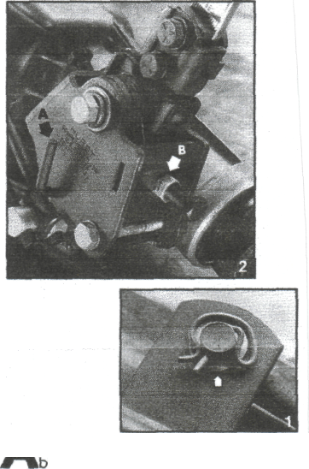

Thanks to: Bob Bennion

**Do you have an interesting tech tip to share with the readers? We are always interested in any submissions**.

**Vintage Racing**

Info for NW vintage events sponsored by SOVREN can be found at: www.sovren.org

**FOR SALE:**

1967 - Sunbeam Alpine

Soft top, original hard top and cover.

98% Original

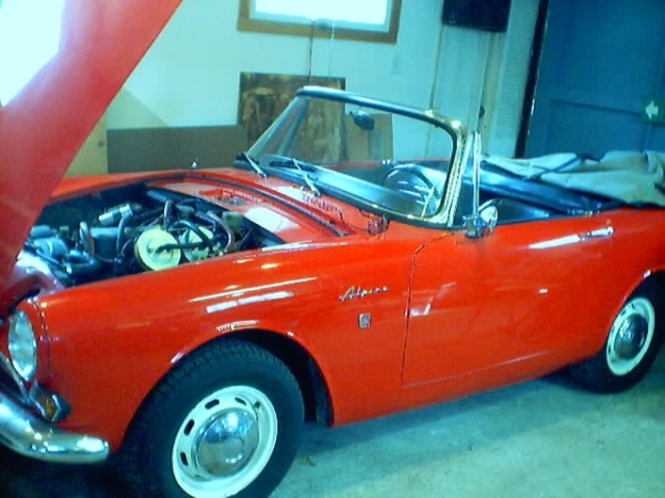

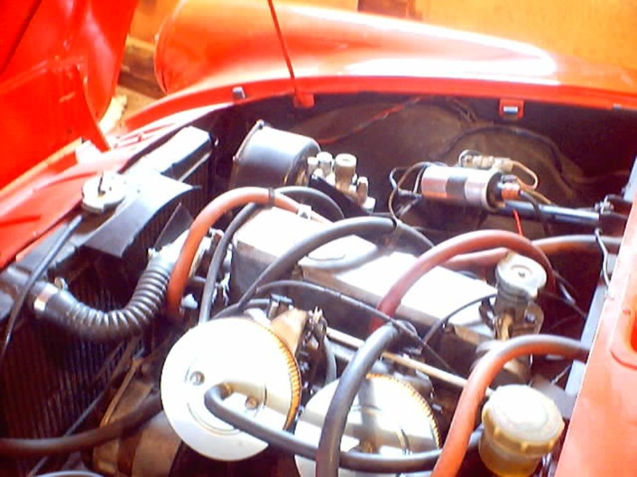

**Are you buying, selling or trading? Email us at Tiger2@telus.net**

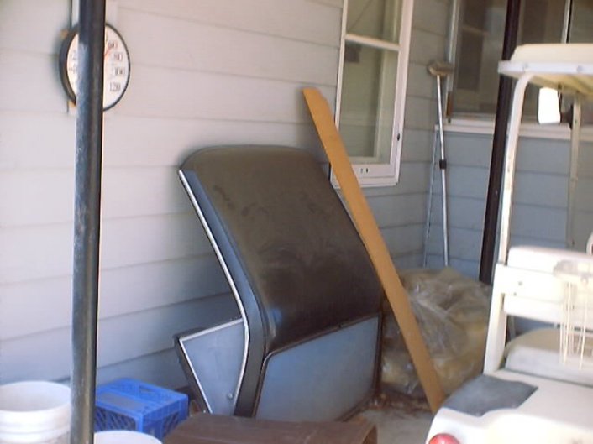

Price: $ 5,000.00

Mike Seek 236 W Second St.

Tonasket, WA. 98855 Phone: (509) 486-1301

Email To: [lou6453@yahoo.com](mailto:lou6453@yahoo.com)

**___________________________________**

1965 Sunbeam Tiger for Sale, the real deal, $27,000.00 OBO, please call, 425-271-2459 for questions or pictures.

Paul Mason

___________________________________

1- forged Ford 347 stroker = 350 h.p.

1 - scatter shield for sale.  
2 - Stainless steel exhaust pipes , 2.500"x4"  .065 wall Premium Grade 304 Alloy#555-3910  
1 - 6 ft. flex coil 2 1/2" diameter 1.0 541 015 ROI

Vicki Komori - vkomori@gmail.com

**REGALIA**

Hats, Hats, Hats… We got ‘em! $15.00 +2.50 for shipping, all have the "Pacific Tiger Club" Logo on the front, some have Tiger or Alpine on the side and some have no added logo on the side.  Make all forms of payment to "Pacific Tiger Club" and mail to Budd Bennion, 14720 30th Ave NE, Seattle WA 98155-7512.

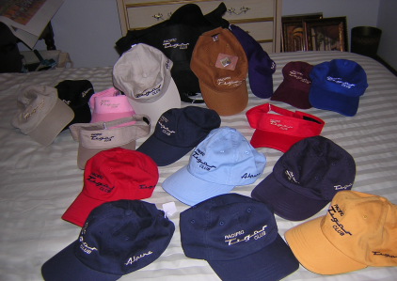

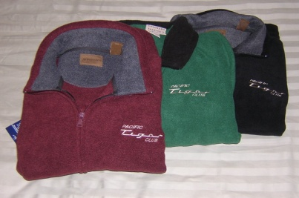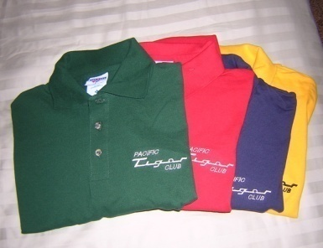

Save postage by picking up regalia at club meeting 

Fleece jackets $30 + postage $4

Polo shirts- Lady's = $20 + postage $3

Men’s = $15 + postage $3



**Pacific Tiger Club**

12120 – 202nd Ave. SE

Woodinville, WA 98077-5639

425-885-0103

[kevinj@olyprecast.com](mailto:kevinj@olyprecast.com)