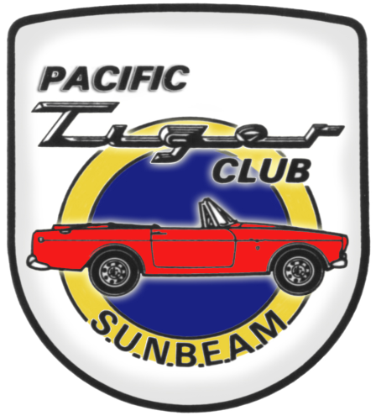

Rootes of the Pacific Northwest

In this issue:
President’s report… page 1
Calendar of Events… page 3&4
Next PTC Meeting… page 7
Tech Tip… page 8&9

Common Rootes

Our next club activity will be the Tulip Ralley, on April 24. In the event calendar, you will find the meeting spot should you want to caravan to the ralley. Since your order of departure is based upon the order of your registration, we suggest you register sooner than rather than day of event. You can download a registration form from their web site, which is shown in the event calendar. We last participated as a group at this event maybe 10 years ago. So if you haven’t been for a few years, put this one on your list. I am hoping that the weather will cooperate for the ralley, but in the years I have gone, it has been 50-50. We live the Northwest, so we are used to a little rain.

I want to remind you to make your plans and also make reservations for your stay at the Maryhill Hill Climb. I have heard from six people that have already made reservations. Sunbeam is the featured marque, so we want to put on a good show.

This year we are trying to present our event calendar in a different format, to allow you to plan further ahead. If you know of any events that you think should be included on the calendar (even if not officially club meetings) please just let your activity chairs or Kevin know about the event. We know you can’t do everything, but our goal is to give you a variety of events from which to choose.

See you on the road…Kevin Jewell

Secretary’s Report:

“Super bowl” Meeting held at Budd Bennion’s home. Meeting called to order by Kevin Jewell on 7 February 2010

Attendees: Kevin Jewell, Bob Bennion, Budd Bennion, Dave Dunn, Dick Sanders, and Jim Clark. Paul Jelinek along with Larry and Ilene Ingersoll left early

New Business: none

Old Business: Bob B wanted it known that a larger number of hard copies of the newsletter were mailed out, than previously reported. 46 copies of newsletters were mailed and at present we have 77 members.

Kevin J reminded everyone who wants to participate in the Tulip rally to send in their registration right away. The event is usually held about April 24th. As the cars arrive they are lined up in rows of about 50 cars; then the organizers release a line of cars to start the rally. The next group starts a few minutes later, on a different route through the fields.
We’d like to go as a group, so a predetermined meeting place will be named at a later date. (Possibly a park and ride) Details may be emailed, so please pass the word along to those who don’t have email.

Discussion for club events:
Meeting for March - not yet determined
Meeting for April – Tulip Rally
Meeting for May – possibly a driving tour that Kevin has driven previously. Meet at Target, and driving to Snohomish.
Meeting for June – the Greenwood car show
Meeting for July – the Car Corral
Meeting for August – the LeMay museum
Meeting for September – Option 1 Kirkland car show, arrive as group in parking lot. Option 2 Larry and Ilene suggested visiting the Mustang Restoration Shop in Auburn. Those in attendance favored this option.
Meeting for October – Maryhill Hill Climb event. Locations for the AGM were also discussed. Mid-day is still favored, as is the informal style of last year. Golden Gardens was mentioned and would be a venue to drive and show the Rootes cars. The Nile Golf Course was nice, but too pricy at $60.00 a person. Budd is still researching meeting locations. Contact Budd with any ideas about the AGM meeting.

For the Maryhill Hill Climb - six members have signed up: One Hillman, one Alpine, two tigers, and two race cars.

Meeting was adjourned to watch the second half.

Minutes submitted by Jim Clark.

2009-2010 Executive and Officers

President: Kevin Jewell
12120 – 202nd Ave. SE
Woodinville, WA 98077-5639
425-885-0103
kevinj@olyprecast.com

VP/Newsletter Kathryn Fitzgerald/Mike Clark
4723 Woodside Place
West Vancouver, BC V7S 2X5
Tiger2@telus.net

Secretary: Jim Clark
17711 – 10th Ave. NW
Shoreline, WA 98177
206-533-1187
jwclark2@comcast.net

Treasurer: Bob Bennion
37904 Fawn Rd NE.
Hansville, WA 98340
360-638-1992
904star@centurytel.net

Chairpersons

Activities: Larry & Eileen Ingersoll
29206 61st Ave S
Auburn, WA 98001
253-946-0762
Laingersol@aol.com

Membership: Budd Bennion
14720 30th NE
Seattle, WA 98155
206-364-8478
budd.bennion@comcast.net

Historian: Brett Simpson
10005 SE 267th St.
Kent, WA 98031
253-859-5096
brsjal1@comcast.net

Are you buying, selling or trading? Email us at Tiger2@telus.net
2010 EVENTS CALENDAR

Official PTC activities are printed in red. We have listed other possible activities of which you might want to participate. Call a couple friends and try something new.

Now Exotics at Redmond Town Center (Desert Fire Restaurant). On nice Saturdays the exotics (mostly Italian), mingle starting about 08:30 AM.

April 10 PACCAR Test Center open house, 11 AM – 3 PM. The 242 acre site is only open to the public one day each year. Full size heating and freezing chambers for testing trucks, a large test track and everything in between. If you have never been there, make a day trip of it. You will find lots of car clubs in attendance. Many interesting new and old truck displays. The test center is about 1 mile north of highway 20 near Mt. Vernon/LaConner at 12479 Farm to Market Road.

Apr 24 Tulip Rally. Gimmick rally thru the LaConner tulip fields. Last year there were about 300 vehicles. They dispatch cars in the order you register, so register as early as you can. Starts at Cascade Mail I-5, Exit 230. First car out at 9:30 AM. Please bring a donation for NW Harvest. http://mgccnwc.com/ calendar.htm. We will caravan from Quality Inn in south Everett. On I-5 north take exit 186, turn right on 128 St. SE and do the legal U turn at 3rd Ave. SE. Quality Inn is on the right, meet in the east parking lot. Departure 8:15 AM sharp.

May 15 PTC tour of The Mustang Shop in Auburn (1929 West Valley Highway S). They specialize in restoration and performance parts for all Mustangs. Meet 9:45 AM at Bahama Breeze restaurant in the NW corner of Southcenter, with departure at 10:00 AM. If you want to meet us at TMS, plan to be there by 10:30. We will have an optional lunch visit at the local Red Robin, following the tour/meeting.

May 15 Monroe Swap Meet.

May 15-16 SOVREN Spring Sprints at Pacific Raceway. This year a featured class will be the 1966-69 under 2 Liter Trans AM race cars.

May 16 XXX spring opener, Issaquah, 425-392-1266

May 22 25th Anniversary ABFM at Van Dusen botanical gardens in Vancouver, B.C. register at http://www.westerndriver.com/

May 30 CruZin to Colby, Everett, WA 425-337-9335

Jun 26 Greenwood Car Show. This just keeps getting bigger and better. It is time we attended as a club. Advanced registration is $25.00, with about half that money going to charity. If we want to come and park as a club, they ask that we have a minimum of 10 cars and that we submit our registration forms together. If you want to pre-register, contact Kevin Jewell and he will coordinate the club’s participation. Last year they were completely full and turned away some of the day of event registrations. www.greenwoodcarshow.com

Jul 3 Car Corral at SOVERN Historic Races at Pacific Raceway. We display our cars as a club at the entrance to the pits. During the lunch break, we have the opportunity to drive the race track. The car corral is free, but it is required to make advance arrangements for the car corral passes and purchase our race admission ticket. More info to come. Please remember, you cannot participate in the car corral without a pass.

Jul 22 Corvette Club School Daze track event, at Pacific Raceway. Learn how to handle your vehicle at speed and drive it (legally) as it was meant to be driven. You do not need a Corvette; any performance oriented vehicle is generally acceptable, except that convertibles must have hardtops or roll bars. Novices will be paired with an instructor. www.corvettemarqueclub.com.

Jul 24 ABFM, Bellevue. BBQ get together afterwards at the Jewell’s. Judy will be attending Kevin’s family reunion, so any and all hostess help for Kevin would be appreciated.

Aug 22 Pt Townsend Classic Car Show. PTC did this maybe 15 years ago. Fun town to visit and there is lots to see outside the car display area.

Aug 28 LeMay Open House, Parkland. This year could be the last year the collection is opened to the public, due to the construction of the new museum. We can tour and park together as a club. Admission is very reasonable; I believe $10 last year. Probably 600 vehicles on display plus all the clubs.

Sep 3-5 Portland ABFM at Portland International Raceway.

Sep 12 Kirkland Concours d’Elegance 9 AM- 4 PM. One of the featured judging classes will be “Screamers-Powered by Ford”. We have approached the organizers about a side display of Tigers

Sep 18-19 Run to the Sea. htpp://abfm.com/. Similar to the long time Run to the Gorge event except the tour is to the ocean.

Sep 18 Vancouver to Whistler All British Run.

Oct 1-3 Maryhill Hill Climb. Sunbeam is the featured marque at the car display on Sat. On Sunday we get the chance to cheer for all the Sunbeams racing. Quality Inn 509 773 5881 or camp out.

? Day trip to Leavenworth, and possibly Icicle Creek Winery. Where does this fit in for you?

Oct 8-11 Tigers East/Alpines East
If you know of other events we should be listing, please contact our activity chairs, Larry & Eileen Ingersoll.

Maryhill Hill Climb,
Oct 2 & 3, 2010 Let’s Go!

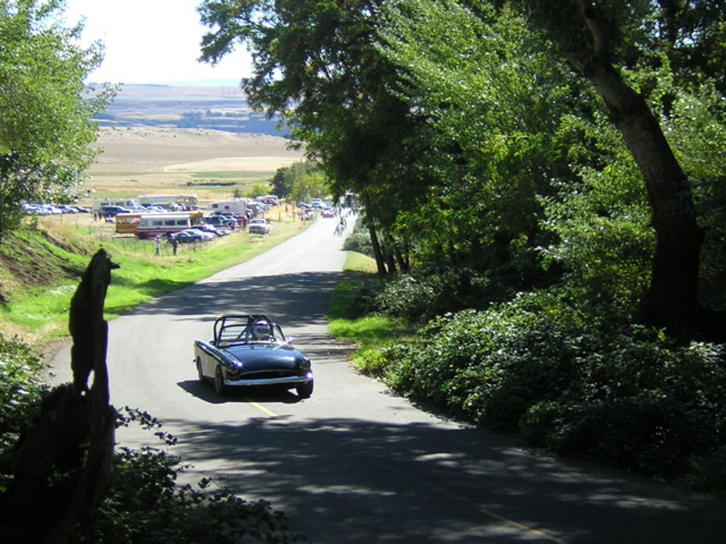

In the last PTC Newsletter, we announced that Sunbeam will be the featured marque during the weekend activities at the Maryhill Hill climb during the weekend of Oct 2 & 3. The hill climb is a SOVERN racing event and generally well attended. The formal activities start Saturday with a car show on the Maryhill Museum grounds. Last year, Studebaker was the featured marque and there were 18 Studebakers among all the cars on display. Certainly, we should be able to do better than 18. You might remember that Maryhill is the home of the replica Stonehenge.

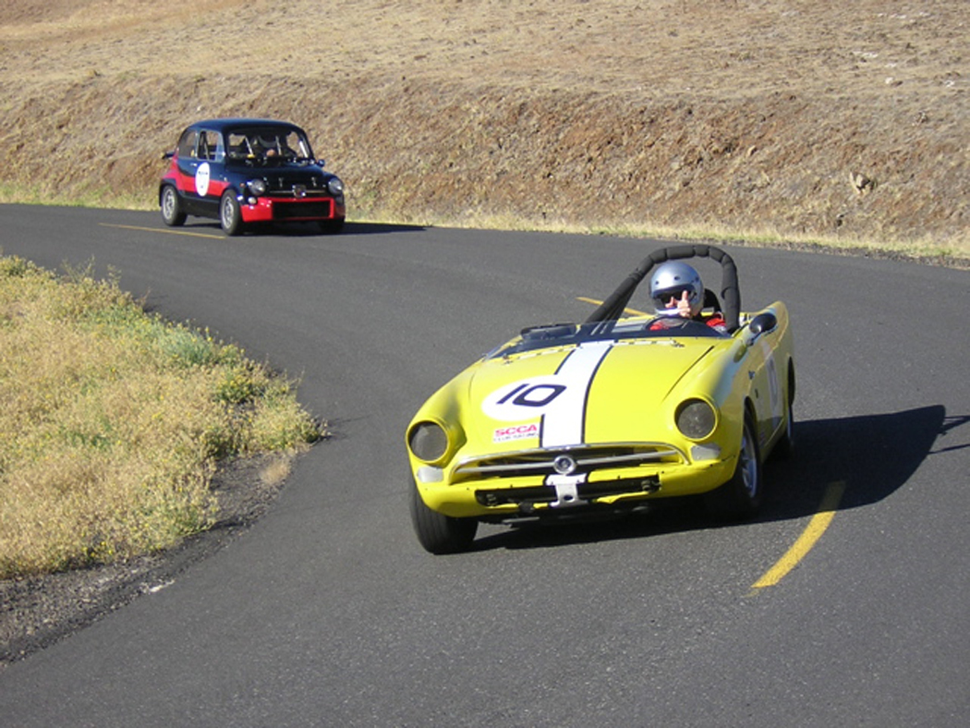

Then on Sunday, we move to the actual hill climb. I have talked about going to this event for years, but somehow there was always something keeping me away. With the Sunbeam involvement, this is the year to attend. We can treat this as sort of a Sunbeam Northwest, since we will have the caravan, a car show, and the competitive event (although most of us will be spectators), parties, etc. So we can have fun, but someone else has done all the work. I am planning on traveling to Goldendale on Friday and depart late afternoon on Sunday, or even Monday if enough people want to stay over. I have already booked my room for Friday and Saturday.

There are limited accommodations in Goldendale. The Quality Inn & Suites (509 773-5881) is where most of the SOVERN racers hang out and sort of party central. There are only 48 rooms and they are already being booked. If you are even thinking of going, I suggest you reserve your room right now. You can always cancel if you decide not to go. If you would rather pitch your tent or take your RV, try Maryhill State Park http://www.parks.wa.gov/parks/?selectedpark=Maryhill. I have talked to others who have camped out for the hill climb and they tell me the park can also be a party central. This is a reservation park, so visit the web site and secure your site. You can always cross the river over to Biggs, but wouldn’t you rather be with the action? So pick up your phone or go on-line and make your reservation. Make plans to join us for what sounds like a fun weekend.

Kevin Jewell

PTC Roster Update:

We haven’t printed a roster since October 2005. Probably time we did so. Budd Bennion is the “keeper” of the roster information. Please update your address, phone number and email address to Budd at 206-364-8478, or budd.bennion@comcast.net. If we have your email address we can also get you an earlier copy of the newsletter. Further we can send you email alerts to upcoming activities. We promise not to spam you or to sell your information. Please update your information today, before the request is forgotten.

PTC Newsletter - by E-Mail?

Do you wish you got your newsletter earlier? Well, we can solve that very easily. If you are willing to receive your newsletter via email, we can probably save at least a week in the time it takes for you to get the newsletter. That week is what it takes us to print the newsletter, collate, and mail. Sound good? Simply confirm with our newsletter editors your current email address to (tiger2@telus.net). Not only will you get the info earlier, but you will help the club control our costs. Don’t forget that if you didn’t get the email reminders about the fall tour organized by Craig Burlingame, that you should also forward your new email address to budd.bennion@comcast.net and kevin&judy@isomedia.com.
Remember that we promise not to spam you, we only want to be sure you get the club notices…Kevin

TIGER’S UNITED XXXII

Sponsored by: STOA (Sunbeam Tiger Owners Association)
When: Thursday June 17, 2010 thru Sunday June 20, 2010
Where: Santa Rosa, CA. (approximately 1 hour north of San Francisco in the heart of the beautiful Sonoma County wine county).
Chairperson: Me - John Stithem and Kelley Keogh-Wife
Event Hotel: Hilton Sonoma Wine Country
3555 Round Barn Blvd., Santa Rosa, CA 95403
707/523-7555 www.winecountryhilton.com
(At this time you must call the hotel directly to obtain the group discount, It is not available with internet booking.
We have the usual events lined up:
Welcome BBQ
Rally: For those of you that have said "I will never do another rally", you will not want to miss this one).
Guest Speakers – outlined below.
Auto-Cross: We tried to get Infineon Raceway but unfortunately they have a NASCAR event that weekend. By the way---if you are driving into the Tigers United event from the east-STAY CLEAR OF INFINEON RACEWAY and HWY 37 (unless you want to test your radiator!!!).
Concours
Event registration forms and schedule of events will be posted on the website soon http://web.me.com/kanejeff
If you have any questions email me at mai65tai@sonic.net
If you would like to volunteer to help out with any of the many parts of TU
XXXII email me (I am putting together lists right now and there are still a
few spots open for volunteers).
Since the restoration of the Hollywood Sport Cars B Production Tiger, we have all been waiting for that special moment when the driver of the #55 Tiger, Jim Adams could be reunited with the Tiger that he helped to make so famous. Well mark your calendars and book your rooms, it’s happening!
Jim is coming to Tigers United XXXII! This is a historic reunion with Jim Adams and the #55 car. The Doane Spencer built 1966 HSC McLaren Mk1 and 1976 Dekon Monza that Jim Adams drove will be there too.
Chris Vandargriff, owner of the Historic Motor Sports Association who played an instrumental role in the rebirth of the #55 car is another honored guest. We have invited several lifetime friends of Mr. Adams to our celebration.
This will be a once in a lifetime opportunity as Jim has not seen any of these cars in 30+ years. Join us at the optional Jim Adams dinner on Saturday night to see a presentation on Hollywood Sport Cars efforts and Jim Adams has agreed to talk about his time in the Tiger.
Registration forms will be posted to the TU XXXII website http://web.me.com/kanejeff this week. (Those planning to trailer their cars will want to get their registration forms in ASAP.) If you have any questions please contact me at mai65tai@sonic.net
John Stithem

ABFM - Bellevue update

Arnie Taub died Friday 2/26/2010 from Mercer (MRSA) disease and complication of his Diabetes. Arnie was the long time one man organizer of the ABFM Bellevue. He loved his cars and all the people he met through his association with automobiles. This year’s ABFM will go on.

I went to the first organizational meeting for the Bellevue ABFM. Things will mostly be the same except there was discussion about small classes, giving out trophies to classes with 1 or 2 cars doesn't really fit the reason of what best in class is about. Better would be a “thanks for showing up.” The organizers are not sure how they will handle small turn outs. One thing was noted that deleting a class will be determined by pre registration sign up. Pre registration even 2 week in advance of any car show really helps the organizers figure out space requirements, vendor locations, where to locate volunteers, even how many “port-a potties” to order. If your class is deleted and you wonder why, ask your self did I pre-register?

Budd Bennion

Next PTC meeting:
Tulip Rallye – April 24th, we will caravan from Quality Inn in south Everett. On I-5 north take exit 186, turn right on 128 St. SE and do the legal U turn at 3rd Ave. SE. Quality Inn is on the right, meet in the east parking lot. Departure 08:15 AM SHARP!!!!!!

Laps From The Past

March 2005: Club meeting is held at the Hydroplane and Race boat Museum. We only had 16 in attendance, but it was a fun venue. Club president Dick Sanders is a rabid hydro fan, so this was natural.

March 2000: The cover photo shows at least 4 Alpine bodies in a storage rack at Smitty’s Shop in San Diego. Photo by Larry Atkisson. In Roger Fletcher’s recap about competition in 1999 he quotes club member Stake Shelby about the Maryhill Hill Climb “If I hadn’t spun on the inside of that corner, I coulda had the fast time of the day”. Let’s plan to be at Maryhill in 2010 to see if Starke can uphold the Tiger’s honor. I believe Roger plans to provide a bit of competition.

Sept/Oct 1995: OK, so whomever was saving the newsletters in the storage box, only saved one from 1995, so that will have to do. The issue is dedicated to the memory of Doane Spencer. Everyone in the Tiger community knows that name. He was quite the speaker at SUNI I, in 1989. The issue reported that Brett Simpson recently purchased the first JAL Tiger (#550001). The issue had a long article about the 65 Mustang vintage race car that was being prepared by Dave Dunn and Tom Bennett (Benn-Dunn Racing). Larry Atkisson and Kevin Jewell helped with the car’s preparation. The car originally used the recently removed, but still running, 289 from Kevin’s Tiger. I still remember Tom driving the car over to my house and all of us taking turns driving it around the “block”. No mufflers, license, lights, but it did have a roll bar, so we could always say “But officer, it has the necessary safety equipment.

Tigers East/Alpines East

Encourages all Rootes Group cars and their owners to participate in its annual United to be held in the Rockland, Maine area on Columbus Day weekend (Oct. 8 – 11, 2010). The event will be held in concert with the Owls Head Transportation Museum (www.ohtm.org) and their annual Foreign Auto Festival & Antique Aeroplane Show. The Samoset Resort (www.samosetresort.com), a luxury resort on the shore of Penobscot Bay, is the guest hotel for the event.

Some of the activities planned for the event include:
Autocross on Saturday
Concours d’Elegance on Sunday for all Tours of OHTM and other local Rootes Group cars Museums
Tiger Authentication (TAC)
Lobster Bake Dinner Cruise
Road Rallye/Tour of local area Parts Room/Hospitality Suite
Technical Sessions Awards Banquet
Sight Seeing Tour(s)

See our web site, www.RootesAmerica.org, for more information. We have been fortunate in obtaining a very favorable room rate at the Samoset ($119/night) that will be honored for a week on either side of the United for those who wish to explore the area more thoroughly. OHTM will contribute two biplane rides for two that will be raffled off to early registrants.

Come and see the beautiful fall colors of Maine and enjoy the company of other Rootes owners.

We need your help! If you know of any Sunbeam Events, please contact your Activities Co-coordinator and we’ll get it in the newsletter.
Want to avoid mail delays? Receive your next issue of the PTC Newsletter emailed to you on-line. Contact us at Tiger2@telus.net with your email address

We want to hear your great stories! Do you have a great story to share? Send us the details with your photos. Let us know!

DO WE HAVE YOUR CURRENT ADDRESS AND EMAIL? HELP US KEEP OUR RECORDS UP TO DATE AND SEND YOUR CHANGES TO BUDD OR THE EDITOR.

Renewing your membership?
Members are asked to observe their renewal dates on each month’s address label. The date indicates when your dues are due to continue receiving the PTC Newsletter. Please send all membership correspondence to Budd at: 14720 30th NE, Seattle, WA. 98155 (206)364-8478 or via email: budd.bennion@comcast.net.
Annual Membership fee $32.00 US/35.00 Foreign for foreign members.
Canadian Funds Payment to PTC
We ask each Canadian member to calculate the current exchange rate into US funds. Example: dues today $35.00USD=38.50 CAD (based on 10% exchange rate)
Make payment payable to Pacific Tiger Club and we will process via our bank. Exchange rates are constantly changing. For assistance you may use the following website: http://www.xe.com
TECH TIP

THE ETHANOL ISSUE

What's the problem, you ask?
The key problem is that ethanol absorbs water from the atmosphere. In fact, fuel with 1 0 percent ethanol absorbs up to 50 times more water than standard gasoline. Older gas tanks found in many classic cars vent to the atmosphere, increasing the likelihood that moisture will be absorbed into the gas tank at a rapid pace.
The end result of water in the fuel is phase separation. The fuel separates into two distinct layers: a thick layer of gasoline mixed with a little ethanol on top, and a thinner layer on the bottom consisting of water mixed with most of the ethanol. And it doesn't take much water for this to happen — phase separation occurs in a gallon of 1 0 percent ethanol blend with just 3.8 teaspoons of water

Fuel Phase Separation Problems

Reduced fuel longevity: A gasoline/ethanol blend absorbs water until it triggers phase separation. The blend has a 90-day product life in a closed tank, but lasts just 30 to 45 days in a vented tank often found in classic cars. With 10 percent ethanol blends, owners are supposed to replace the fuel in vented tanks about once a month by driving or draining, taking into consideration the humidity in the atmosphere and temperatures.
Lower fuel octane: When phase separation occurs, the octane rating of the remaining fuel can drop by as much as three points.
Poor engine performance: The fuel pump could easily pick up a slug of the water/ethanol slum" at the bottom of the tank.
Corrosion and rust: Water in the bottom of the fuel tank and inside the fuel lines will cause corrosion and rust, and the solvent properties of the ethanol will loosen that up, along with bits of sediment and deposits.

Avoiding Ethanol Problems
Run your engine on fresh fuel from a major supplier in a location with lots of traffic.
Add fuel stabilizers when you put gas in your car to lengthen the life span of the fuel.
Buy higher-octane gasoline to be certain your engine gets the minimum octane necessary for good performance.
Keep track of the dates you buy fuel, how much you bought, and how much is in the tank when left sitting for a period of time. Keep a log book for reference.
If you have a closed tank, make sure it is truly closed. Listen for a hiss of air escaping when you
take the gas cap off after driving.
Test your gas tank periodically to see if water is accumulating or phase separation has occurred, treat accordingly.
If you don't have a fuel filter before the carburetor (many British cars only have a screen), consider installing one to catch loosened rust and sediments from the gas tank before it clogs engine components. Moss offers one with a glass bowl for at-a-glance inspection, yet it features a period-correct look (Fuel Pressure Regulator/ Filter #377-435). Check your fuel filter often.
Consider adding a second fuel filter between the tank and the fuel pump to protect the fuel pump from damage from loose debris from the tank (Moss part #377-310).
Keep engine parts well lubricated to counteract the solvent effect of ethanol.
Regularly inspect all fuel system components, seals and connectors from the tank to the carburetor. Ensure there are no leaks and the system is in good shape. BM

Thanks to: Bob Bennion

Profile your car!
We would like to have a profile of your car, even if everyone knows who you are. Please email your profile to Mike & Kathryn. New to the PTC, Let us know the details, as we would like to do a feature article on your car!

Vintage Racing

2010 SOVERN EVENT CALENDAR

All vintage events sponsored by SOVREN. More info for these and other NW vintage events can be found at: http://www.sovren.org/

We want to hear your great stories! Do you have a great story to share? Send us the details with your photos. Let us know!

Want to avoid mail delays? Receive your next issue of the PTC Newsletter emailed to you on-line. Contact us at Tiger2@telus.net with your email address

FOR SALE:

1963 Sunbeam Alpine - $14,500.00 (Clackamas, OR.)
1963 Sunbeam Alpine (English) car. Orange / Sunset Red color with matching aluminum hardtop. Chrome wire wheels and a SS luggage rack make this car a real show stopper. A great runner and touring unit with a 1725, 4 cylinder engine with 32-36 Weber carburetor, 105 amp chrome alternator, 5 blade light gage cooling fan. 4 speed with Overdrive.
Like new steering joints and wheel bearings. New exhaust system, oil cooler and all running gear has less than 10,000 miles since new overhaul. Tires are in good condition and all electrics work, even has an optional back up light. All glass is in very good condition, the Plexiglas in the hard top has some scratches. It has a professional built roll bar mounted into the lower frame. The hard top is removable, and has a like new soft top stored inside. . Serious interest only please! Cash speaks.
Please call for an appointment. I can send a CD with video and photos. 503-698-7549

1966 SUNBEAM TIGER MARK 1A

Serial# B382002277 JAL # 662297
Color Code 86 Current Color – Forest Green
Engine # 7172B19KC (260 Cubic Mostly Stock) TAQ # 0641, Issued May 2007
Description and Features:
Former California Car, previously owned in the Los Angeles area. Original factory hardtop, black. Black leather interior. 15” Panasport wheels with 2 BF Goodrich G-Force Sport 195/50R15 “V” speed tires (Front) 2 BF Goodrich “G-Force Sport 205/50R15 “V” speed tires (Rear) purchased June 2006, less than 1000 miles.

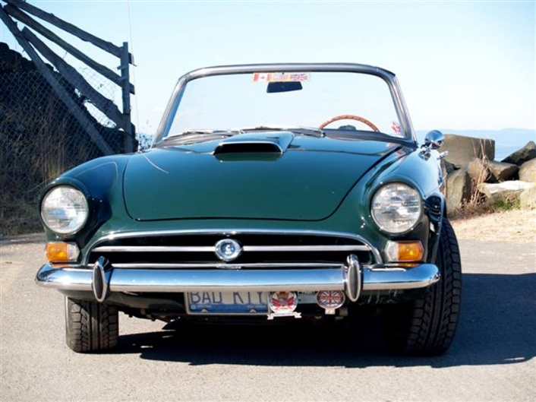

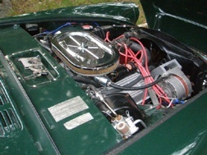

Upgrades and changes made since 2005 purchase:
Top loader transmission rebuilt and gearing changed from close ratio to wide ratio - High volume oil pump - New radiator with 6 bladed fan - Headers and old Edelbrock style medium riser manifold, ceramic coated - New Centre Force clutch and pilot bearing - New Pertronix ignition with 8mm ignition wires - Rebuild of brake servo and install steel braided lines - New remote oil filter assembly with steel braided hoses - Miscellaneous new rubber seal, grommets etc. Work was completed in 2007.

Gas tanks and pipes removed, cleaned and coated, July 2006. 2” exhaust system with Magniflow mufflers installed in 2007. New Carter fuel pump installed, 2007. New wood dash board with cubby door - New cubby box - New wiring harness and cleanup of wiring under hood - Wiring redone to original specs - Cleaning of all gauges including painting of needles - New soft top hardware. Work completed in 2008

ALSO - BIG TEX 70 CAR HAULER

7,000 lb - 2006 Car hauler Model # 70CH-16. Purchase price July 2006 - $3225.00 Cdn. Asking price - $2400 US includes all tie downs and straps.

Asking price for both the car and the trailer (outfitted for the car) $39,500.00US
Tiger purchased without the trailer, asking $38,000US

Contact: Bob Seifert, mbseifert@shaw.ca
Telephone: 1 250 629-3184 Pender Island, B.C.

1967 - Sunbeam Alpine
Soft top , original hard top and cover.
98% Original

Price : $ 5,000.00

Mike Seek 236 W Second St.
Tonasket, Wa. 98855 Phone: (509) 486-1301

Email To : lou6453@yahoo.com

Do you have an interesting tech tip to share with the readers? We are always interested in any submissions.

LAUNCHING LEMAY

Ongoing museum project gets auction boost
The recession has forced the LeMay Museum in Tacoma, Washington, to delay their opening, but they should get a shot in the arm with the first of at least five contracted annual auctions. Bonhams & Butterfields will run the Pacific Northwest Collector Car Auction September 11-12, in conjunction with the Kirkland Concours d'Elegance. "I have great respect for the Bonhams & Butterfields team and have been in conversation with them for a number of years about creating a major auction in the Pacific Northwest," said museum president and CEO David Madeira. The sale will be largely no-reserve, and the majority of the cars will be long-unseen examples from the enormous LeMay Collection, along with a few select consignments. Contact: www.bonhams.com/lemay

Sunbeam Racing:

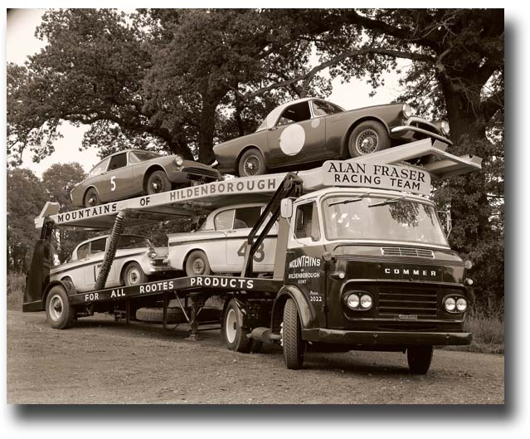

REGALIA

Hats, Hats, Hats… We got ‘em! $15.00 +2.50 for shipping, all have the "Pacific Tiger Club" Logo on the front, some have Tiger or Alpine on the side and some have no added logo on the side. Make all forms of payment to "Pacific Tiger Club" and mail to Budd Bennion, 14720 30th Ave NE, Seattle WA 98155-7512.
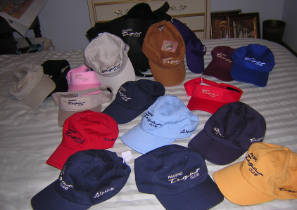

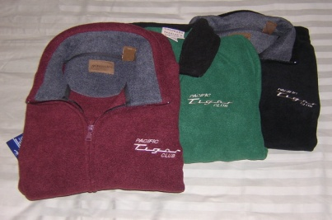
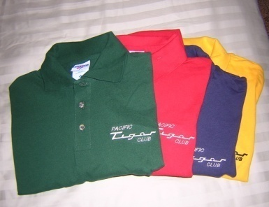

Save postage by picking up regalia at club meeting
Fleece jackets $30 + postage $4
Polo shirts- Lady's = $20 + postage $3
Men’s = $15 + postage $3

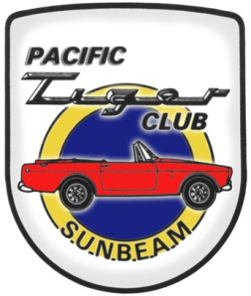
Next Meeting: April 24th
Pacific Tiger Club
12120 – 202nd Ave. SE
Woodinville, WA 98077-5639
425-885-0103
kevinj@olyprecast.com

