

Rootes of the Pacific Northwest

Common Rootes

By the time you receive this issue, the 2010 LeMay open house will be history. I hope that you had the opportunity to see this amazing car collection. There is serious concern that once the museum is open (and construction is under way) the open house will be history. After Harold’s death, his widow, Nancy, has graciously continued the tradition. However, I have heard that the strain of the event is starting to show on her. I can remember attending McLeod’s auctions and seeing Harold buy 5 cars in one day. It was always an eclectic mix of cars, seemingly bought at random.

Our next major event will be participation in the Concours de Maryhill Loops car show on Oct 2 and watching the vintage racers in the hill climb on Sunday. Sunbeam is the featured marque for the weekend event. We have been talking about this event for several months and the momentum is growing. If you are uncommitted, get off the fence, and get your registration and room reservation locked in. It looks like we will have a good group of people attending. We will put together a caravan leaving Seattle on that Friday. I expect we will meet at the XXX drive in Issaquah and we will have more information on departure as the event gets closer. We will take the back roads from Cle Elum to Ellensburg and then the

canyon road into Yakima. We are using attendance at this event as a barometer as to whether we think we can generate enough participation at a Sunbeam Northwest event for 2011. So let’s plan to have fun with our friends at this event. Isn’t this why we all still own these “old” cars?

Club elections are coming up. Do you have the desire to perhaps lead the club in a new direction? Then step up to the plate and run for office. Many of the current officers and chairs have been in place for several years, and some would frankly welcome the opportunity to allow someone else to lead. All social organizations, and certainly any car club is a social organization, need to recruit new blood, or the organization starts to stale. So is this the year that you will offer to help? We appreciate your consideration.

See you on the road….Kevin Jewell

______________________________________

2009-2010 Executive and Officers

President: Kevin Jewell
12120 – 202nd Ave. SE
Woodinville, WA 98077-5639
425-885-0103
kevinj@olyprecast.com

VP/Newsletter Kathryn Fitzgerald/Mike Clark
4723 Woodside Place
West Vancouver, BC V7S 2X5
Tiger2@telus.net

Secretary: Jim Clark
17711 – 10th Ave. NW
Shoreline, WA 98177
206-533-1187
jwclark2@comcast.net

Treasurer: Bob Bennion
37904 Fawn Rd NE.
Hansville, WA 98340
360-638-1992
904star@centurytel.net

Chairpersons

Activities: Larry & Eileen Ingersoll
29206 61st Ave S
Auburn, WA 98001
253-946-0762
Laingersol@aol.com

Membership: Budd Bennion
14720 30th NE
Seattle, WA 98155
206-364-8478
budd.bennion@comcast.net

Historian: Brett Simpson
10005 SE 267th St.
Kent, WA 98031
253-859-5096
brsjal1@comcast.net

2010 EVENTS CALENDAR

Official PTC activities are printed in red. We have listed other possible activities of which you might want to participate. Call a couple of friends and try something new.

PTC Activities: Official PTC activities are printed in red. We have listed other possible activities of which you might want to participate. Call a couple friends of and try something new.

Now Exotics at Redmond Town Center (Desert Fire Restaurant). On nice Saturdays the exotics (mostly Italian, but others also show) mingle starting about 8:30 AM. There is no cost and if you are looking to see some impressive vehicles up close, it is worth a visit.
Sept 12 Kirkland Concours d’Elegance 9 AM- 4 PM. One of the featured judging classes will be “Screamers-Powered by Ford”.
Sept 18-19 Run to the Sea. htpp://abfm.com/. Similar to the long time Run to the Gorge event except that the tour is to the ocean.
Sept 18 Vancouver to Whistler - All British Run.
Oct 1-3 Maryhill Hill Climb. Sunbeam is the featured marque at the car display on Sat. On Sunday we get the chance to cheer for all the Sunbeams racing. Quality Inn 509 773 5881 or camp out. The registration form is elsewhere in the newsletter, I am told that the dinner buffet is a great value, so I would encourage all attending to sign up.
Oct 8-11 Tigers East/Alpines East, Rockland, ME, http://teae.org/.

Dec 5 PTC Christmas party. This year we are changing the format to start at noon. Dave & Anita Dunn will be our hosts. The address is 5906 Mont Blanc Pl. NW, Issaquah.
? Day trip to Leavenworth, and possibly Icicle Creek Winery. Where does this fit in for you?

If you know of other events we should be listing, please contact our activity chairs, Larry & Eileen Ingersoll.

Are you buying, selling or trading? Email us at Tiger2@telus.net

PTC Annual General Meeting Oct 16

Even though it was a significant trip for many, the casual BBQ at Hansville for our AGM was very well received last year. We searched for a place on East side of the pond for this year, but for one reason or another, none of the places we tried worked out.

We then looked at a luncheon at a restaurant, but the guarantees were a bit daunting, and frankly we haven’t great attendance at restaurants recently. So in the interests of keeping the AGM casual, Kevin & Judy Jewell have volunteered to host the AGM at their house on Oct 16, starting at 1 PM. We are looking at some menu ideas, but we expect the club to furnish a main course, with everyone bringing pot luck. The club would also purchase some adult beverages and soft drinks. As is also the norm for the club, we will have oodles of door prizes. There will be more information coming later, but we wanted to be sure to get the date to you so you can plan to attend.
RSVP if you will to help us when ordering a main course and prizes. Reply to Budd or Kevin.
Regards,
Kevin Jewell
_________________________

Maryhill Hill Climb,
Oct 2 & 3, 2010 Let’s Go!

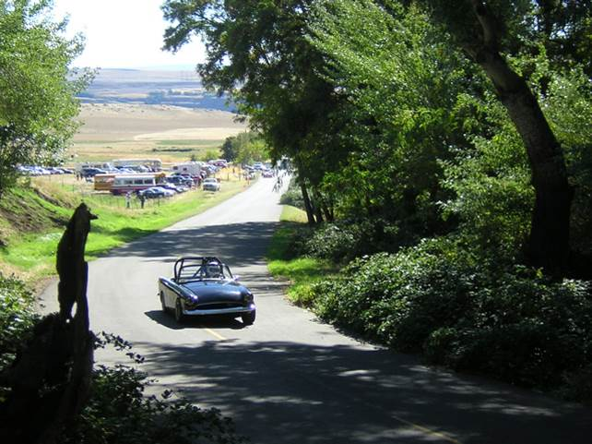

Sunbeam will be the featured marque during the weekend activities at the Maryhill Hill climb during the weekend of Oct 2 & 3. The hill climb is a SOVERN racing event and generally well attended. The formal activities start Saturday with a car show on the Maryhill Museum grounds. Last year, Studebaker was the featured marque and there were 18 Studebakers among all the cars on display. Certainly, we should be able to do better than 18. You might remember that Maryhill is the home of the replica Stonehenge.

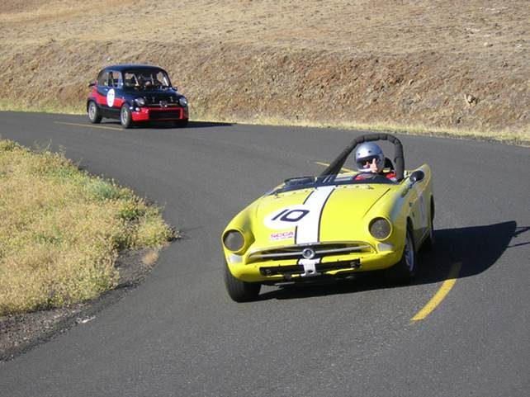

Sunday, we move to the actual hill climb. With the Sunbeam involvement, this is the year to attend. We can treat this as sort of a Sunbeam Northwest, since we will have the caravan, a car show, and the competitive event (although most of us will be spectators), parties, etc. So we can have fun, but someone else has done all the work. I am planning on traveling to Goldendale on Friday and depart late afternoon on Sunday, or even Monday if enough people want to stay over.

There are limited accommodations in Goldendale. The Quality Inn & Suites (509 773-5881) is where most of the SOVERN racers hang out and sort of party central. There are only 48 rooms and they are already being booked. If you are even thinking of going, I suggest you reserve your room right now. You can always cancel if you decide not to go. If you would rather pitch your tent or take your RV, try Maryhill State Park http://www.parks.wa.gov/parks/?selectedpark=Maryhill. I have talked to others who have camped out for the hill climb and they tell me the park can also be a party central. This is a reservation park, so visit the web site and secure your site. You can always cross the river over to Biggs, but wouldn’t you rather be with the action? So pick up your phone or go on-line and make your reservation. Make plans to join us for what sounds like a fun weekend.

Kevin Jewell

Editor’s note: Below you will find some additional information regarding the Maryhill event weekend – looks like fun.

Maryhill Loops Hill Climb, 9 a.m. to 5 p.m., Sunday, October 3
Vintage sports cars from the 1930s to 1960s race singly in a three-mile timed race up the historic Maryhill Loops Road. Spectators can view the hill climb race from the Highway 97 Overlook and from designated viewpoints along the race route. Organized by the Society of Vintage Racing Enthusiasts of Seattle; only their approved cars and drivers will be competing. Should be fun! 25 curves and 8 hairpin turns!

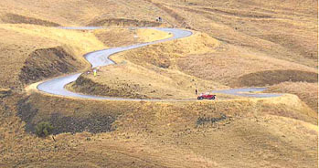

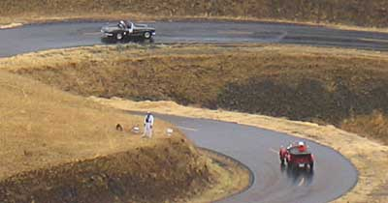

Saturday October 02, the road is open to the public for a spin from Noon to 2 PM.

Concours de Maryhill, 10 a.m. to 4 p.m., Saturday, October 2
The museum’s east lawn is transformed into the Concours de Maryhill with dozens of classic, sport and customized cars on view, competing for prizes such as best original, classic, hot rod and muscle car. This is an open car show and anyone with a special car may enter. The day concludes with the presentation of the car show awards. Organized by the Goldendale Motorsports Association. www.maryhillmuseum.org/2010_1002a.html

LeMay Open House

On 8/28/10, the day dawned cold, but at least dry with a reasonable forecast. Four Sunbeams headed for the LeMay open house. Joining Kevin & Judy were Larry & Eileen Ingersoll, Bob Bennion, and Ed Erikson. The two facilities are so large and the number of people so great that it is tough to find anyone at the event. However, we did run into Brett Simpson, Dave & Anita Dunn and Dick Sanders. There were probably others there, we just didn’t see them. This is the first year that I can remember that they actually had reserved parking for the various clubs. We hadn’t called ahead, but they found someplace in the corner to put the four of us. By the time we left at about 1 PM, I would guess that less than half the reserved spaces had cars, in fact entire car clubs were absent, so it will be interesting if they do this next year. Also finding us in the corral area were prospective club members Gerry & Kathleen Loeffler. If you have attended the vintage races in the last couple of years, you must have seen their dark blue #94 Tiger race car.

Was it worth the trip? Absolutely, every time I attend I see something new. There were beautifully restored Duesenberg’s and Cadillac’s, including a V16. There is whole room of Chrysler 300 letter cars, including an F & G with the long cross ram manifold. Judy, Larry & Eileen were all probably bored to tears as I explained how Chrysler sold a slower car with these manifolds because the typical Chrysler buyer felt the higher torque (of this type manifold) and thus thought it must be faster than a more normal dual quad manifold. However, the volunteer working that room heard me talking and came over to listen, which then generated another 10 minutes of conversation. I certainly hope that he didn’t get embarrassed by any of my “facts” with the Chrysler owners coming thru later. Of course there was a Tucker, nice C1 & C2 Corvettes and several Shelby’s. For the English crowd there were Healey’s, Mini’s, Austin’s, Bentley’s Morris’s, Metropolitan’s, Humber’s, and we saw at least one Alpine in the third level new storage rack in one of the buildings. If you like Chevy’s of the 50-65 vintage, there were dozens. Similar displays of Buicks, Dodges, and Packards. Sprinkle in a few race cars, from a small Crosley speed record car to a 90’s Indy car. Like bikes? There was another room of motorcycles and on the lawn a huge display of bicycles. Also on the lawn another display of tear drop trailers including one made of wood with two accompanying wood boats that wood (OK, pretty bad) be the envy of any wood builder. In other words, there is something for everyone at LeMay, and you owe it to yourself to see it before it no longer exists in its present form…Kevin

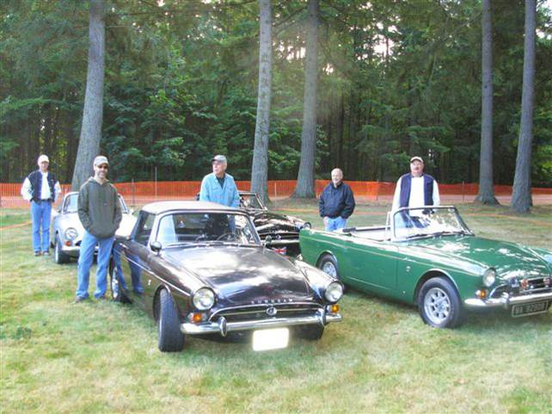

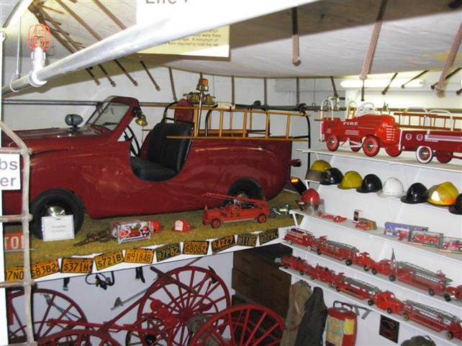

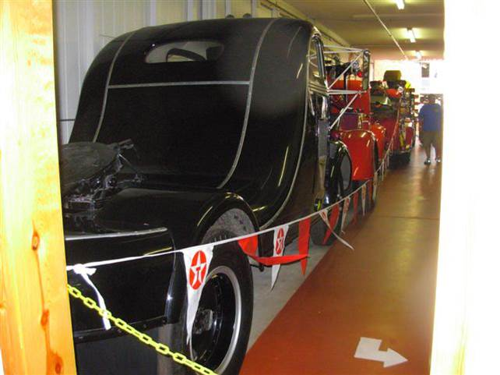

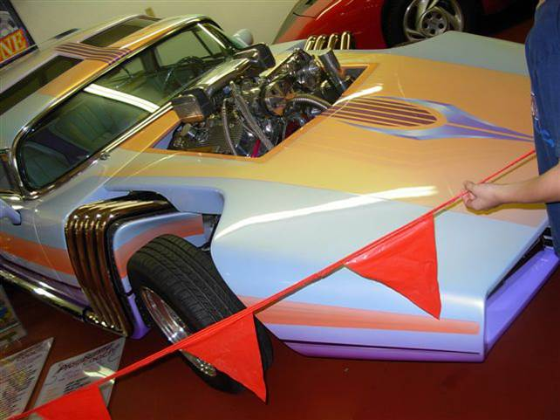

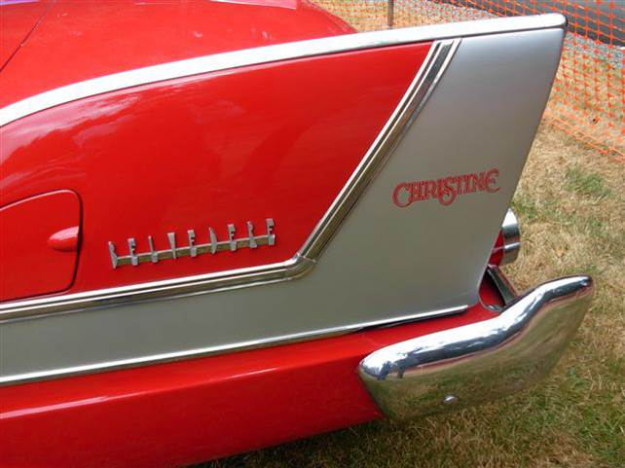

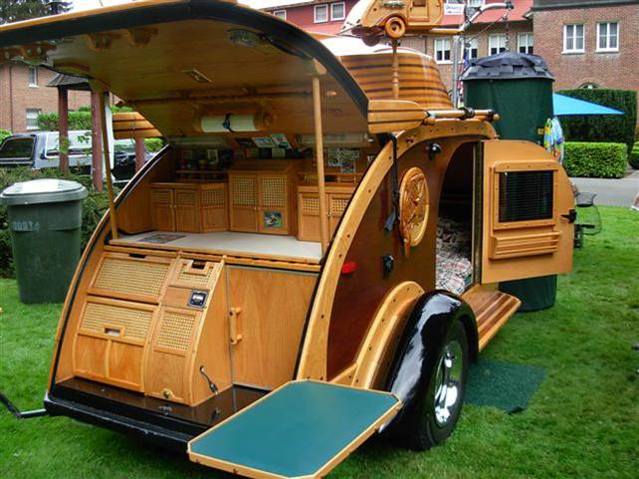

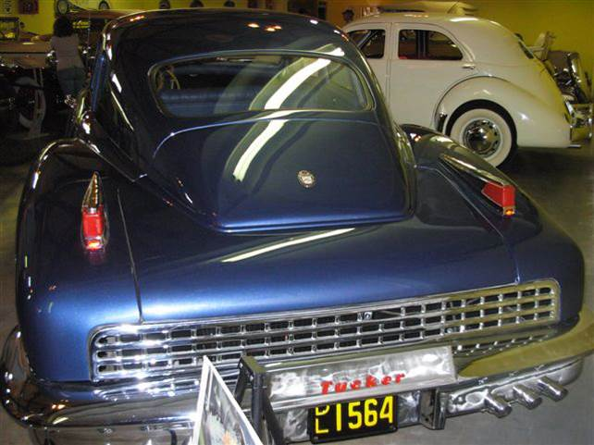

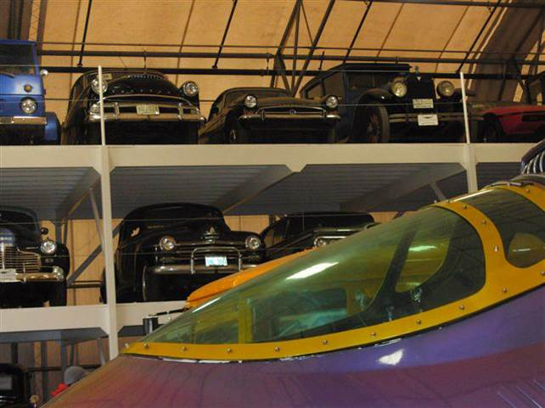

Thanks to: Kevin & Judy Jewell & Bob Bennion
______________________________________

PTC Roster Update:

We haven’t printed a roster since October 2005. Probably time we did so. Budd Bennion is the “keeper” of the roster information. Please update your address, phone number and email address to Budd at 206-364-8478, or budd.bennion@comcast.net. If we have your email address we can also get you an earlier copy of the newsletter. Further we can send you email alerts to upcoming activities. We promise not to spam you or to sell your information. Please update your information today, before the request is forgotten.

PTC Newsletter - by E-Mail?

Do you wish you got your newsletter earlier? Well, we can solve that very easily. If you are willing to receive your newsletter via email, we can probably save at least a week in the time it takes for you to get the newsletter. That week is what it takes us to print the newsletter, collate, and mail. Sound good? Simply confirm with our newsletter editors your current email address to: (tiger2@telus.net). Not only will you get the info earlier, but you will help the club control our costs. Don’t forget that if you didn’t get the email reminders about the fall tour organized by Craig Burlingame, that you should also forward your new email address to budd.bennion@comcast.net and kevin&judy@isomedia.com.
Remember that we promise not to spam you.

Laps From The Past

Aug, 1992: Brian Doan submits an article about Sunbeams at an SIR open track. Brett Simpson, Jim Leach, Dick Sanders, Brent Edinger and Brian all drove Sunbeams and Kevin Jewell had his supercharged Mustang. Brian reported that he drove 65 miles on the track which is about 30 laps.

Aug, 1997: Editor reports that she will be on her honeymoon during the last week of August, so there will be no September issue. Staying with our SIR theme the issue reported on the July vintage races. Tom Bennett was there with his 65 Mustang, and John Brosius, Starke Shelby, Doug Yip, and Al Denson all competed with their Tigers.

Aug, 2000: Cover photo show Starke Shelby leading a Corvette thru turn 7 at SIR. Do you detect a theme here? The August club meeting was held at the Sunbeams & Salmon event at Rodger Flescher’s home in Bellingham. Rodger has been inviting club members to the event for many years.

Aug, 2003: There were 22 Rootes cars at the Bellevue ABFM. Kevin and Judy Jewell host a BBQ at their home after the event. Hollie Sanders wows us with her Tiger earrings.

Thanks to: Kevin

“Road Trip” (sort of) to The UK SAOC National in England
Rob Carpenter

I became a member of the UK Sunbeam Alpine Owner’s Club (SAOC) shortly after purchasing my current Alpine in 1996. I have wanted to attend one of their events in the UK for a long time. The SAOC scheduled its 33rd Annual National meeting this year in Somerset and I decided it was time to go. Living for a year in Spain has had its benefits and one was the short distance to travel to the UK compared to coming from the USA. I took a bus to Málaga where I caught a plane to Bristol and from there the train to Castle Cary. At last I took a taxi to my bed and breakfast at the Catash Inn, North Cadbury, and Somerset.

The National site was the Haynes Motor Museum in Sparkford, Somerset. The Haynes Motor Museum is sponsored by Haynes Book Publishing which is, of
course, the source of all the Haynes repair manuals you are familiar with.

I thought I would enjoy the two mile hike from my rural B&B to the site but it was more of a challenge than I expected. I had a choice between walking much of the way along a freeway or on a curvy two lane road with no shoulders. I liked neither so I tried to shortcut across the fields on one of England’s famed “public paths”. Fair Warning: if you travel to England and you are ever tempted to take a shortcut on a “public path” - Don’t.

After an arrival day and BBQ on Friday the major events took place on Saturday. Here is the Saturday Schedule:
8:30 – 10:30 Track available – only Alpines - one car at a time. 4 laps
9:00 – 10:00 Breakfasts (Museum Café)
10:30 for 11:00 Concours (Track Area)
10:30 – 12:00 Children’s Activities (Marquee)
11:00 – 3:00 Driving Tests (Track Area)
3:45 Prize giving (Track Area/Marquee if wet)
4:30 Charity Auction (Marquee)
7:00 for 7:30 Dinner (Merlin Suite
8:30 – 11:30 Dancing with the Dart Valley Stompers (Merlin Suite)

I was naturally very interested in seeing the track action so I watched for a couple hours wishing my Alpine was not 6,000 or so miles away. This was not a timed event. Each car took the course as the driver chose. In some cases the car was full including children the “occasional seat” and the drive was sedate. Other [always male] drivers were alone and tried to wind it up a bit on the straight only to brake hard for a 90 degree right curve. The course began with a straight leading to a gradual right curve leading to the opposite straight, which featured an optional chicane. The 90 degree right curve at the end of the second straight led to either a gradual curve to the starting point or a 145 right turn to a short left hand loop that returned the driver to the turn at the end of the second straight but going the opposite direction, obviously an option not available if other cars were on the track. From there a left turn led to a lane across the midfield to return the driver to the first straight at about the midpoint. Only one driver made full use of all these optional routes.

I have a personal web site with a blog entry containing a three minute video features several cars using the track including one driver, a German driving a white Series II, who is seen doing all the above described alternate turns. You will also see a Balmoral Grey 1965 Sunbeam Alpine Series IV GT with a rare automatic transmission. This is a real “owned by a little old lady and stored in her garage for decades” car. This car had 9893 original miles and won Best of Show. Balmoral Grey was only offered on the Series IV.

After the track time the field was opened to all cars for Concours judging and open show. Nineteen cars entered the Concours. On a nearby part of the track infield the remaining cars lined up for display. I counted 65 Alpines plus one Tiger. A couple more Rootes cars remained in the camping and parking areas including several Hillmans, Rapiers and several Alpines.

The final dinner was in a private suite at the Museum and featured the jazz music of the Dart Valley Stompers. On my blog you can click on a photo to hear “Bourbon Street Parade.” On Sunday morning the SAOC AGM was scheduled followed by a tour to tea by the sea. I had to catch a plane that afternoon so I did not try to hitch a ride, maybe next time. My train back to Bristol passed through historic Bath so I took a couple hour walk through the tourist filled town. I will certainly want to return to Somerset with Beryl and spend sometime in the area. I might even rent a car and try driving on the left. Well, maybe not.

Our personal web site is: http://web.me.com/robertcarpenter/CarpenterFamily/Welcome.html
Click on “Our Blog” on the upper right corner of the Welcome Page.
The SAOC National is described on the Blog entry dated July 31, 2010.
______________________________________

Roger’s BBQ

I went to Bellingham yesterday to Roger and Ann's Pot luck. It was a beautiful day for a drive. There was a large group; PTC members in attendance were Brett and Denise Simpson, Jim Clark, Earl and Marga Baird (non- members), Stark and Jane Shelby and myself. The only old cars that showed up was one Hillman Husky and one '32 Ford hot rod and of course Roger had his Tiger parked out front.
There were, maybe 20 other cars parked at on and around Rogers house. There was good food and lots of talking…Budd Bennion

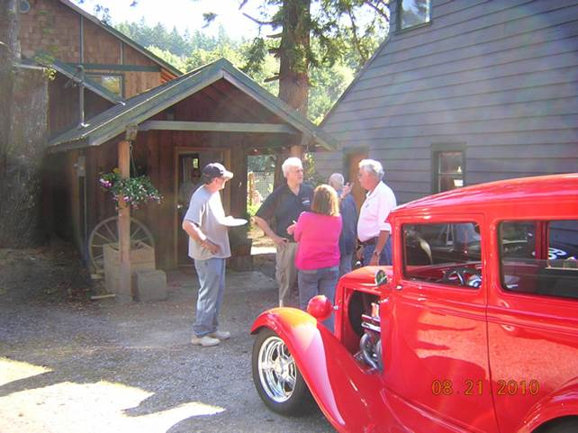

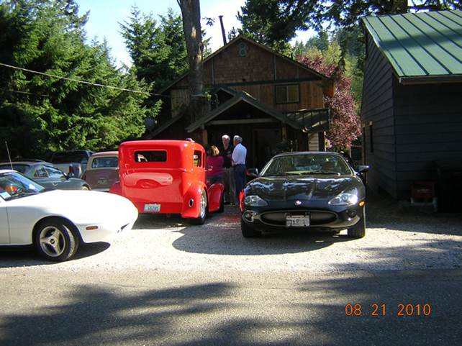

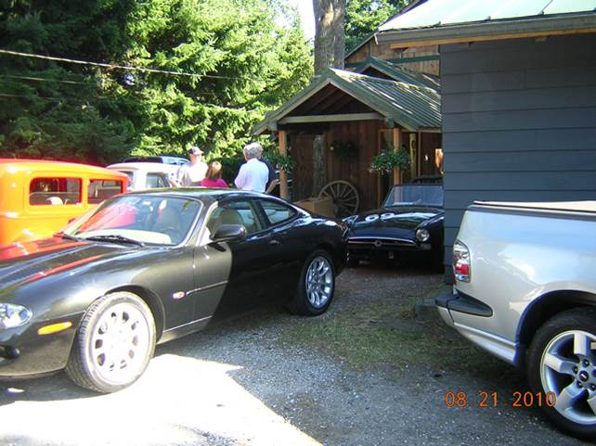

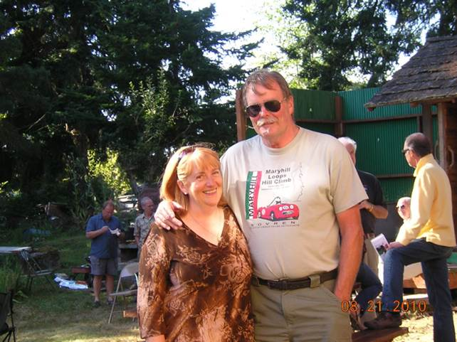

Tigers East/Alpines East

We encourage all Rootes Group cars and their owners to participate in its annual United to be held in the Rockland, Maine area on Columbus Day weekend (Oct. 8 – 11, 2010). The event will be held in concert with the Owls Head Transportation Museum (www.ohtm.org) and their annual Foreign Auto Festival & Antique Aeroplane Show. The Samoset Resort (www.samosetresort.com), a luxury resort on the shore of Penobscot Bay, is the guest hotel for the event.

Some of the activities planned for the event include:
Autocross on Saturday
Concours d’Elegance on Sunday for all Tours of OHTM and other local Rootes Group cars Museums
Tiger Authentication (TAC)
Lobster Bake Dinner Cruise
Road Rallye/Tour of local area Parts Room/Hospitality Suite
Technical Sessions Awards Banquet
Sight Seeing Tour(s)

See our web site, www.RootesAmerica.org, for more information. We have been fortunate in obtaining a very favorable room rate at the Samoset ($119/night) that will be honored for a week on either side of the United for those who wish to explore the area more thoroughly. OHTM will contribute two biplane rides for two that will be raffled off to early registrants.

Come and see the beautiful fall colors of Maine and enjoy the company of other Rootes owners.

We need your help! If you know of any Sunbeam Events, please contact your Activities Co-coordinator and we’ll get it in the newsletter.

Want to avoid mail delays? Receive your next issue of the PTC Newsletter emailed to you on-line. Contact us at Tiger2@telus.net with your email address

We want to hear your great stories! Do you have a great story to share? Send us the details with your photos. Let us know!

DO WE HAVE YOUR CURRENT ADDRESS AND EMAIL? HELP US KEEP OUR RECORDS UP TO DATE AND SEND YOUR CHANGES TO BUDD OR THE EDITOR.

Profile your car!
We would like to have a profile of your car, even if everyone knows who you are. Please email your profile to Mike & Kathryn. New to the PTC, Let us know the details, as we would like to do a feature article on your car!

Renewing your membership?
Members are asked to observe their renewal dates on each month’s address label. The date indicates when your dues are due to continue receiving the PTC Newsletter. Please send all membership correspondence to Budd at: 14720 30th NE, Seattle, WA. 98155 (206)364-8478 or via email: budd.bennion@comcast.net.
Annual Membership fee $32.00 US/35.00 Foreign for foreign members.
Canadian Funds Payment to PTC
We ask each Canadian member to calculate the current exchange rate into US funds. Example: dues today $35.00USD=38.50 CAD (based on 10% exchange rate)
Make payment payable to Pacific Tiger Club and we will process via our bank. Exchange rates are constantly changing. For assistance you may use the following website: http://www.xe.com

TECH TIP

Brake Fluid Tech
Fluid Basics:
Brake fluids are all synthetic chemicals and are NOT petroleum based. The DOT class system sets standards and testing procedures only; the ingredients used are up to the manufacturer. If it meets the standards, it will qualify as “brake fluid.” Based on a combination of the properties determined by testing, glycol based brake fluids are labeled DOT 4 or 5.1. Then there’s DOT 5 fluid, which by weight contains 70 percent diograno polysiloxane – which we call silicone. Only silicone based fluids met the DOT 5 standards when they were created. As a result, DOT 5 has come to be synonymous with silicone brake fluid.
When glycol brake fluids with vorate esters appeared, that met DOT 5 specifications; they introduced them as DOT 5.1 to avoid the confusion of having fluids with two very different bases under the same DOT number. Unfortunately, for many people, the 5.1 implies some connection to DOT 5 and that has created confusion rather than prevented it. Think of 5.1 as glycol based DOT 4 fluid that meets DOT 5 standards. The 5.1 fluids are used primarily in vehicles equipped with ABS brake systems. DOT 3, 4 & 5.1 fluids are all hygroscopic, meaning they will absorb water out of the atmosphere. This will lower the boiling point of the fluid. In addition to lowering the boiling point, the water in the system will corrode the metal components if given enough time. All brake fluids have corrosion inhibitors, but these break down and become less effective over time. Glycol fluids must be completely drained and replaced every 18 to 24 months, regardless of how much you drive your car. A small word of caution; Glycol fluids will strip the paint off the car if they are spilled or if you have a leak.
Silicon Solution?
Unlike glycol based fluids, silicone brake fluid will not absorb water from the atmosphere or act like a paint remover. Silicone has very high dry and wet boiling points. However, it is more compressible because it will absorb more air than a glycol based fluid. The air is in solution and should not be confused with air bubbles. The dissolved air gives a slightly spongy pedal feel which most people cannot detect. A poor choice for racing, but it is considered an appropriate choice for a classic car that is not driven daily. Bleeding systems with silicone takes more time and may have to be repeated because it takes time for the air to work its way out.

Thanks to: Bob Bennion

______________________________________
Vintage Racing

2010 SOVREN EVENT CALENDAR

All vintage events sponsored by SOVREN. More info for these and other NW vintage events can be found at: http://www.sovren.org/

We want to hear your great stories! Do you have a great story to share? Send us the details with your photos. Let us know!

Want to avoid mail delays? Receive your next issue of the PTC Newsletter emailed to you on-line. Contact us at Tiger2@telus.net with your email address

FOR SALE:

1967 - Sunbeam Alpine
Soft top, original hard top and cover.
98% Original

Price: $ 5,000.00

Mike Seek 236 W Second St.
Tonasket, Wa. 98855 Phone: (509) 486-1301

Email To: lou6453@yahoo.com

WANTED

- I am looking for a Tiger to buy. I would prefer a good driver with the thought of restoring it in the future. I would also consider a relatively rust free car that is in need of restoration. If you happen to know anyone that would want to trade a Tiger for a Series I E-Type coupe that is rust free but in need of restoration, I would consider that as well.

Don Joy
Yakima, WA
britcar1@msn.com

- “Looking for Sunbeam Alpine/Tiger hardtop for a Tiger Mark 1a.
Please call Josie at 250 613-0065.”

- Hi my name is Eric Schlichte. I am currently looking for a series 2 radiator and a fan to help make my alpines more competitive in vintage racing, (sovren). Also, I would like to pick up a couple other parts for spares, starter solenoid and zenith wip carb parts. Please call or e-mail me ericsnotsocool@comcast.net or 425-235-6656, I have a few parts that I can trade, just ask.
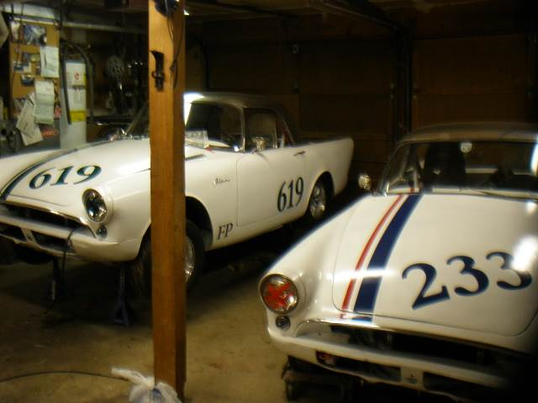

Do you have an interesting tech tip to share with the readers? We are always interested in any submissions.

More pics of Lemay

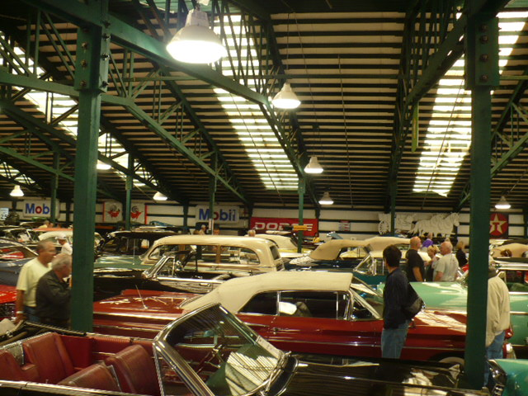

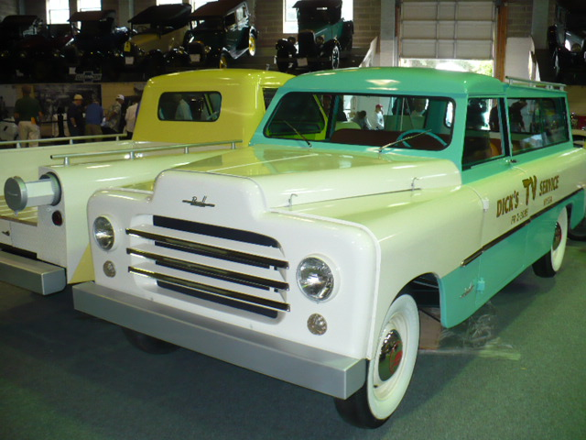

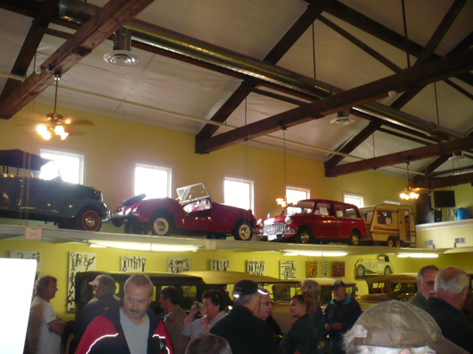
REGALIA

Hats, Hats, Hats… We got ‘em! $15.00 +2.50 for shipping, all have the "Pacific Tiger Club" Logo on the front, some have Tiger or Alpine on the side and some have no added logo on the side. Make all forms of payment to "Pacific Tiger Club" and mail to Budd Bennion, 14720 30th Ave NE, Seattle WA 98155-7512.
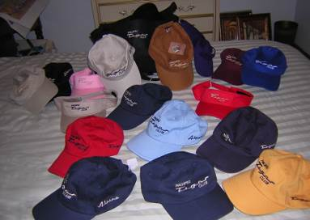

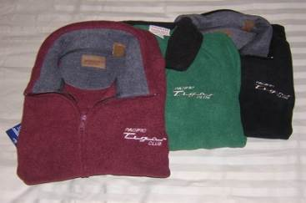
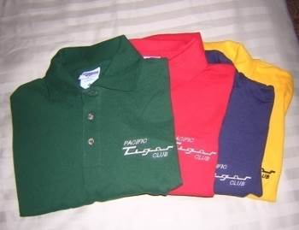

Save postage by picking up regalia at club meeting
Fleece jackets $30 + postage $4
Polo shirts- Lady's = $20 + postage $3
Men’s = $15 + postage $3



Pacific Tiger Club
12120 – 202nd Ave. SE
Woodinville, WA 98077-5639
425-885-0103
kevinj@olyprecast.com



