

Rootes of the Pacific Northwest

In this issue:
President’s report… page 1
Calendar of Events… page 3
Next PTC Meeting… page 10
Tech Tip… page 11

President’s Report

I would like to thank Bill & Diane Kane for hosting the July meeting at their home in Belfair and David & Gale Wright for hosting the August meeting at their home in Bellingham.

The next meeting will be September 19th the AGM—BBQ—Potluck to be held at the Driftwood Key Clubhouse, 37608 Vista Key Dr. NE Hansville, WA (2 properties north our place) from 1:00 – 4:00pm. PTC will provide hamburgers, hotdogs, the fixings, paper plates, etc. Please bring a salad or desert. RSVP to Budd Bennion by September 8th so that we can buy groceries. Call or e-mail Budd: 206-364-8478 or budd.bennion@comcast.net; there is plenty of safe parking---so weather permitting, drive your Sunbeam. Also, weather permitting; a walk on the beach may appeal to you.

All officers have agreed to resume their positions for another term, with the exception of president. Kevin Jewell has stepped forward and, unless contested, will be the next PTC president. The newsletter staff: Bob & Nancy Bennion and Linda & I, will continue to pick up the newsletter from the printer in Poulsbo, assemble & mail out the hard copy.

I want to remind all of you that many PTC members have opened up their homes to host our monthly club meetings. Some of the meetings have been well attended ----and others not so well attended. I’m disappointed in the not so well attended meetings. I realize that we are all busy these days---but when club members open their homes to host a PTC meeting, it usually involves a lot of work, providing and preparing food and refreshments, etc. It puzzles me as to why many of you do not turn out. It is your participation that drives the club. If you have any ideas or suggestions on how we can light a spark under those who are not turning out ---please let one of the officers know, or perhaps write to the newsletter editors with your thoughts. Remember, the Club is what you make it---it can’t survive on its own. PTC needs its members to be proactive.

It is with sadness that I must tell you that Maureen Bohrer, longtime PTC member passed away August 3, 2009. She will be missed. Our sympathies go out to her husband Bud and her family.

See you at the AGM/BBQ/Potluck September 19th. If you need further info: contact Budd, Bob or me.

Larry

Secretary’s Report

An Informal meeting on the 8th of August 2009 was held at Dave and Gale Wright’s home.

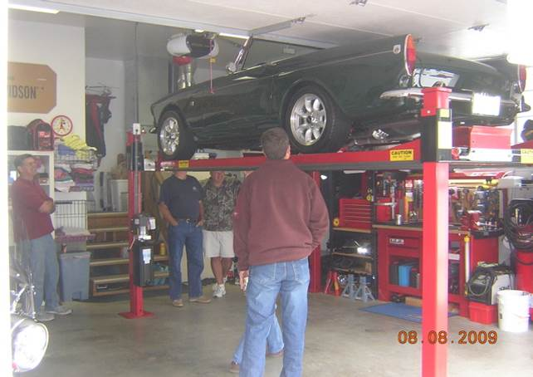

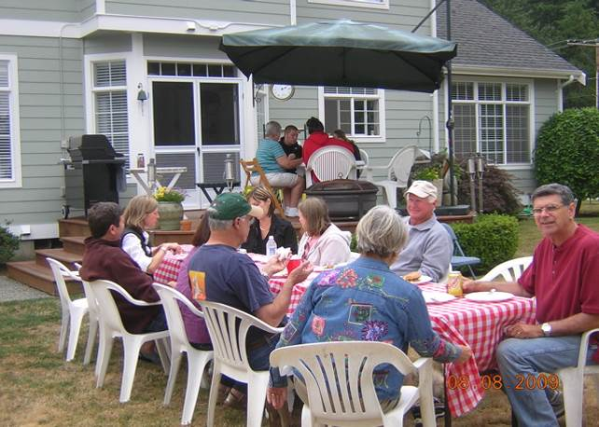

Meeting called to order by Larry Atkisson

Members present were: Larry/Linda Atkisson, Earle/Marga Baird, Jim/Vicki Clark, Dave/Gale Wright, Dave/Anita Dunn, and Budd Bennion.

Old Business: none

New business:
Larry Atkisson announced that Kevin Jewel has stepped up and volunteered to be our new club president. The actual changing over to new officers occurs at the AGM meeting.
The AGM meeting is scheduled for the 19th of September 2009, and will be a potluck. However the club will provide burgers and buns and hot dogs. The rest of the previous year’s officers will remain the same.

There was discussion about who would like to receive the emailed newsletter. Some members did not receive a newsletter, so Budd has put together a list of people who would like to receive the emailed newsletter. Let him know if you don’t get the newsletter you want.
To improve attendance at the monthly meetings, the club decided-some time ago-to email the newsletter. However, monthly attendance is still low.
While it is much cheaper to email a newsletter, some people still like the paper copy. If the paper copy becomes too expensive, one way to help pay for it, might be to lower the club dues a certain amount to those who want just the emailed newsletter. Or, the club could raise dues a token amount to cover costs. Having the newsletter on line was suggested. Another suggestion was to have the newsletter on our website and all club members would know the password to access the newsletter. Members knew of several other car clubs that use the password/access format on their website.
This discussion was tabled. No special committee was appointed.

We also need some volunteers to hold club meetings for the months of October, November, December, and a Christmas get together.

Meeting was adjourned

Jim C

2008-2009 Executive and Officers

President: Larry Atkisson
37624 Vista Key Drive NE
Hansville, Wa 98340
360-638-1998
catkisson@aol.com

VP/Newsletter Kathryn Fitzgerald/Mike Clark
4723 Woodside Place
West Vancouver, BC V7S 2X5
Tiger2@telus.net

Secretary: Jim Clark
17711 – 10th Ave. NW
Shoreline, WA 98177
206-533-1187
jwclark2@comcast.net

Treasurer: Bob Bennion
37904 Fawn Rd NE.
Hansville, WA 98340
360-638-1992
904star@centurytell.net

Chairpersons

Activities: Larry & Eileen Ingersoll
29206 61st Ave S
Auburn, WA 98001
253-946-0762
Laingersol@aol.com

Membership: Budd Bennion
14720 30th NE
Seattle, WA 98155
206-364-8478
budd.bennion@comcast.net

Historian: Brett Simpson
10005 SE 267th St.
Kent, WA 98031
253-859-5096
brsjal1@comcast.net

CALENDAR OF EVENTS

August 2009
Sun | Mon | Tues | Wed | Thurs | Fri | Sat  1  Hillm Holdy
2  Hillm Hldy | 3 | 4 | 5 | 6 | 7 | 8  PTC Mtg
9 | 10 | 11 | 12 | 13 | 14 | 15  LaCnr Classic  Show
16 | 17 | 18 | 19 | 20 | 21 | 22
23 | 24 | 25 | 26 | 27 | 28 | 29
30 | 31

Sept 2009
Sun | Mon | Tues  1 | Wed  2 | Thurs  3 | Fri  4 | Sat  5
6 | 7 | 8 | 9 | 10 | 11 | 12
13 | 14 | 15 | 16 | 17 | 18 | 19  PTC AGM
20 | 21 | 22 | 23 | 24 | 25 | 26
27 | 28 | 29 | 30

Oct 2009
Sun | Mon | Tues | Wed | Thurs  1 | Fri  2 | Sat  3
4 | 5 | 6 | 7 | 8 | 9 | 10
11 | 12 | 13 | 14 | 15 | 16 | 17
18 | 19 | 20 | 21 | 22 | 23 | 24
25 | 26 | 27 | 28 | 29 | 30 | 31

TIGERR makes SUNI V Road Trip

Over Snoqualmie Pass to Cle Elum - from there secondary roads only - son Bill was driving outside of Spokane - a little rain and got real dark. With the Lucas head lights on (dim or dimmer), suddenly Bill says DEER! He collided with the side of the car, knocks off the mirror, bangs into the windshield and catches the door handle causing a dent there. Never saw the deer or mirror again, 362 miles today.

Day 2 off to Great Falls MT. 453 miles today. Saw a brown bear along the road. Outside of Billings I missed a turnoff, hit the brakes and the left headlight ring kept going! Luckily I did not run over it; just got a little bent and dinged the paint. It starts to rain a little, and the windshield wiper decided to come off, but Bill reached out a snatched it off the windshield before it exited forever. East from here, man, this is some open country. You can see for 15 miles in all directions and not a house, cow, horse, or windmill. WOW! Never saw so many antelope grazing along the road. Our overnight stop was to be in south-eastern Montana, but just because the name of the town is in bold writing on the map does not mean it has a motel. So on to Belle Fourche, SD (pop 4757), 397 miles today. Monday arrived in Rapid City to check in and head over to the concourse.

Son Bill caught a flight out on Wednesday and brother Budd arrives to takes his place and readies for the trip home. Trip to the Badlands and Wall, SD and it was 100 degrees; the old Tigerr was just under 200 degrees. I lost a Carroll Shelby Industries hubcap somewhere. Great, I knew I should have removed them. Something is noisy as we arrive back at the hotel. The license plate fell off when we stopped. Air pressure had kept it in place.

We head for home out of Rapid City, to Cody, WY for our first stop, 415 mi today. Next to Yellowstone Park and Old Faithful., buffalo on the road slow us up. Boy, 8000 ft. elevation and a carburetor sure make a difference! Gasp. Across southern Idaho one stretch was 16 miles straight as a string, on into Boise, 530 miles today. Somewhere in eastern Oregon a Crow is trying to pick up my blue grille center badge medallion. Next wound our way north to Goldendale, WA and west to Yakima, WA, 510 miles today. Over White Pass headed home today. Going down the pass and would you believe after 3000+ miles, I get pulled over, 55 in a 50 zone. Actually he wanted to see the car. Whew, we talked Tigers and he sent me on my way. Headed to Hansville, had to do 36 miles of I-5 Freeway. Total trip mileage was 3699 miles as close as I can correct my speedometer. Great trip, boy did we see lots of country, top down almost the entire trip. Collected a few bugs on the license plate.

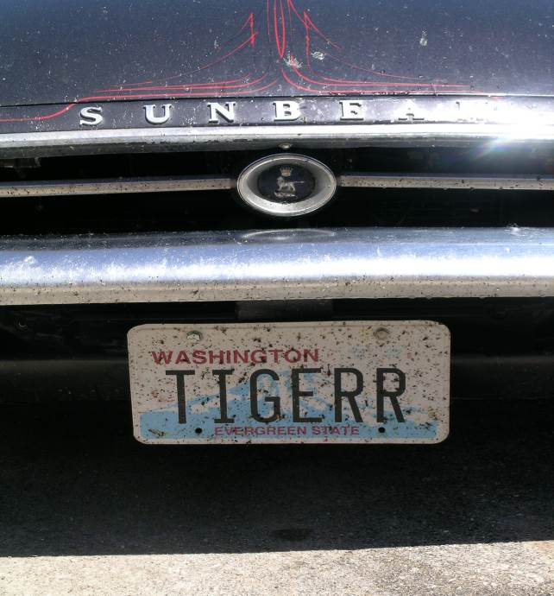

Now just to reassemble the car a little “bondo” and paint and next time an airplane ticket.

Bob Bennion

SUNI RESULTS & PHOTOS:

AUTO X
Top Time: David Boyd (No actual times were reported at the time.)
Women Alpine: Jane Alcala Day1
Rosemary Smith Day2
Tiger: Claudia Tripple Day1&2
Men Alpine: Steve Alcala Day1&2
Tiger: Dave Boyd Day1&2
Alpine Women, Stock:
1st Jane Alcala
Personalized
1st Michelle Babb
Tiger Women, Stock:
1st Claudia Tripple
Alpine Men, Stock:
1st Steven Alcala
2nd Rex Funk
Personalized:
1st Brad Babb
Modified:
1st Larry Young
Tiger Men, Stock:
1st Class (Elvis) Jones
2nd Bill Rogers
3rd Tom Hall
Personalized:
1st Rob Guerra
2nd Tom Kukla
3rd John Kathman
Modified:
1st Dave Boyd
2nd Tom McDaniels
3rd Doug Jennings, Jr.
CONCOURS:
Alpine, Stock:
1st Jean Webb
2nd Steven Alcala
3rd Bob Webb
Personalized:
1st Bill Smith
2nd Brad Babb

3rd Rex Funk
Modified:
1st Larry Young
2nd Joel Griffin
Tiger, Stock:
1st Terry Shulte
2nd Tom Hall
3rd Alan Geschke Tie
3rd Duke Samouce Tie
Personalized:
1st Mike Swope
2nd Rob Guerra
3rd John Dawso
Modified:
1st Dale Akuszewski (Scifres owner)
2nd John Engle
3rd Jerry Vanderpool
RALLYE POKER RUN:
1st Dave Green Sue Tuscon
POPULAR VOTE:
Alpine:
Steven Alcala (# 43 Sebring works Alpine)
Tiger:
John Dawso (Blue MkII from FL)
THE MOST POPULAR:
David McDermott (Targa Floria Tiger)
QUIZ:
1st Jean Webb
2nd Doug Babcock
3rd Rex Funk

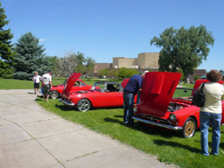

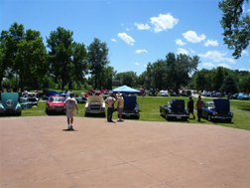

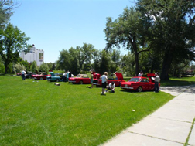

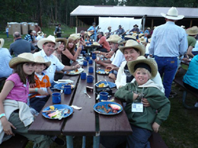

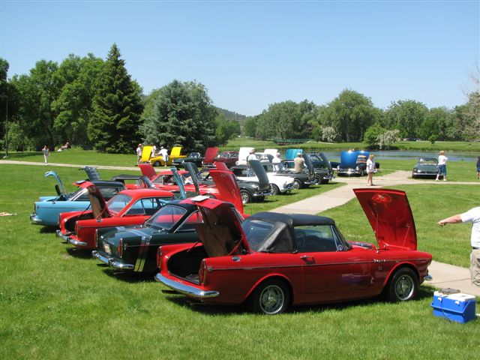

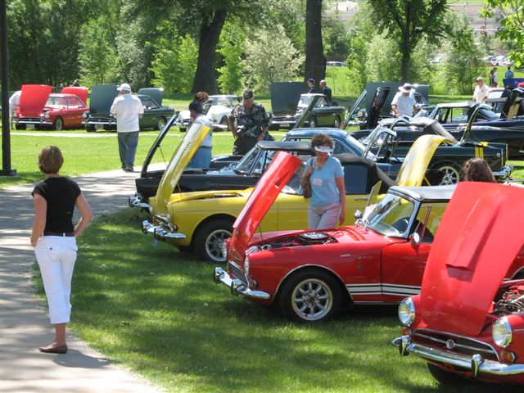

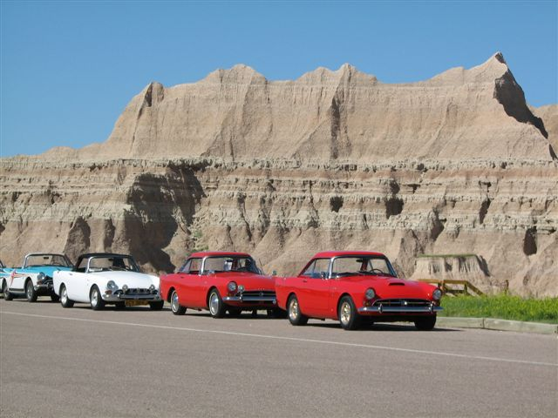

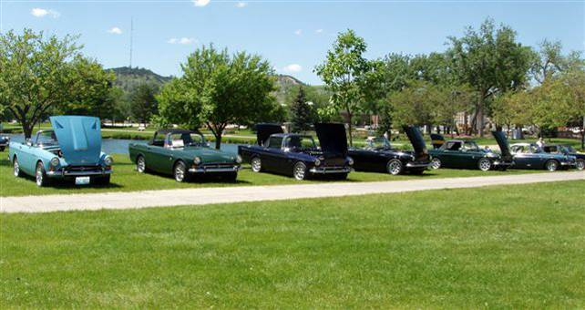

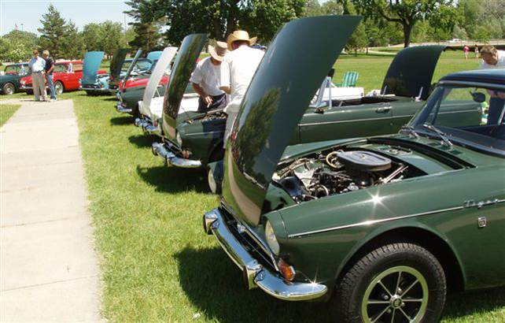

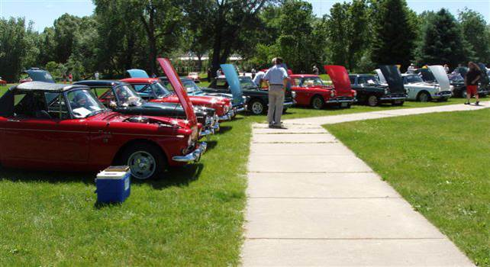

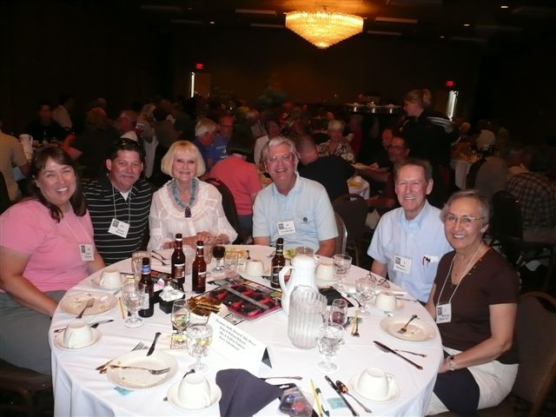

PHOTOS FROM THE BELLEVUE ABFM:

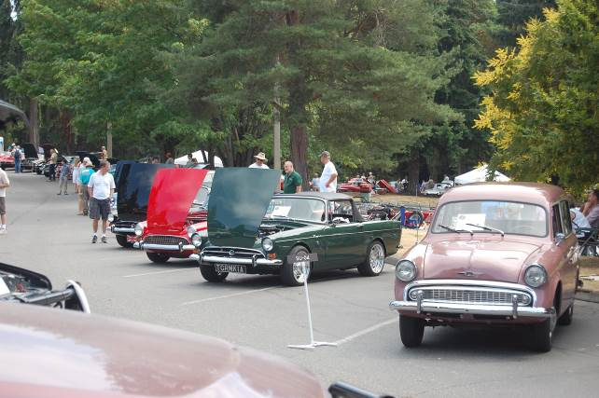

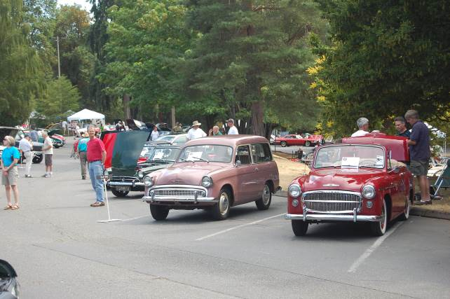

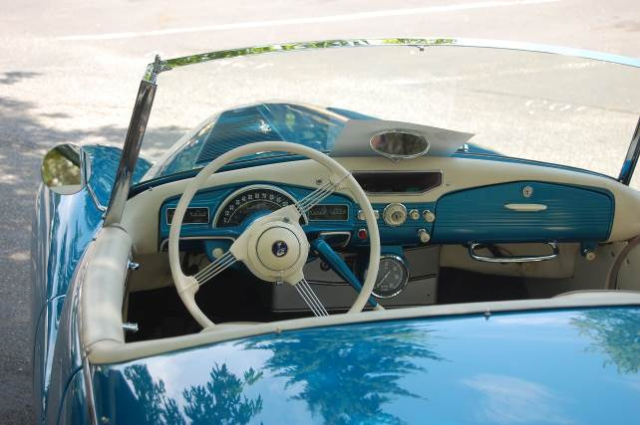

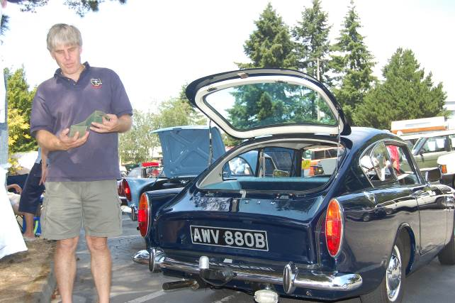

Fill ‘er Up!
By Dick Sanders

“We’ve got Sunbeam spirit, Yes we do!!”

Located between three TV broadcast towers high atop Queen Anne Hill in Seattle, long-time landmark Queen Anne High School is visible from much of the city. It was a public school from 1909 to 1981, when it was shut down and the building converted to apartments and, more recently, condos. Having joined PTC in 1978, I always knew that at least a few fellow members had also attended Queen Anne, but I’d never taken the time to actually do a count. When I finally did, the number surprised me. At least nineteen current and former PTC members attended. Take a look through the list below and see if you’ve met some of them over the years. Thanks to fellow-grad Jim Leach for help in filling in numerous foggy memories. If you attended QAHS and don’t see your name below, let me know!

Bobbie Barnhart – Attended QAHS not as a student but a very popular art teacher who often drove her baby blue Tiger to work/school.

Carol Bosanko – Photos of Carol once graced magazines ranging from a Seattle International Raceway program (posing across the trunk of her white Series III Alpine) to a spread in Penthouse. Moved to Hawaii, taking her Alpine with her. A few years later, in a nasty head-on crash in the Alpine, she reportedly avoided serious injury or even death thanks to a pair of previously implanted cosmetic procedures. Eventually sold the Alpine to her brother Jeff (see below) back here in Seattle. Also sister of Dave Bosanko (see below).

Dave Bosanko – Still owns a Tiger. Once when I found two large cracks, heading towards each other from opposite sides of the front crossmember of my former Mk II Tiger, Dave kindly helped me out and welded the heck out of it. So much so that it warped enough that the front end shop couldn’t set the camber. They had to put chains and come-alongs on each shock tower overnight to gradually pull them back apart. Also, Dave can tell why it’s not a good idea to race your Tiger at Seattle’s Golden Gardens.

Jeff Bosanko – Owned numerous Alpines. Sold them all about four years ago, including a Series I to former member Phil Edwards, who plans to vintage race it this year.

John Caminitti - Owned two Alpines. Says he still has a few parts stashed in his attic – soon to be for sale?

Owen Cooney – Another Tiger owner and a classmate of Wayne Reuter (see below).

Nick Fadich & Colleen Whaley – Long-time members who married out of high school. They and their sharp red Tiger has been active in the club for years, regularly attending events like the old club shows at the Ballard Locks and last year’s Get Smart movie premier.

Eric Heuscher - Another long-time PTC member, Eric is the only one in the club to win the coveted Lord Rootes Award, at Tigers United XXII in 2000, with his immaculate green Mk IA.

Roland Heuscher – Yes, a sibling of Eric. Still owns two Alpines and a Tiger, all awaiting restoration in Seattle’s Ballard neighborhood. I’ll mention Eric’s and Roland’s other brother, Renee, though he was never a PTC member (but did attend QAHS), but was notable for crashing his own Alpine hard into a concrete abutment on the Ballard Bridge, sans seatbelts, in the early ’70s and living to tell about it.

Jim Leach – Currently owns a flush of Audax-bodied Rootes cars: a Tiger, an Alpine, a Minx, a Rapier and a Husky. Jim inherited the Minx from his father, also a QAHS grad. A list of Rootes cars previously owned by Jim would take up too much space. A list of Rootes cars Jim has worked on would fill a small phone book. Jim is responsible for me and many others on the list getting involved in Sunbeams and PTC.

Terry & Lisa McMacken –Another couple who eventually married out of high school; Very active in the club for several years with their two early-Series Alpines. Sadly, Terry passed away last November from complications of injuries suffered in a bicycle/auto accident on the Ballard Bridge in 2007.

Ed Mosiman – Owned a Tiger and Alpine, plus a Jensen Interceptor that he eventually sold to the same person who bought my old Mk II Tiger. Ed’s Tiger was the first I ever saw and recognized as such during high school. I was thoroughly unimpressed by the Tiger as Ed laid down a half-block long patch in front of my house, scaring our cat up a tree.

Wayne Pomerville – I didn’t know Wayne was a QAHS grad (1969) til I read that he had passed away while vacationing in Puerto Vallarta a few months ago. Wayne was one of the first to swap a Toyota four-banger into an Alpine. When not driving his Sunbeam, Wayne got his kicks driving roundy-rounds at Monroe for ten years. At a Sunbeam Northwest event in Chehalis several years ago Wayne, who had never autocrossed before, had the third-fastest time of the day in his Alpine.

Wayne Reuter – Though he’s autocrossed only his Mustang in recent years, Wayne used to eat up the competition in his dark blue Mk I Tiger at the old Boeing Space Center parking lot in Kent. He once took the top prize in his class at the SCCA nationals in Kansas - driving a Tiger borrowed from another club member, Bud Bohrer. Wayne joined PTC shortly after the club was founded in 1972 and is still active in the club along with his wife, Sharon.

Dick & Hollie Sanders – Both ’75 graduates, we didn’t get together ‘til after our 20th reunion. We share a yellow Series V Alpine that I bought back around 1984 and have put roughly 150,000 miles on since. Another dozen Sunbeams of various models and condition have come and gone from my garage since joining PTC, including an Mk II Tiger and my first Sunbeam, a ’69 Alpine Coupe. I nicknamed the Coupe “Irving,” after an old novelty song from the Dr. Demento radio show, “The Ballad of Irving – The 142nd Fastest Gun in the West.” I figured my Irving, with its iron head, single-carbed 1725 engine was about the 142nd fastest Alpine in the West. Irving was apparently offended by this notion and soon caught on fire (twice) from electrical shorts, burned a rod bearing, dropped a ball joint, burned a piston and finally blew a head gasket before being given the heave-ho to a new owner with delusions of installing a V-6 or a rotary.

Leonard Sponaugle – Owned two Alpines in the late ’70s, including a black Series IV he nicknamed “Damien” after an engine rebuild ended in supreme frustration. I bought it from him, assembled it, and drove it for a summer then sold it, which paid for a couple quarters’ tuition at the U-Dub.

For British Cars - 2009
PTC 2009 Meeting Schedule
September 19th - AGM @ Driftwood Key Clubhouse Hansville, WA
We need your help! If you know of any Sunbeam Events, please contact your Activities Co-coordinator and we’ll get it in the newsletter.
Want to avoid mail delays? Receive your next issue of the PTC Newsletter emailed to you on-line. Contact us at Tiger2@telus.net with your email address

We want to hear your great stories! Do you have a great story to share? Send us the details with your photos. Let us know!
DO WE HAVE YOUR CURRENT ADDRESS AND EMAIL? HELP US KEEP OUR RECORDS UP TO DATE AND SEND YOUR CHANGES TO BUDD OR THE EDITOR.

Profile your car!
We would like to have a profile of your car, even if everyone knows who you are. Please email your profile to Mike & Kathryn. New to the PTC, Let us know the details, as we would like to do a feature article on your car!

SEPTEMBER PTC MEETING

Saturday, September 19th from
1:00 to 4:00 pm at the Driftwood Key Clubhouse 37608 Vista Key Dr. NE Hansville, WA, just north of our house. PTC will provide hamburgers, hotdogs, fixings & water. As this is a potluck we ask that members bring a salad or dessert. You will need to RSVP to Budd Bennion by September 8th as we need a head count to make sure we have enough food (206-364-8478 or budd.bennion@comcast.net). The DFK Clubhouse has plenty of parking & there is access to the beach.

We ask each Canadian member to calculate the current exchange rate into US funds. Example: dues today $35.00USD=38.50 CAD (based on 10% exchange rate)
Make payment payable to Pacific Tiger Club and we will process via our bank. Exchange rates are constatntly changing. For assistance you may use the following website:http://www.xe.com

Do you have an interesting tech tip to share with the readers? We are always interested in any submissions.
We want to hear from you! Share your stories with the PTC members. We are always interested in any submissions.
Want to avoid mail delays? Receive your next issue of the PTC Newsletter emailed to you on-line. Contact us at Tiger2@telus.net with your email address

A question from Carol and some reminders:

I have the "Bibliography on Rootes Cars" compiled by Rex Funk 2/94. Has anyone updated this list? If so, where can I obtain it?
Please respond to Carol at tigerracer@aol.com

Saturday, Sept 5
BBQ following Portland ABFM
Carol Christensen's House
Food provided. Bring drinks.

Portland ABFM and Portland Historics
Sept 5 - 6

Shelby Club Track Day
Sept 8 www.saccnw.org

Thank you,
Carol Christensen

Are you buying, selling or trading? Email us at Tiger2@telus.net

Renewing your membership?
Members are asked to observe their renewal dates on each month’s address label. The date indicates when your dues are due to continue receiving the PTC Newsletter. Please send all membership correspondence to Budd at: 14720 30th NE, Seattle, WA. 98155 (206)364-8478 or via email: budd.bennion@comcast.net.
Annual Membership fee $32.00 US/35.00 Foreign for foreign members.
Canadian Funds Payment to PTC

TECH TIP

Product Review:
Everything is becoming computerized. That’s a good thing in most instances and a great thing when it comes to recharging a battery.
Consider the new “Xtreme Charge.” The model XC100 12 volt charger is so sophisticated it can tell you when the proper charge connections have been made, if the leads are connected correctly, or if the battery being charged can even be charged.
Sounds good, but that’s still not all. The Xtreme Charge is available as a single battery charger for about $95 that can handle two batteries at once. That means you can keep the vintage ride fully charged at the same time you are keeping the boat battery fully charged as well.
Since boat batteries and vintage ride batteries seem to constantly need a charge, the Xtreme Charge unit comes with extra leads that can be permanently attached to two separate batteries. When you are ready to head for the lake or to the car show, all you have to do is unplug from the charger and away you go.
When you return home sunburned, it is a simple matter of plugging the charger back in to maintain a full charge. Now that’s convenience.
The Xtreme Charge unit plugs into a common household 110 volt outlet and works off of pulse technology.
I don’t know exactly what that is, but they tell me this technology increases the duty and life cycles of most 12 volt batteries by reducing the size of the lead sulfate crystals formed as the batter works.
The unit charges at 2.5 amps and 14.8 volts. That’s enough charge to ensure the peak charge on any type of 12 volt battery.
As I’ve already mentioned, the unit comes with two sets of permanently attachable leads, as well as two sets of alligator style clamps. All leads have a quick disconnect feature with a built-in fuse protector.
You can find the Xtreme Charge where automotive parts and accessories are sold, or contact Xtreme Charge, 1100 S. Kimball Ave. Southlake TX 76092; 888-287-9314.

Thanks to: Budd Bennion

Vintage Racing

2009 SOVERN EVENT CALENDAR
DATE | EVENT | TRACK
January 24 | AGM Banquet | Spirit of Washington Event Ctr. - Renton
April 17-19 | Defrost Kickoff | Pacific Raceways
May 16-17 | Spring Sprints | Pacific Raceways
July 3-5 | Pacific Northwest Historics | Pacific Raceways
July 11-12 | Portland Historic Races | Portland International Raceway
July 17-19 | VRC of BC Historic Races | Mission Raceway, British Columbia
Aug 29 - 30 | SCCA Vintage Grids | Bremerton Airport
Sept 5 - 7 | Columbia River Classic Road Race | Portland International Raceway
Sept 19- 20 | Fall Finale with Enduro | Pacific Raceways
Sept 26-27 | Maryhill Loops Hill Climb | Maryhill Loops Road, WA

All vintage events sponsored by SOVREN. More info for these and other NW vintage events can be found at: http://www.sovren.org/

We want to hear your great stories! Do you have a great story to share? Send us the details with your photos. Let us know!

Want to avoid mail delays? Receive your next issue of the PTC Newsletter emailed to you on-line. Contact us at Tiger2@telus.net with your email address

FOR SALE:

1963 Sunbeam Alpine - $14,500.00 (Clackamas, Or.)
1963 Sunbeam Alpine (English) car. Orange / Sunset Red color with matching aluminum hardtop. Chrome wire wheels and a SS luggage rack make this car a real show stopper. A great runner and touring unit with a 1725, 4 cylinder engine with 32-36 Weber carburetor, 105 amp chrome alternator, 5 blade light gage cooling fan. 4 speed with Overdrive.
Like new steering joints and wheel bearings. New exhaust system, oil cooler and all running gear has less than 10,000 miles since new overhaul. Tires are in good condition and all electrics work, even has an optional back up light. All glass is in very good condition, the Plexiglas in the hard top has some scratches. It has a professional built roll bar mounted into the lower frame. The hard top is removable, and has a like new soft top stored inside. . Serious interest only please! Cash speaks.
Please call for an appointment. I can send a CD with video and photos.
503-698-7549

1966 SUNBEAM TIGER MARK 1A

Serial# B382002277 JAL # 662297
Color Code 86
Current Color – Forest Green
Engine # 7172B19KC (260 Cubic Mostly Stock)
TAQ # 0641, Issued May 2007

Description and Features:

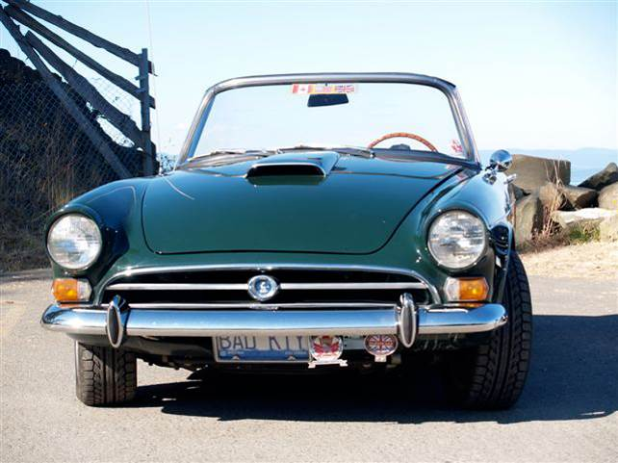

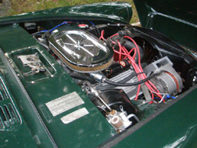

Former California Car, previously owned in the Los Angeles area. Original factory hardtop, black. Black leather interior. 15” Panasport wheels with 2 BF Goodrich G-Force Sport 195/50R15 “V” speed tires (Front) 2 BF Goodrich “G-Force Sport 205/50R15 “V” speed tires (Rear) purchased June 2006, less than 1000 miles.

Upgrades and changes made since 2005 purchase:

Top loader transmission rebuilt and gearing changed from close ratio to wide ratio - High volume oil pump - New radiator with 6 bladed fan - Headers and old Edelbrock style medium riser manifold, ceramic coated - New Centre Force clutch and pilot bearing - New Pertronix ignition with 8mm ignition wires - Rebuild of brake servo and install steel braided lines - New remote oil filter assembly with steel braided hoses - Miscellaneous new rubber seal, grommets etc. Work was completed in 2007.

Gas tanks and pipes removed, cleaned and coated, July 2006. 2” exhaust system with Magniflow mufflers installed in 2007. New Carter fuel pump installed, 2007. New wood dash board with cubby door - New cubby box - New wiring harness and cleanup of wiring under hood - Wiring redone to original specs - Cleaning of all gauges including painting of needles - New soft top hardware. Work completed in 2008

ALSO - BIG TEX 70 CAR HAULER

7,000 lb - 2006 Car hauler Model # 70CH-16. Purchase price July 2006 - $3225.00 Cdn. Asking price - $2400 US includes all tie downs and straps.

Asking price for both the car and the trailer (outfitted for the car) $39,500.00US
Tiger purchased without the trailer, asking $38,000US

Contact: Bob Seifert, mbseifert@shaw.ca
Telephone: 1 250 629-3184 Pender Island, B.C.

REGALIA

Hats, Hats, Hats… We got ‘em! $15.00 +2.50 for
Shipping, all have the "Pacific Tiger Club" Logo on the front, some have Tiger or Alpine on the side and some have no added logo on the side. Make all forms of payment to "Pacific Tiger Club" and mail to Budd Bennion, 14720 30th Ave NE, Seattle WA 98155-7512.
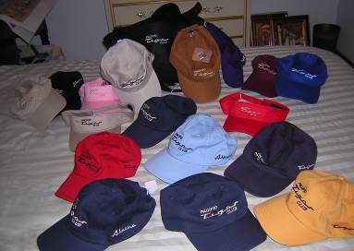

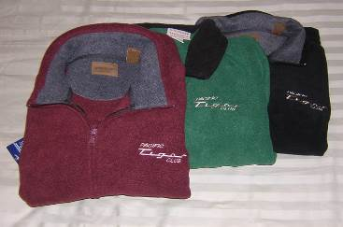
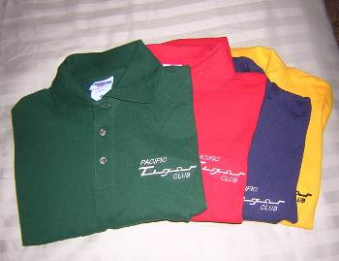

Save postage by picking up regalia at club meeting
Fleece jackets $30 + postage $4
Polo shirts- Lady's = $20 + postage $3
Men’s = $15 + postage $3

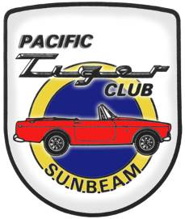
Next Meeting: Sep 19th
Pacific Tiger Club
37624 Vista Key Drive NE
Hansville, WA 98340

